Members Committee
Two Hundred Eighth Meeting
Webex Only
March 29, 2021
1:00 p.m. – 5:00 EPT
*Operator assisted phone lines will be opened 30 minutes prior to the start of the meeting. Due to the high volume of remote participation, stakeholders are asked to connect early to allow additional time for operator queue processing.

Administration (1:00-1:05)
- Announce sector selections of new members since the last meeting – David Anders
- Confirm the presence of a quorum of representatives or designated alternates for this meeting – David Anders
- Anti-trust, Code of Conduct, Meeting Participation, and Safety announcements – David Anders

Consent Agenda (1:05-1:10)
- Approve draft minutes of the February 24, 2021 meeting.

Endorsements/ Approvals (1:10-1:40)
- Black Start Unit Testing, CRF, Involuntary Termination, MTSL, and Substitution Rules (1:10-1:40)
Susan Bruce, PJM Industrial Customer Coalition, and Sharon Midgley, Exelon, will review a proposed compromise solution and corresponding Tariff revisions addressing Black Start Unit Involuntary Termination, Substitution Rules, Capital Recovery Factor (CRF) and Minimum Tank Suction Level (MTSL). The committee will be asked to endorse the proposed solution and Tariff revisions.
Black Start Unit Involuntary Termination & Substitution Rules

First Reads (1:40-2:15)
- Manual 34 Revisions (1:40-2:15)
- Michele Greening will provide an update regarding work activities related to Manual 34: PJM Stakeholder Process revisions under discussion at the Stakeholder Process Forum.
- John Horstmann, The Dayton Power & Light Company, will sponsor proposed Manual 34: PJM Stakeholder Process revisions addressing the motions and amendments. The committee will be asked to approve the proposed revisions at its next meeting.

Reports (2:15-2:30)
- MC Vice Chair Report (2:15-2:25)
- Provide an update on the Members Committee Annual Plan – Erik Heinle

- Provide a preview on the April 19, 2021 Liaison Committee meeting with the PJM Board of Managers – Erik Heinle
- Webinar Feedback (2:25-2:30)
Stakeholders may raise any items identified for further discussion from the March 22, 2021 Members Committee Webinar.
 | Future Agenda Items (2:30)
 | Future Meeting Dates
April 21, 2021 |  | 1:15 p.m. | WebEx
May 3, 2021 (PJM Annual Meeting) |  | 1:15 p.m. | WebEx
June 23, 2021 |  | 1:15 p.m. | WebEx
July 28, 2021 |  | 1:15 p.m. | TBD
September 29, 2021 |  | 1:15 p.m. | TBD
October 20, 2021 |  | 1:15 p.m. | TBD
November 17, 2021 |  | 1:15 p.m. | TBD
December 15, 2021 |  | 1:15 p.m. | TBD

Author: M. Greening

Antitrust:
You may not discuss any topics that violate, or that might appear to violate, the antitrust laws including but not limited to agreements between or among competitors regarding prices, bid and offer practices, availability of service, product design, terms of sale, division of markets, allocation of customers or any other activity that might unreasonably restrain competition. If any of these items are discussed the chair will re-direct the conversation. If the conversation still persists, parties will be asked to leave the meeting or the meeting will be adjourned.

Code of Conduct:
As a mandatory condition of attendance at today's meeting, attendees agree to adhere to the PJM Code of Conduct as detailed in PJM Manual M-34 section 4.5, including, but not limited to, participants' responsibilities and rules regarding the dissemination of meeting discussion and materials.

Public Meetings/Media Participation:
Unless otherwise noted, PJM stakeholder meetings are open to the public and to members of the media. Members of the media are asked to announce their attendance at all PJM stakeholder meetings at the beginning of the meeting or at the point they join a meeting already in progress. Members of the Media are reminded that speakers at PJM meetings cannot be quoted without explicit permission from the speaker. PJM Members are reminded that "detailed transcriptional meeting notes" and white board notes from "brainstorming sessions" shall not be disseminated. Stakeholders are also not allowed to create audio, video or online recordings of PJM meetings. PJM may create audio, video or online recordings of stakeholder meetings for internal and training purposes, and your participation at such meetings indicates your consent to the same.
Participant Identification in Webex:
When logging into the Webex desktop client, please enter your real first and last name as well as a valid email address. Be sure to select the “call me” option.
PJM support staff continuously monitors Webex connections during stakeholder meetings. Anonymous users or those using false usernames or emails will be dropped from the teleconference.

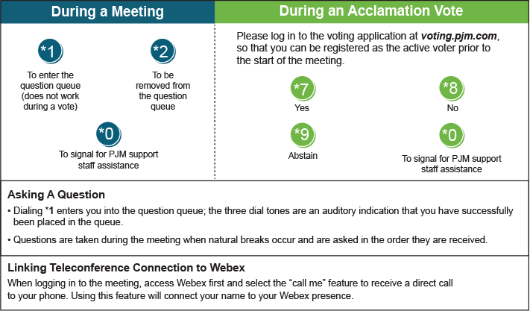

Provide feedback on the progress of this group: Facilitator Feedback Form
Visit learn.pjm.com, an easy-to-understand resource about the power industry and PJM’s role.

