Market Implementation Committee
PJM Conference & Training Center, Audubon, PA
February 6, 2019
9:00 a.m. – 2:15 p.m. EPT

Administration (9:00-9:15)
Ms. Bhavana Keshavamurthy and Ms. Chantal Hendrzak will provide announcements; review the Antitrust, Code of Conduct, Public Meetings/Media Participation, the WebEx Participant Identification Requirement, and Issue Tracking.

The Committee will be asked to approve the draft minutes from the January 9, 2018 MIC meeting.

        - Ms.Suzanne Daugherty, PJM, will give an informational update on the FERC waiver denial related to Financial Transmission Rights liquidation rules in connection with the July 2018 FTR auction. Mr. Chris O’Hara, PJM, and Mr. Timothy Horger, PJM, will also be available to address questions on this topic.

First Readings (9:15-11:00)
- Load Management Testing Requirements - Problem Statement & Issue Charge (9:15-9:30)
Mr. Jack O’Neill, PJM, will present a problem statement and issue charge to address Load Management testing requirements.

- Updates to Location Fields in DR Hub (9:30-09:40)
Ms. Andrea Yeaton, PJM, will review updates to Manual 11 due to addition of location fields in DR Hub.

- Cover to Cover Review of Manual 11 (9:40-10:00)
Ms. Susan Kenney, PJM, will review updates to Manual 11 as part of the biennial review.

- Must Offer Exception Process (10:00-10:30)
Mr. Pat Bruno, PJM, will provide a first read of an alternate propsoal for the Must Offer Exception Process.
Issue Tracking: Must Offer Exception Process

- Fuel Cost Policy (10:30-11:00)
Ms. Bhavana Keshavamurthy, PJM, will provide a first read of the consensus package addressing the Fuel Cost Policy Annual Review requirement developed at the MIC Special Sessions related to Fuel Cost Policy Enhancements.
Issue Tracking: Fuel Cost Policy

Working Issues (11:00-12:00)
- Electric Storage Participation - FERC Order 841 (11:00-11:30)
Mr.Scott Benner, PJM, will provide education on the cost based offer development for storage resources. PJM is requesting that stakeholders bring feedback on energy storage cost offers for discussion at this meeting. PJM is also providing a FAQ on Order 841 and hybrid resources; additional questions can be sent to esr@pjm.com
Issue Tracking: Electric Storage Participation FERC Order 841

- Incremental Auction Revenue Rights Coordination with MISO (11:30-11:45)
Mr. Brian Chmielewski, PJM, will provide an update on the work completed to date on IARR coordination with MISO and introduce the potential for a problem statement to address outstanding concerns.

- FTR Forfeiture update (11:45-12:00)
Mr.Brian Chmielewski, PJM, will provide an update on an issue identified in the FTR Forfeiture calculations.

Lunch (12:00-1:00)

Additional Items (1:00-2:15)
- 2019/20 ARR/FTR Update (1:00-1:15)
Mr. Brian Chmielewski, PJM, will review ARR/FTR modeling processes completed to date and upcoming deadlines for the 2019/2020 planning year.

- Incremental Auction Revenue Rights for RTEP Upgrades (1:15-1:25)
Ms. Xu Xu, PJM, will provide an update on Incremental Auction Revenue Rights for upgrades in the Regional Transmission Expansion Plan 2019/2020 planning year.

- Non-Synchronized Reserves Updates (1:25-1:35)
Ms. Lisa Morelli, PJM, will review Manual 11 changes for Non-Synchronized Reserves (NSR) eligibility for non-telemetered resources.

- Network Model Alignment Initiative (1:35-2:00)
Ms. Nicole Scott, Mr. Jason Sexauer and Mr. Kyle Clifford, PJM, will present accomplishments of the Network Model Alignment Initiative outlining the work performed and its relevance.

- ComEd SPS/RAS Retirement (2:00-2:15)
Mr.Alan Engelmann and Mr. Minh Nguyen, ComEd, will present on the retirement of the SPS/RAS at Lisle substation.

Informational Section
Credit Subcommittee (CS)
Meeting materials will be posted to the CS website.

Demand Response Subcommittee (DRS)
Meeting materials will be posted to the DRS web site.

Intermittent Resources Subcommittee (IRS)
Meeting materials will be posted to the IRS web site.

Net Energy Injections Quarterly Report
Materials are posted as informational only.

Interregional Coordination Update
Materials are posted as informational only.

Market Settlements Subcommittee (MSS)
Meeting materials are posted to the MSS web site.

Report on Market Operations
The Report on Market Operations will be reviewed during the MC Webinar.

Fuel Requirements for Black Start Resources Update
Updates are posted at Issue Tracking: Fuel Requirements for Black Start Resources

Future Meeting Dates
March 6, 2019 | 9:00 a.m. | PJM Conference & Training Center/ WebEx
April 10, 2019 | 9:00 a.m. | PJM Conference & Training Center/ WebEx
May 15, 2019 | 9:00 a.m. | PJM Conference & Training Center/ WebEx
June 12, 2019 | 9:00 a.m. | PJM Conference & Training Center/ WebEx
July 10, 2019 | 9:00 a.m. | PJM Conference & Training Center/ WebEx
August 7, 2019 | 9:00 a.m. | PJM Conference & Training Center/ WebEx

Author: Bhavana Keshavamurthy

Antitrust:
You may not discuss any topics that violate, or that might appear to violate, the antitrust laws including but not limited to agreements between or among competitors regarding prices, bid and offer practices, availability of service, product design, terms of sale, division of markets, allocation of customers or any other activity that might unreasonably restrain competition. If any of these items are discussed the chair will re-direct the conversation. If the conversation still persists, parties will be asked to leave the meeting or the meeting will be adjourned.

Code of Conduct:
As a mandatory condition of attendance at today's meeting, attendees agree to adhere to the PJM Code of Conduct as detailed in PJM Manual M-34 section 4.5, including, but not limited to, participants' responsibilities and rules regarding the dissemination of meeting discussion and materials.

Public Meetings/Media Participation:
Unless otherwise noted, PJM stakeholder meetings are open to the public and to members of the media. Members of the media are asked to announce their attendance at all PJM stakeholder meetings at the beginning of the meeting or at the point they join a meeting already in progress. Members of the Media are reminded that speakers at PJM meetings cannot be quoted without explicit permission from the speaker. PJM Members are reminded that "detailed transcriptional meeting notes" and white board notes from "brainstorming sessions" shall not be disseminated. Stakeholders are also not allowed to create audio, video or online recordings of PJM meetings. PJM may create audio, video or online recordings of stakeholder meetings for internal and training purposes, and your participation at such meetings indicates your consent to the same.

Participant Identification in WebEx:
When logging into the WebEx desktop client, please enter your real first and last name as well as a valid email address. Be sure to select the “call me” option.
PJM support staff continuously monitors WebEx connections during stakeholder meetings. Anonymous users or those using false usernames or emails will be dropped from the teleconference.

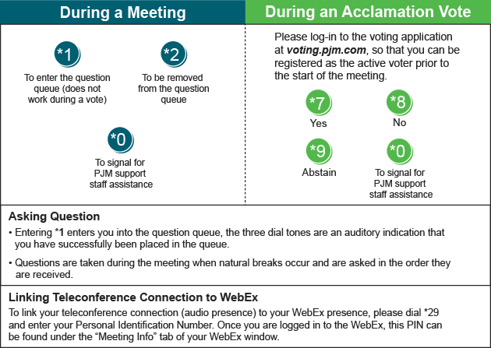

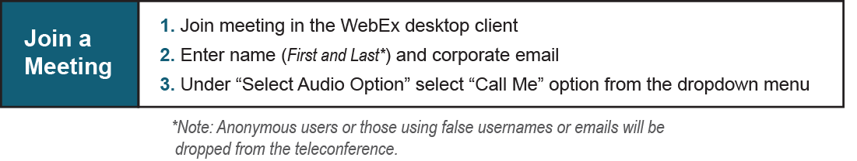

Provide feedback on the progress of this group: Facilitator Feedback Form
Visit learn.pjm.com, an easy-to-understand resource about the power industry and PJM’s role.

