Market Implementation Committee
WebEx Only
June 3, 2020
9:00 a.m. – 4:00 p.m. EPT

Administration (9:00-9:05)
Bhavana Keshavamurthy will review the Antitrust, Code of Conduct, Public Meetings/Media Participation and the WebEx Participant Identification Requirements.

The Committee will be asked to approve the draft minutes from the May 13, 2020 Market Implementation Committee meeting.

Endorsements/Approvals (9:05-10:15)
- Manual 6 revisions(9:05-9:15)
Emmy Messina will review updates to Manual 6: Financial Transmission Rights as part of the periodic review. All changes are administrative in nature, including clarifications, grammar, punctuation, capitalization and spacing changes throughout the manual.
The committee will be asked to endorse the manual revisions at this meeting.

- Five Minute Dispatch and Pricing (9:15-9:45)
- Tim Horger and Vijay Shah will review the PJM proposal.
- Catherine Tyler, Monitoring Analytics will review the IMM proposal.
- Susan Kenney will review the status of the work pending under this issue charge.
The committee will be asked to vote on the PJM and IMM proposals at this meeting. If any of the packages receives greater than 50%, a second non-binding vote will be taken asking whether participants prefer that package over the status quo.
Issue Tracking: Five Minute Dispatch and Pricing

- Solar-Battery Hybrids( 9:45-10:15)
Scott Baker will provide a first read and request a vote on the Issue Charge related to the Solar-Battery Hybrids Issue.
The committee will be asked to vote on the Issue Charge at this meeting.

First Readings (10:15-11:50)
- Subcommittee Consolidation (10:15-10:45)
Scott Baker will propose the sunset of the Intermittent Resources Subcommittee (IRS) and provide a first read on the charter for the Distributed and Inverter-based Resources Subcommittee (DIRS). The committee will be asked to approve the sunset of the IRS and approve the DIRS charter at the July MIC.

- PRD Credits Disposition(10:45-11:15)
Sharon Midgley, Exelon, will provide a first read of the Problem Statement and Issue Charge addressing the Price Responsive Demand (PRD) Credits Disposition. The committee will be asked to vote on the issue charge approval at the July MIC.

- Transparency in Performance Assessment Interval Settlements( 11:15-11:35)
Danielle Croop will review the problem statement and issue charge addressing additional transparency in settlement calculations for non-performance charge. The committee will be asked to vote on the issue charge approval at the July MIC.

- Manual 14D and Manual 27 revisions(11:35-11:50)
Ray Fernandez will review updates to Manual 14D: Generator Operational Requirements and Manual 27: Open Access Transmission Tariff Accounting related to changes to deadlines for adjustments associated with finalizing the zonal network service peak load values. The committee will be asked to endorse the manual revisions at the July MIC.

Additional Items (11:50-12:05)
- FERC Transmission Orders Requiring Reallocations and Refunds(11:50-12:05)
Ray Fernandez will provide updates on cost allocation issues associated with multiple orders from FERC that require resettlement.

Lunch (12:05-12:45)
- Forward Looking Energy & Ancillary Services Offset Methodology (12:45-2:00)
PJM and Monitoring Analytics staff will provide education on work that has previously been done on the development of a forward energy and ancillary services (E&AS) offset methodology as a primer for future discussions on this topic in response to the FERC ruling the historical looking E&AS offset unjust and unreasonable in docket EL19-58.
- Gary Helm will provide education on the forward energy and ancillary services offset methodology that proposed as part of the 2014 triennial review.
- Monitoring Analytics will provide education on the forward looking energy and ancillary services offset methodology they have previously proposed.

Informational Section
Note: Discussion on the working issue Stability Limits in Markets and Operations will resume at the July MIC after the MIC Special Session: Stability Limits in Markets and Operations scheduled for Jun. 23.

Interface Pricing Points Update
This presentation provides an overview of updates being made to Interface Pricing Points. Materials are posted as informational only.

Interregional Coordination Update
Materials are posted as informational only.

Credit Subcommittee (CS)
Meeting materials will be posted to the CS website.

Demand Response Subcommittee (DRS)
Meeting materials will be posted to the DRS web site.

Intermittent Resources Subcommittee (IRS)
Meeting materials will be posted to the IRS web site.

Market Settlements Subcommittee (MSS)
Meeting materials are posted to the MSS web site.

Report on Market Operations
The Report on Market Operations will be reviewed during the MC Webinar.

Future Meeting Dates
July 8, 2020 | 9:00 a.m. | WebEx
August 5, 2020 | 9:00 a.m. | WebEx
September 2, 2020 | 9:00 a.m. | PJM Conference & Training Center/ WebEx
October 7, 2020 | 9:00 a.m. | PJM Conference & Training Center/ WebEx
November 5, 2020 | 9:00 a.m. | PJM Conference & Training Center/ WebEx
December 2, 2020 | 9:00 a.m. | PJM Conference & Training Center/ WebEx
Author: Bhavana Keshavamurthy

Antitrust:
You may not discuss any topics that violate, or that might appear to violate, the antitrust laws including but not limited to agreements between or among competitors regarding prices, bid and offer practices, availability of service, product design, terms of sale, division of markets, allocation of customers or any other activity that might unreasonably restrain competition. If any of these items are discussed the chair will re-direct the conversation. If the conversation still persists, parties will be asked to leave the meeting or the meeting will be adjourned.

Code of Conduct:
As a mandatory condition of attendance at today's meeting, attendees agree to adhere to the PJM Code of Conduct as detailed in PJM Manual M-34 section 4.5, including, but not limited to, participants' responsibilities and rules regarding the dissemination of meeting discussion and materials.

Public Meetings/Media Participation:
Unless otherwise noted, PJM stakeholder meetings are open to the public and to members of the media. Members of the media are asked to announce their attendance at all PJM stakeholder meetings at the beginning of the meeting or at the point they join a meeting already in progress. Members of the Media are reminded that speakers at PJM meetings cannot be quoted without explicit permission from the speaker. PJM Members are reminded that "detailed transcriptional meeting notes" and white board notes from "brainstorming sessions" shall not be disseminated. Stakeholders are also not allowed to create audio, video or online recordings of PJM meetings. PJM may create audio, video or online recordings of stakeholder meetings for internal and training purposes, and your participation at such meetings indicates your consent to the same.
Participant Identification in WebEx:
When logging into the WebEx desktop client, please enter your real first and last name as well as a valid email address. Be sure to select the “call me” option.
PJM support staff continuously monitors WebEx connections during stakeholder meetings. Anonymous users or those using false usernames or emails will be dropped from the teleconference.

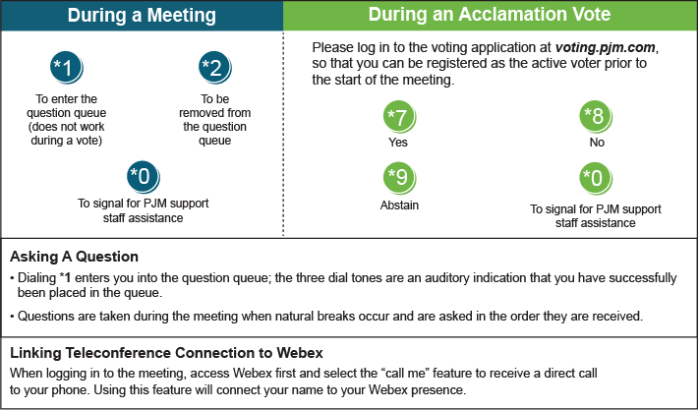

Provide feedback on the progress of this group: Facilitator Feedback Form
Visit learn.pjm.com, an easy-to-understand resource about the power industry and PJM’s role.

