Markets and Reliability Committee
PJM Conference and Training Center, Valley Forge, PA
January 23, 2019
9:00 a.m. – 10:55 a.m. EPT

Administration (9:00-9:10)
Welcome, announcements and Anti-trust and Code of Conduct announcement – Mr. Stu Bresler and Mr. Dave Anders

Consent Agenda (9:10-9:15)
- Approve minutes of the December 19, 2019 meeting of the Markets and Reliability Committee (MRC).
- Endorse proposed revisions to PJM Manual 38: Operations Planning including updates from the periodic cover-to-cover review and updated procedures.

Endorsements/Approvals (9:15-9:40)
- Modeling Generation Senior Task Force (MGSTF) (9:15-9:30)
Mr. Glen Boyle will provide an overview of the Modeling Generation Senior Task Force recommendation regarding soak time. The committee will be asked to endorse a proposed solution package.
Issue Tracking: Modeling Generation in Markets Gateway
- Primary Frequency Response Task Force Update (9:30-9:40)
Mr. Glen Boyle will provide an overview of the Primary Frequency Response Task Force and recommendation future direction. The committee will be asked to endorse the recommended future direction.
Issue Tracking: Primary Frequency Response Requirement

First Readings (9:40-10:25)
- Fuel Cost Policy (9:40-10:00)
Ms. Bhavana Keshavamurthy will provide an overview of the Fuel Cost Policy proposals endorsed by the Market Implementation Committee. The committee will be asked to endorse a proposed solution package at its next meeting.
Issue Tracking: Fuel Cost Policy
- PJM Manuals (10:00-10:25)
    - Mr. Jason Bilash will review proposed revisions to Manual 14F: Competitive Planning Process regarding the removal of FERC 715 language from the proposal window. The committee will be asked to endorse the revisions at its next meeting.
    - Ms. Amanda Egan will review proposed revisions to Manual 33: Administrative Services for the PJM Interconnection Operating Agreement to incorporate information regarding CAM roles and responsibilities. The committee will be asked to endorse these changes at its next meeting.
    - Mr. Michael Hoke will review proposed revisions to Manual 40: Training and Certification Requirements to update language for consistency across sections and incorporate revisions resulting from the periodic cover to cover review. The committee will be asked to endorse the revisions at its next meeting.

Informational Reports (10:25-10:55)
- Market Participation Risk Evaluation Enhancements (10:25-10:55)
Ms. Nigeria Bloczynski will provide a status update on the development of proposed revisions to the Tariff to implement the Market Participant Risk Evaluation and Enhancement solution package endorsed by the Financial Risk Mitigation Sr. Task Force. In response to stakeholder requests for additional time to refine the proposed Tariff revisions, PJM is deferring for up to 60 days holding a vote at this time.
Issue Tracking: Financial Risk Mitigation

Informational Postings Only
None

Future Agenda Items (10:55)

Future Meeting Dates
February 20, 2020 | 9:00 a.m. | PJM Conference & Training Center/ WebEx
March 26, 2020 | 9:00 a.m. | PJM Conference & Training Center/ WebEx
April 30, 2020 | 9:00 a.m. | PJM Conference & Training Center/ WebEx
May 28, 2020 | 9:00 a.m. | PJM Conference & Training Center/ WebEx
June 18, 2020 | 9:00 a.m. | PJM Conference & Training Center/ WebEx
July 23, 2020 | 9:00 a.m. | PJM Conference & Training Center/ WebEx
August 20, 2020 | 9:00 a.m. | PJM Conference & Training Center/ WebEx
September 17, 2020 | 9:00 a.m. | PJM Conference & Training Center/ WebEx
October 29, 2020 | 9:00 a.m. | PJM Conference & Training Center/ WebEx
November 19, 2020 | 9:00 a.m. | PJM Conference & Training Center/ WebEx
December 17, 2020 | 9:00 a.m. | PJM Conference & Training Center/ WebEx
Author: M. Greening

Antitrust:
You may not discuss any topics that violate, or that might appear to violate, the antitrust laws including but not limited to agreements between or among competitors regarding prices, bid and offer practices, availability of service, product design, terms of sale, division of markets, allocation of customers or any other activity that might unreasonably restrain competition. If any of these items are discussed the chair will re-direct the conversation. If the conversation still persists, parties will be asked to leave the meeting or the meeting will be adjourned.

Code of Conduct:
As a mandatory condition of attendance at today's meeting, attendees agree to adhere to the PJM Code of Conduct as detailed in PJM Manual M-34 section 4.5, including, but not limited to, participants' responsibilities and rules regarding the dissemination of meeting discussion and materials.

Public Meetings/Media Participation:
Unless otherwise noted, PJM stakeholder meetings are open to the public and to members of the media. Members of the media are asked to announce their attendance at all PJM stakeholder meetings at the beginning of the meeting or at the point they join a meeting already in progress. Members of the Media are reminded that speakers at PJM meetings cannot be quoted without explicit permission from the speaker. PJM Members are reminded that "detailed transcriptional meeting notes" and white board notes from "brainstorming sessions" shall not be disseminated. Stakeholders are also not allowed to create audio, video or online recordings of PJM meetings. PJM may create audio, video or online recordings of stakeholder meetings for internal and training purposes, and your participation at such meetings indicates your consent to the same.
Participant Identification in WebEx:
When logging into the WebEx desktop client, please enter your real first and last name as well as a valid email address. Be sure to select the “call me” option.
PJM support staff continuously monitors WebEx connections during stakeholder meetings. Anonymous users or those using false usernames or emails will be dropped from the teleconference.

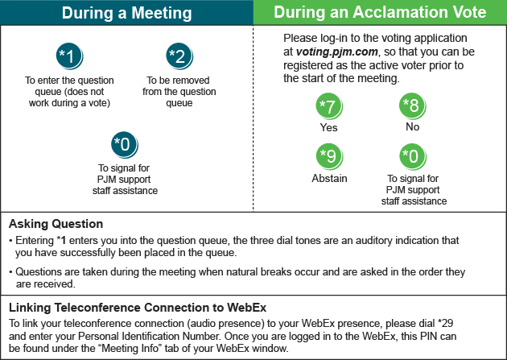

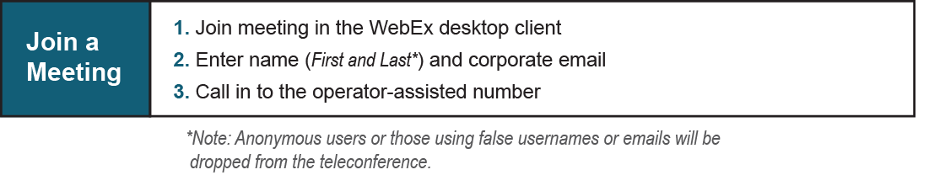
Provide feedback on the progress of this group: Facilitator Feedback Form
Visit learn.pjm.com, an easy-to-understand resource about the power industry and PJM’s role.

