Markets and Reliability Committee Special Session - Transparency & End of Life Planning
Webex Only
May 15, 2020
9:00 a.m. – 12:00 p.m. EPT

Administration (9:00-9:10)
- Jeffrey McLaughlin, PJM, will review administrative items.

Work plan (9:10-9:20)
- Jim Gluck, PJM, will review the updated work plan for this initiative.

Related Updates (9:20-9:45)
- PJM Package Follow-up
Dave Souder, PJM, will review the assessment of governing document and manual language changes required to support its package.
- Proposed Attachment M-3 Amendments
A Transmission Owner representative will address the recently posted notice of their intent to amend Attachment M-3 of the PJM Open Access Transmission Tariff (OATT).

Solution Development (9:45-11:45)
- Develop Packages
Jim Gluck will lead stakeholders in an exercise to review and develop solution packages in the ‘Options and Packages Matrix’.
- Narrow Packages
Jim Gluck will lead stakeholders in an exercise to narrow packages in the ‘Options and Packages Matrix’.
- Compare Packages to Interests
Jim Gluck will ask stakeholders to compare the packages to interests identified earlier in the solution development process.

For further information about these steps in the Consensus-based Issue Resolution (CBIR) process, please refer to Manual 34, Section 7.3.

Informational Postings
- Package A – Draft OA Language
- Package C – Draft Manual Language

Future Agenda Items (11:45-12:00)
- Governing Document Page Turn (if needed)

Future Meeting Dates
June 5, 2020 [if needed] | 9:00 a.m. – 12:00 p.m. | PJM Conference & Training Center/ WebEx
June 12, 2020 [if needed] | 1:00 p.m. – 4:00 p.m. | PJM Conference & Training Center/ WebEx
Author: J. McLaughlin

Antitrust:
You may not discuss any topics that violate, or that might appear to violate, the antitrust laws including but not limited to agreements between or among competitors regarding prices, bid and offer practices, availability of service, product design, terms of sale, division of markets, allocation of customers or any other activity that might unreasonably restrain competition. If any of these items are discussed the chair will re-direct the conversation. If the conversation still persists, parties will be asked to leave the meeting or the meeting will be adjourned.

Code of Conduct:
As a mandatory condition of attendance at today's meeting, attendees agree to adhere to the PJM Code of Conduct as detailed in PJM Manual M-34 section 4.5, including, but not limited to, participants' responsibilities and rules regarding the dissemination of meeting discussion and materials.

Public Meetings/Media Participation:
Unless otherwise noted, PJM stakeholder meetings are open to the public and to members of the media. Members of the media are asked to announce their attendance at all PJM stakeholder meetings at the beginning of the meeting or at the point they join a meeting already in progress. Members of the Media are reminded that speakers at PJM meetings cannot be quoted without explicit permission from the speaker. PJM Members are reminded that "detailed transcriptional meeting notes" and white board notes from "brainstorming sessions" shall not be disseminated. Stakeholders are also not allowed to create audio, video or online recordings of PJM meetings. PJM may create audio, video or online recordings of stakeholder meetings for internal and training purposes, and your participation at such meetings indicates your consent to the same.
Participant Identification in WebEx:
When logging into the WebEx desktop client, please enter your real first and last name as well as a valid email address. Be sure to select the “call me” option.
PJM support staff continuously monitors WebEx connections during stakeholder meetings. Anonymous users or those using false usernames or emails will be dropped from the teleconference.



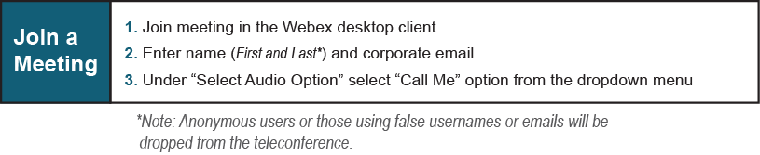

Provide feedback on the progress of this group: Facilitator Feedback Form
Visit learn.pjm.com, an easy-to-understand resource about the power industry and PJM’s role.

