Markets and Reliability Committee
Webex Only
October 29, 2020
9:00 a.m. – 11:35 a.m.
*Operator assisted phone lines will be opened 30 minutes prior to the start of the meeting. Due to the high volume of remote participation, stakeholders are asked to connect early to allow additional time for operator queue processing.

Administration (9:00-9:05)
Welcome, announcements and Anti-trust, Code of Conduct, and Public Meetings/Media Participation – Stu Bresler and Dave Anders

Consent Agenda (9:05-9:10)
- Approve minutes of the September 17, 2020 meeting of the Markets and Reliability Committee (MRC).
- Endorse revisions to Manual 15: Cost Development Guidelines resulting from its biennial periodic review process.

Endorsements/Approvals (9:10-9:45)
- 2020 Installed Reserve Margin Study Results (9:10-9:25)
Patricio Rocha Garrido will review the 2020 Reserve Requirement Study results including the Installed Reserve Margin (IRM) and Forecast Pool Requirement (FPR). The committee will be asked to endorse the IRM and FPR study results.
- Liquidation Process (9:25-9:45)
Nigeria Bloczynski will review proposed revisions addressing PJM’s default management process. The committee will be asked to approve/endorse the proposed revisions. Members Committee endorsement will be sought on the same day.
Issue Tracking: Financial Risk Mitigation

First Readings (9:45-11:10)
- Day Ahead Schedule Reserve (DASR) Update (9:45-10:00)
David Kimmel will review preliminary proposed changes to the 2021 Day Ahead Scheduling Reserve (DASR) requirement. The committee will be asked to endorse the changes at its next meeting.

- PJM Manuals (10:00-11:10)
  - Lagy Mathew will review updates to Manual 3: Transmission Operations to incorporate clarifying changes resulting from its periodic review. The committee will be asked to endorse the revisions at its next meeting.
  - Maria Baptiste will review proposed revisions to Manual 3A: Energy Management System (EMS) Model Updates and Quality Assurance (QA) resulting from its periodic review. The committee will be asked to endorse the revisions at its next meeting.
  - Vince Stefanowicz will review proposed revisions to Manual 10: Pre-Scheduling Operations to incorporate clarifying changes resulting from its periodic review. The committee will be asked to endorse the revisions at its next meeting.
  - Vijay Shah and Kevin Hatch will review proposed revisions to Manual 11: Energy & Ancillary Services Market Operations and Manual 12: Balancing Operations to address changes related to the 5 minute dispatch and pricing MIC special sessions. The committee will be asked to endorse the revisions at its next meeting.
Issue Tracking: Five Minute Dispatch and Pricing
  - This item has been removed.
  - Darrell Frogg will review proposed revisions to Manual 14D: Generator Operational Requirements to incorporate changes resulting from its periodic review. The committee will be asked to endorse these changes at its next meeting.
  - Jeff Bastian will review a minor correction to Manual 18: PJM Capacity Market with regards to an effective date for notifying pseudo-tied resource owners of their assigned LDA prior to each delivery year. The committee will be asked to endorse the revisions at its next meeting.

Informational Reports (11:10-11:35)
- Minimum Offer Price Rule Order (11:10-11:35)
Chen Lu will provide an overview of the October 15 FERC order partially approving PJM’s compliance filings in the Minimum Offer Price Rule (MOPR) (Docket Nos. EL16-49-003, EL18-178-003, and ER18-1314-006) and outline the compliance directives provided therein.

Informational Posting Only

Future Agenda Items (11:35)

Future Meeting Dates
November 19, 2020 | 9:00 a.m. | PJM Conference & Training Center/ WebEx
December 17, 2020 | 9:00 a.m. | PJM Conference & Training Center/ WebEx

Author: M. Greening

Antitrust:
You may not discuss any topics that violate, or that might appear to violate, the antitrust laws including but not limited to agreements between or among competitors regarding prices, bid and offer practices, availability of service, product design, terms of sale, division of markets, allocation of customers or any other activity that might unreasonably restrain competition. If any of these items are discussed the chair will re-direct the conversation. If the conversation still persists, parties will be asked to leave the meeting or the meeting will be adjourned.

Code of Conduct:
As a mandatory condition of attendance at today's meeting, attendees agree to adhere to the PJM Code of Conduct as detailed in PJM Manual M-34 section 4.5, including, but not limited to, participants' responsibilities and rules regarding the dissemination of meeting discussion and materials.

Public Meetings/Media Participation:
Unless otherwise noted, PJM stakeholder meetings are open to the public and to members of the media. Members of the media are asked to announce their attendance at all PJM stakeholder meetings at the beginning of the meeting or at the point they join a meeting already in progress. Members of the Media are reminded that speakers at PJM meetings cannot be quoted without explicit permission from the speaker. PJM Members are reminded that "detailed transcriptional meeting notes" and white board notes from "brainstorming sessions" shall not be disseminated. Stakeholders are also not allowed to create audio, video or online recordings of PJM meetings. PJM may create audio, video or online recordings of stakeholder meetings for internal and training purposes, and your participation at such meetings indicates your consent to the same.
Participant Identification in WebEx:
When logging into the WebEx desktop client, please enter your real first and last name as well as a valid email address. Be sure to select the “call me” option.
PJM support staff continuously monitors WebEx connections during stakeholder meetings. Anonymous users or those using false usernames or emails will be dropped from the teleconference.

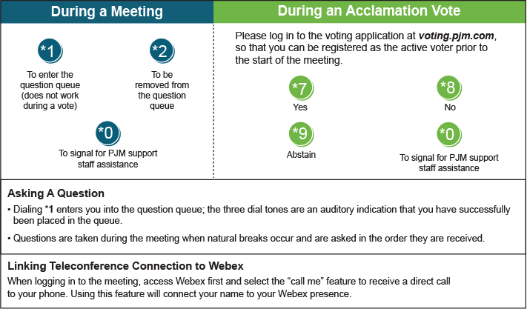

Provide feedback on the progress of this group: Facilitator Feedback Form
Visit learn.pjm.com, an easy-to-understand resource about the power industry and PJM’s role.

