Markets and Reliability Committee
Webex Only
February 24, 2021
9:00 a.m. – 12:15 p.m.
*Operator assisted phone lines will be opened 30 minutes prior to the start of the meeting. Due to the high volume of remote participation, stakeholders are asked to connect early to allow additional time for operator queue processing.

Administration (9:00-9:05)
Welcome, announcements and Anti-trust, Code of Conduct, and Public Meetings/Media Participation – Stu Bresler and Dave Anders

Consent Agenda (9:05-9:10)
- Approve minutes of the January 27, 2021 meeting of the Markets and Reliability Committee (MRC).
- Endorse proposed revisions to Manual 40: Training and Certification Requirements resulting from the periodic review.

Endorsements/ Approvals (9:10-11:00)
- Black Start Unit Testing, CRF, Involuntary Termination, MTSL and Substitution Rules including Existing Resources (9:10-9:35)
Greg Poulos, on behalf of Delaware Division of the Public Advocate, will review a proposed solution package addressing Black Start Unit Involuntary Termination, Substitution Rules, Capital Recovery Factor (CRF) and Minimum Tank Suction Level (MTSL) that includes existing resources. The committee will be asked to endorse the proposed solution.
Black Start Unit Involuntary Termination & Substitution Rules
- Black Start Unit Testing, CRF, Involuntary Termination, MTSL, and Substitution Rules (9:35-10:00)
Susan Bruce, PJM Industrial Customer Coalition, and Sharon Midgley, Exelon, will review a proposed compromise proposal addressing Black Start Unit Involuntary Termination, Substitution Rules, Capital Recovery Factor (CRF) and Minimum Tank Suction Level (MTSL). The committee will be asked to endorse the proposed solution upon its first read.
Black Start Unit Involuntary Termination & Substitution Rules
- Storage as a Transmission Asset (SATA) (10:00-10:40)
  - Michele Greening will provide an overview of the SATA work activities and timeline.
  - Jeffrey Goldberg will review the proposed solution package addressing storage as a transmission asset.
  - Pauline Foley will review Tariff and OA revisions supporting the solution package.
  - Sharon Segner, LS Power, intends to propose a friendly amendment to this agenda item. Related materials have been posted with this agenda item in addition to under agenda item 3.
The committee will be asked to endorse the proposed solution.
Issue Tracking: Storage As a Transmission Asset
- Competitive Exemption OA Revisions for SATA Resources (10:40-11:00)
Sharon Segner, LS Power, will review proposed OA revisions regarding the competitive procurement exemption – immediate need process related to SATA resources. Contingent on Item 2 the committee may be asked to endorse the revisions.
Issue Tracking: Storage As a Transmission Asset

First Readings (11:00-11:40)
- Transmission Services Transmission Loading Relief (TLR) Buy-Through (11:00-11:15)
Chris Advena will review revisions to remove the TLR buy-through congestion process from Schedule 1, Section 1.10.6A of the Operating Agreement. The committee will be asked to endorse the proposed revisions at its next meeting.
- PJM Manuals (11:15-11:40)
  - Jeff McLaughlin will review proposed revisions to Manual 02: Transmission Service Request resulting from its periodic cover-to-cover review. The committee will be asked to endorse the revisions as its next meeting.
  - Nikki Militello will review proposed revisions to Manual 11: Energy & Ancillary Service Market Operations resulting from its periodic cover-to-cover review. The committee will be asked to endorse the revisions at its next meeting.
  - Matthew Wharton will review proposed revisions to Manual 37: Reliability Coordination resulting from its periodic cover-to-cover review. The committee will be asked to endorse the revisions as its next meeting.

Informational Reports (11:40-12:15)
- Reliability Assurance Agreement (RAA) Revisions for ELCC (11:40-12:05)
Andrew Levitt and Thomas DeVita will provide an update regarding PJM’s response to the FERC deficiency notice regarding Effective Load Carrying Capability (ELCC).
- Elgin Energy Center and Kincaid SPS/RAS Retirement (12:05-12:15)
Alan Engelmann, ComEd, will review the retirement of the Elgin Energy Center and Kincaid Special Protection Systems (SPS) and Remedial Action Schemes (RAS).

Future Agenda Items (12:15)

Future Meeting Dates
March 24, 2021 | 9:00 a.m. | WebEx
April 21, 2021 | 9:00 a.m. | WebEx
May 26, 2021 | 9:00 a.m. | WebEx
June 23, 2021 | 9:00 a.m. | WebEx
July 28, 2021 | 9:00 a.m. | TBD
August 25, 2021 | 9:00 a.m. | TBD
September 29, 2021 | 9:00 a.m. | TBD
October 20, 2021 | 9:00 a.m. | TBD
November 17, 2021 | 9:00 a.m. | TBD
December 15, 2021 | 9:00 a.m. | TBD

Author: M. Greening

Antitrust:
You may not discuss any topics that violate, or that might appear to violate, the antitrust laws including but not limited to agreements between or among competitors regarding prices, bid and offer practices, availability of service, product design, terms of sale, division of markets, allocation of customers or any other activity that might unreasonably restrain competition. If any of these items are discussed the chair will re-direct the conversation. If the conversation still persists, parties will be asked to leave the meeting or the meeting will be adjourned.

Code of Conduct:
As a mandatory condition of attendance at today's meeting, attendees agree to adhere to the PJM Code of Conduct as detailed in PJM Manual M-34 section 4.5, including, but not limited to, participants' responsibilities and rules regarding the dissemination of meeting discussion and materials.

Public Meetings/Media Participation:
Unless otherwise noted, PJM stakeholder meetings are open to the public and to members of the media. Members of the media are asked to announce their attendance at all PJM stakeholder meetings at the beginning of the meeting or at the point they join a meeting already in progress. Members of the Media are reminded that speakers at PJM meetings cannot be quoted without explicit permission from the speaker. PJM Members are reminded that "detailed transcriptional meeting notes" and white board notes from "brainstorming sessions" shall not be disseminated. Stakeholders are also not allowed to create audio, video or online recordings of PJM meetings. PJM may create audio, video or online recordings of stakeholder meetings for internal and training purposes, and your participation at such meetings indicates your consent to the same.
Participant Identification in Webex:
When logging into the Webex desktop client, please enter your real first and last name as well as a valid email address. Be sure to select the “call me” option.
PJM support staff continuously monitors Webex connections during stakeholder meetings. Anonymous users or those using false usernames or emails will be dropped from the teleconference.

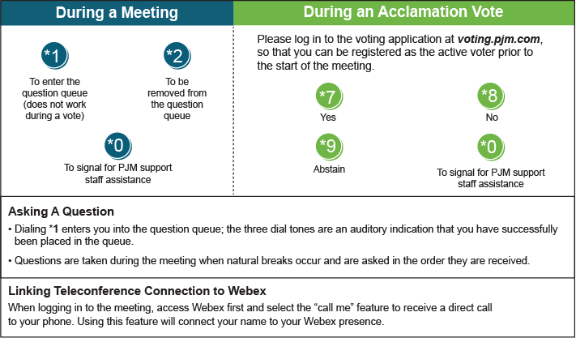

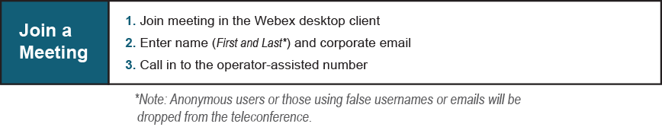
Provide feedback on the progress of this group: Facilitator Feedback Form
Visit learn.pjm.com, an easy-to-understand resource about the power industry and PJM’s role.

