Markets & Reliability Committee
PJM Conference and Training Center / WebEx
September 21, 2022
9:00 a.m. – 12:10 p.m. EPT
*Operator assisted phone lines will be opened 30 minutes prior to the start of the meeting. Due to the high volume of remote participation, stakeholders are asked to connect early to allow additional time for operator queue processing.

Administration (9:00-9:05)
Welcome, announcements and Anti-trust, Code of Conduct, and Public Meetings/Media Participation – Stu Bresler and Dave Anders

Consent Agenda (9:05-9:10)
- Approve minutes of the August 24, 2022 meeting of the Markets and Reliability Committee (MRC).
- Endorse proposed revisions to Manual 10: Pre-Scheduling Operations, Manual 12: Balancing Operations, and Manual 13: Emergency Operations to address the Reserve Price Formation implementation.
Issue Tracking: Energy Price Formation
- Endorse proposed revisions to Manual 14D: Generator Operational Requirements and Manual 13: Emergency Operation as associated with NERC standards EOP-011 – Emergency Preparedness and Operations, IRO-010 – Reliability Coordinator Data Specification and Collection, and TOP-003 – Operational Reliability Data will be performed.
- Endorse proposed revisions to Manual 15: Cost Development Guidelines to address the Reserve Price Formation implementation and to address changes resulting from the Manual’s periodic review process. Same day endorsement may be sought at the MRC and MC meetings.
Issue Tracking: Energy Price Formation
- Endorse conforming revisions to Manual 10: Pre-Scheduling Operations, Manual 14D: Generator Operational Requirements, and Manual 18: PJM Capacity Market to support the recent hybrid resources FERC filing (Docket No. ER22-1420).
Issue Tracking: Solar-Battery Hybrid Resources
- Endorse proposed revisions to Manual 18: PJM Capacity Market and Manual 18B: Energy Efficiency Measurement & Verification resulting from the periodic review process.
- Endorse proposed revisions to Manual 27: Open Access Transmission Tariff Accounting, Manual 28: Operating Agreement Accounting, and Manual 29: Billing to address the Reserve Price Formation implementation.
Issue Tracking: Energy Price Formation

Endorsements (9:10-10:15)
- Reserve Price Formation Manual Revisions (9:10-9:30)
- Damon Fereshetian and Michael Olaleye will review proposed revisions to Manual 11: Energy & Ancillary Services Market Operations to address the Reserve Price Formation implementation.
- Joe Bowring, IMM, will provide perspectives on Manual 11 revisions.
The committee will be asked to endorse the proposed Manual revisions.
Issue Tracking: Energy Price Formation
- Bankruptcy Protections (9:30-9:45)
Eric Scherling will review a solution package and corresponding Tariff revisions addressing bankruptcy protections. The committee will be asked to endorse the proposed solution and corresponding Tariff revisions.
Issue Tracking: Bankruptcy Protections
- Market Seller Offer Cap (9:45-10:15)
- Dave Anders will provide an update regarding Market Seller Offer Cap activities at the Resource Adequacy Senior Task Force (RASTF).
- Pat Bruno will review PJM’s proposed solution as the Main Motion.
- Tom Hoatson, LS Power, will review a proposed solution as the Alternative Motion.
The committee will be asked to endorse a proposed solution and corresponding Tariff revisions.
Issue Tracking: Capacity Market Reform

First Readings (10:15-12:10)
- 2022 Installed Reserve Margin Study Results (10:15-10:30)
Patricio Rocha Garrido will review the 2022 Reserve Requirement Study results (IRM and FPR). The committee will be asked to endorse the study results at its next meeting.
- Fuel Requirements for Black Start Resources (10:30-10:55)
Janell Fabiano will provide background and an overview of the voting results for this issue. Dan Bennett will review the proposed solution. The committee will be asked to endorse the proposed solution and corresponding Tariff and Manual revisions at its next meeting.
Issue Tracking: Fuel Requirements for Black Start Resources

- Operating Reserve Clarification for Resources Operating as Requested by PJM (10:55-11:10)
Lisa Morelli will review proposed revisions to Manual 28: Operating Agreement Accounting to remove an Operating Reserve rule for Combustion Turbine (CT) units. The committee will be asked to endorse the revisions to Manual 28 at its next meeting.
Issue Tracking: Operating Reserve Clarification for Resources Operating as Requested by PJM
- Maximum Emergency Changes for Resource Limitation Reporting (11:10-11:30)
This item has been moved to the October meeting.
- Internal NITS Process (11:10-11:25)
Susan McGill will review a proposed solution and corresponding Tariff revisions addressing the Internal Network Integration Transmission Service (NITS) Process. The committee will be asked to endorse the proposed solution and Tariff revisions at its next meeting.
Issue Tracking: Internal Network Integration Transmission (NITS) Process
- Residential Customer Measurement and Verification for Demand Response (11:25-11:40)
Ken Schisler, CPower, will review a Problem Statement and Issue Charge addressing Residential Customer Measurement and Verification for Demand Response. The committee will be asked to approve the Issue Charge at its next meeting.
- Copy PJM with Members’ Governing Documents Filings (11:40-12:00)
Steve Pincus will review a proposed Problem Statement and Issue Charge addressing a copy to PJM of Members’ Tariff rate and waiver filings under PJM Governing Agreements. The committee will be asked to approve the Issue Charge at its next meeting.
- Manuals (12:00-12:10)
- Darrell Frogg will review proposed revisions to Manual 39: Nuclear Plant Interface Coordination as a part of the periodic review. The committee will be asked to endorse the proposed changes at its next meeting.

Future Agenda Items (12:10)

Future Meeting Dates and Materials |  |  |  | Materials Due  to Secretary | Materials Published
Date | Time | Location
October 24, 2022 | 1:00 p.m. |  | Hyatt Regency Chesapeake Bay Golf Resort, Spa and Marina in Cambridge, MD | October 12, 2022 | October 17, 2022
November 16, 2022 | 9:00 a.m. |  | PJM Conference & Training Center and WebEx | November 4, 2022 | November 9, 2022
December 21, 2022 | 9:00 a.m. |  | PJM Conference & Training Center and WebEx | December 9, 2022 | December 14, 2022

Author: M. Greening

Antitrust:
You may not discuss any topics that violate, or that might appear to violate, the antitrust laws including but not limited to agreements between or among competitors regarding prices, bid and offer practices, availability of service, product design, terms of sale, division of markets, allocation of customers or any other activity that might unreasonably restrain competition. If any of these items are discussed the chair will re-direct the conversation. If the conversation still persists, parties will be asked to leave the meeting or the meeting will be adjourned.

Code of Conduct:
As a mandatory condition of attendance at today's meeting, attendees agree to adhere to the PJM Code of Conduct as detailed in PJM Manual M-34 section 4.5, including, but not limited to, participants' responsibilities and rules regarding the dissemination of meeting discussion and materials.

Public Meetings/Media Participation:
Unless otherwise noted, PJM stakeholder meetings are open to the public and to members of the media. Members of the media are asked to announce their attendance at all PJM stakeholder meetings at the beginning of the meeting or at the point they join a meeting already in progress. Members of the Media are reminded that speakers at PJM meetings cannot be quoted without explicit permission from the speaker. PJM Members are reminded that "detailed transcriptional meeting notes" and white board notes from "brainstorming sessions" shall not be disseminated. Stakeholders are also not allowed to create audio, video or online recordings of PJM meetings. PJM may create audio, video or online recordings of stakeholder meetings for internal and training purposes, and your participation at such meetings indicates your consent to the same.
Participant Identification in Webex:
When logging into the Webex desktop client, please enter your real first and last name as well as a valid email address. Be sure to select the “call me” option.
PJM support staff continuously monitors Webex connections during stakeholder meetings. Anonymous users or those using false usernames or emails will be dropped from the teleconference.

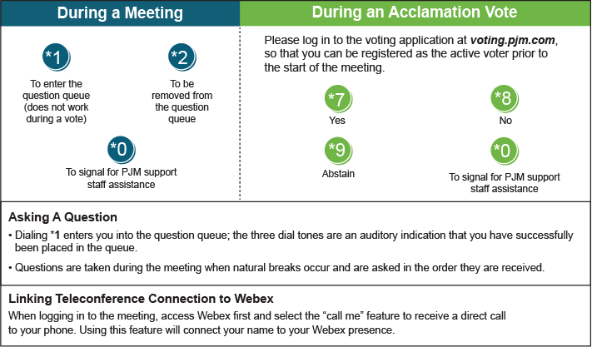

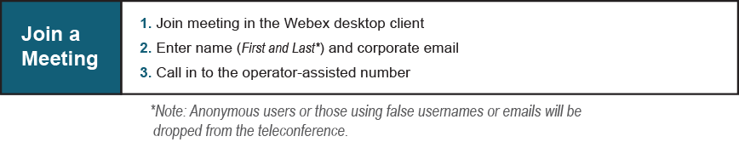
Provide feedback on the progress of this group: Facilitator Feedback Form
Visit learn.pjm.com, an easy-to-understand resource about the power industry and PJM’s role.

