Planning Committee
PJM Conference and Training Center
April 11, 2019
9:00 a.m. – 12:00 p.m. EPT

Administration (9:00-9:15)
- Welcome, announcements and review of the Anti-trust, Code of Conduct, and Media Participation Guidelines
- Approve Planning Committee (PC) Agenda for this meeting
- Approve draft minutes from the March 7th, 2019 PC meeting
- Review of the PC Work Plan

Endorsements (9:15-10:00)
- Manual 21 Proposed Revisions
Mr. Jerry Bell, PJM, will present proposed revisions to PJM Manual 21 Rules & Procedures for Determination of Generating Capability related to generator testing. The committee will be requested to endorse these revisions today. Discussion of the proposed revisions related to ELCC treatment of intermittent resources will be deferred to the May PC meeting.
- Market Efficiency Process Enhancement Task Force
Mr. Brian Chmielewski, PJM, will present the Market Efficiency phase 2 proposal developed at the Market Efficiency Process Enhancement Task Force (MEPETF), and the associated OATT revisions. The Committee will be requested to endorse the proposal and Tariff revisions today.
The Committee will also be requested to endorse the need for phase 3 of the MEPETF.
Issue Tracking: RTEP Market Efficiency Analysis

First Reads (10:00-10:30)
- Benefit/Cost Analysis Problem Statement and Issue Charge
Mr. Howard Haas, Monitoring Analytics, will present a Problem Statement and Issue Charge to review and discuss the current benefit/cost analysis process and solicit feedback from stakeholders. The Committee will be requested to endorse this Problem Statement and Issue Charge at the next meeting.
- Manual 07 Updates
Mr. Mark Kuras, PJM, will present updates to PJM Manual 07 PJM Protection Standards. The Committee will be requested to endorse these updates at the next meeting.

Informational Updates (10:30-12:00)
Cost Commitment Status and Next Steps
Mr. Mark Sims, PJM, will provide an update on the status and next steps for the Consideration of Cost Commitment for Evaluation of Competitive Transmission Proposals.
Issue Tracking: Cost Containment
FERC Order No. 845 Update
Ms. Susan McGill, PJM, will provide an update on the FERC Order No. 845 Special PC session and pending reforms.
DER Ride Through Task Force Update
Ms. Susan McGill, PJM, will provide an update on the activities of the DER Ride Through Task Force.
Model Build Activity Update
Mr. Kyle Clifford will provide an update regarding current model build activities, including the 2019 series MMWG/MOD-032 cases.
Reliability Compliance Update
Mr. Preston Walker, PJM, will provide an update on the activities, issues and items of interest at NERC, SERC, and RF.
- RTEP Process Enhancements Update
Mr. Aaron Berner, PJM, will provide an update concerning the activities of the PC Special Sessions around the subject of upgrade modeling in the RTEP.

Information Only
Manual 03 Updates
Mr. Lagy Mathew, PJM, will be available to answer questions on updates to Manual 03 – Transmission Operations. Materials are posted as Information Only.

Future Meeting Dates
April 12, 2019 | 1:00 p.m. – 4:00 p.m. | Special PC: M-3 Process Lessons Learned | PJM Conference & Training Center/ WebEx
April 16, 2019 | 1:00 p.m. – 4:00 p.m. | Special PC: Merchant Transmission and Off-Shore Wind | PJM Conference & Training Center/ WebEx
May 2, 2019 | 1:00 p.m. – 4:00 p.m. | Special PC: FERC Order 845 | PJM Conference & Training Center/ WebEx
May 3, 2019 | 1:00 p.m. – 4:00 p.m. | Special PC: Merchant Transmission and Off-Shore Wind | PJM Conference & Training Center/ WebEx
May 16, 2019 | 9:00 a.m. – 12:00 p.m. | Planning Committee | PJM Conference & Training Center/ WebEx
May 31, 2019 | 1:00 p.m. – 4:00 p.m. | Special PC: Merchant Transmission and Off-Shore Wind | PJM Conference & Training Center/ WebEx
June 13, 2019 | 9:00 a.m. – 12:00 p.m. | Planning Committee | PJM Conference & Training Center/ WebEx
June 28, 2019 | 1:00 p.m. – 4:00 p.m. | Special PC: Merchant Transmission and Off-Shore Wind | PJM Conference & Training Center/ WebEx
July 11, 2019 | 9:00 a.m. – 12:00 p.m. | Planning Committee | PJM Conference & Training Center/ WebEx
July12, 2019 | 9:00 a.m. – 12:00 p.m. | Special PC: M-3 Process Lessons Learned | PJM Conference & Training Center/ WebEx
July 24, 2019 | 1:00 p.m. – 4:00 p.m. | Special PC: Merchant Transmission and Off-Shore Wind | PJM Conference & Training Center/ WebEx
August 8, 2019 | 9:00 a.m. – 12:00 p.m. | Planning Committee | PJM Conference & Training Center/ WebEx
September 12, 2019 | 9:00 a.m. – 12:00 p.m. | Planning Committee | PJM Conference & Training Center/ WebEx
October 11, 2019 | 9:00 a.m. – 12:00 p.m. | Special PC: M-3 Process Lessons Learned | PJM Conference & Training Center/ WebEx
October 17, 2019 | 9:00 a.m. – 12:00 p.m. | Planning Committee | PJM Conference & Training Center/ WebEx
November 14, 2019 | 9:00 a.m. – 12:00 p.m. | Planning Committee | PJM Conference & Training Center/ WebEx
December 12, 2019 | 9:00 a.m. – 12:00 p.m. | Planning Committee | PJM Conference & Training Center/ WebEx

Author: Anisha Fernandes

Antitrust:
You may not discuss any topics that violate, or that might appear to violate, the antitrust laws including but not limited to agreements between or among competitors regarding prices, bid and offer practices, availability of service, product design, terms of sale, division of markets, allocation of customers or any other activity that might unreasonably restrain competition. If any of these items are discussed the chair will re-direct the conversation. If the conversation still persists, parties will be asked to leave the meeting or the meeting will be adjourned.

Code of Conduct:
As a mandatory condition of attendance at today's meeting, attendees agree to adhere to the PJM Code of Conduct as detailed in PJM Manual M-34 section 4.5, including, but not limited to, participants' responsibilities and rules regarding the dissemination of meeting discussion and materials.

Public Meetings/Media Participation:
Unless otherwise noted, PJM stakeholder meetings are open to the public and to members of the media. Members of the media are asked to announce their attendance at all PJM stakeholder meetings at the beginning of the meeting or at the point they join a meeting already in progress. Members of the Media are reminded that speakers at PJM meetings cannot be quoted without explicit permission from the speaker. PJM Members are reminded that "detailed transcriptional meeting notes" and white board notes from "brainstorming sessions" shall not be disseminated. Stakeholders are also not allowed to create audio, video or online recordings of PJM meetings. PJM may create audio, video or online recordings of stakeholder meetings for internal and training purposes, and your participation at such meetings indicates your consent to the same.
Participant Identification in WebEx:
When logging into the WebEx desktop client, please enter your real first and last name as well as a valid email address. Be sure to select the “call me” option.
PJM support staff continuously monitors WebEx connections during stakeholder meetings. Anonymous users or those using false usernames or emails will be dropped from the teleconference.

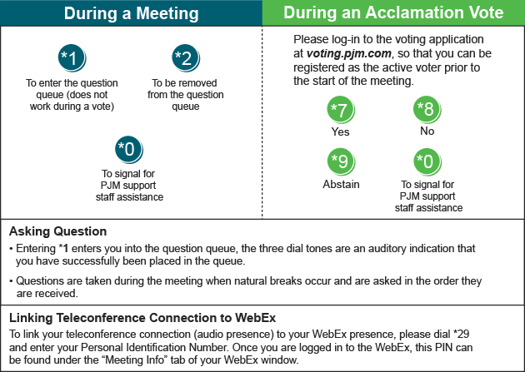

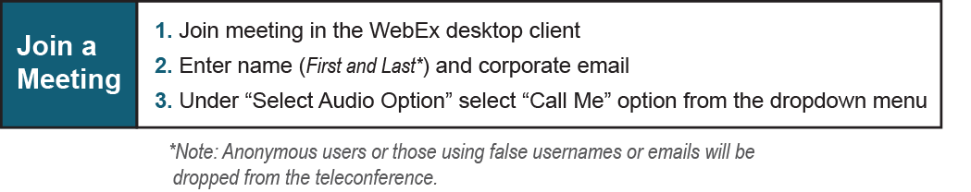
Provide feedback on the progress of this group: Facilitator Feedback Form
Visit learn.pjm.com, an easy-to-understand resource about the power industry and PJM’s role.

