February Planning Committee
Teleconference / WebEx
February 9, 2021
9:00 a.m. – 12:00 p.m. EPT

Administration (9:00 – 9:15)
- Welcome, announcements and review of the Anti-trust, Code of Conduct, and Media Participation Guidelines.
- Approve Planning Committee (PC) Agenda for this meeting.
- Approve draft minutes from the January 11, 2021 PC meeting.

Endorsements (9:15 – 10:15)
- CISO Update
Mike Herman, PJM, will review the PJM proposal to address Mitigation and Avoidance of future CIP-014 facilities, including revisions to associated manual language. A draft version of associated OA language on Mitigation is posted with meeting materials for informational purposes.
The committee will be asked to endorse the following two items at today’s meeting:
    - The package on Avoidance and associated manual language
    - The package on Mitigation
Issue Tracking: Critical Infrastructure Stakeholder Oversight
- TO/TOP Matrix V15
Mark Kuras, PJM, will review the proposed changes to the TO/TOP Matrix. The committee will be requested to provide a recommendation to the TOA-AC to approve the Draft TO/TOP Matrix V15 at today’s meeting.

First Reads (10:15 – 11:00)
- CIR Problem Statement/Issue Charge
Jonathan Kern, PJM, will provide a first read of a problem statement and issue charge to address the Capacity Interconnection Rights of variable resources. The committee will be asked to vote on the issue charge at its next meeting.

Informational Updates (11:00 – 12:00)
- Remedial Action Scheme Retirement
Alan Engelmann, ComEd, will review the removal of the Special Protection Systems (SPS) / Remedial Action Schemes (RAS) at Elgin Energy Center and Kincaid.
- Reliability Compliance Update
Becky Davis, PJM, will provide an update on the activities, issues and items of interest at NERC, SERC, and RF.
- Dynamic Line Rating
Shaun Murphy, PJM, will provide an update on recent Dynamic Line Ratings discussions and PJM’s plans to track and coordinate future stakeholder discussions.

Informational Posting
Model Build Activity Update
2021 Series RTEP
- Powerflow – PJM is currently building the Trial 3 (Pre-Final) cases with the feedback provided by the Transmission Owners on January 15, 2021; PJM staff will internally review the cases through February 2021
- Short Circuit – PJM is currently building the Trial 2 2023 case and will post it by February 12, 2021

Recent Load Impacts
The estimated Covid-19 impacts on recent loads are posted with today’s materials.

Thursday, February 4, 2021 | 2:00 p.m – 5:00 p.m. | Joint SATA & CISO Meeting | WebEx
Tuesday, February 9, 2021 | 9:00 a.m – 12:00 p.m. | Planning Committee | WebEx
Friday, March 5, 2021 | 9:00 a.m. – 4:00 p.m. | Interconnection Process Workshop #4 | WebEx
Tuesday , March 9, 2021 | 9:00 a.m – 12:00 p.m. | Planning Committee | WebEx
Tuesday, April 6, 2021 | 9:00 a.m – 12:00 p.m. | Planning Committee | WebEx
Tuesday, May 11, 2021 | 9:00 a.m – 12:00 p.m. | Planning Committee | WebEx
Tuesday, June 8, 2021 | 9:00 a.m – 12:00 p.m. | Planning Committee | WebEx
Tuesday, July 13, 2021 | 9:00 a.m – 12:00 p.m. | Planning Committee | TBD
Tuesday, August 10, 2021 | 9:00 a.m – 12:00 p.m. | Planning Committee | TBD
Wednesday, September 8, 2021 | 9:00 a.m – 12:00 p.m. | Planning Committee | TBD
Tuesday, October 5, 2021 | 9:00 a.m – 12:00 p.m. | Planning Committee | TBD
Tuesday, November 2, 2021 | 9:00 a.m – 12:00 p.m. | Planning Committee | TBD
Tuesday, Noember 30, 2021 | 9:00 a.m – 12:00 p.m. | Planning Committee | TBD
Author: Molly Mooney

Antitrust:
You may not discuss any topics that violate, or that might appear to violate, the antitrust laws including but not limited to agreements between or among competitors regarding prices, bid and offer practices, availability of service, product design, terms of sale, division of markets, allocation of customers or any other activity that might unreasonably restrain competition. If any of these items are discussed the chair will re-direct the conversation. If the conversation still persists, parties will be asked to leave the meeting or the meeting will be adjourned.

Code of Conduct:
As a mandatory condition of attendance at today's meeting, attendees agree to adhere to the PJM Code of Conduct as detailed in PJM Manual M-34 section 4.5, including, but not limited to, participants' responsibilities and rules regarding the dissemination of meeting discussion and materials.

Public Meetings/Media Participation:
Unless otherwise noted, PJM stakeholder meetings are open to the public and to members of the media. Members of the media are asked to announce their attendance at all PJM stakeholder meetings at the beginning of the meeting or at the point they join a meeting already in progress. Members of the Media are reminded that speakers at PJM meetings cannot be quoted without explicit permission from the speaker. PJM Members are reminded that "detailed transcriptional meeting notes" and white board notes from "brainstorming sessions" shall not be disseminated. Stakeholders are also not allowed to create audio, video or online recordings of PJM meetings. PJM may create audio, video or online recordings of stakeholder meetings for internal and training purposes, and your participation at such meetings indicates your consent to the same.
Participant Identification in WebEx:
When logging into the WebEx desktop client, please enter your real first and last name as well as a valid email address. Be sure to select the “call me” option.
PJM support staff continuously monitors WebEx connections during stakeholder meetings. Anonymous users or those using false usernames or emails will be dropped from the teleconference.

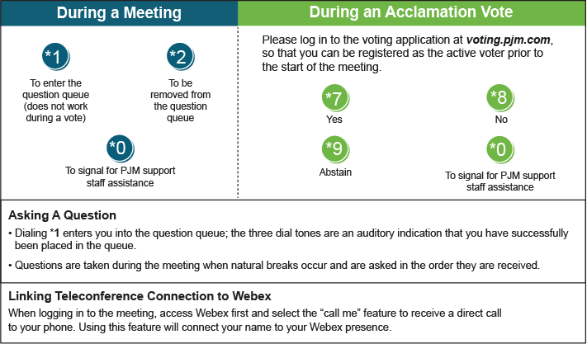

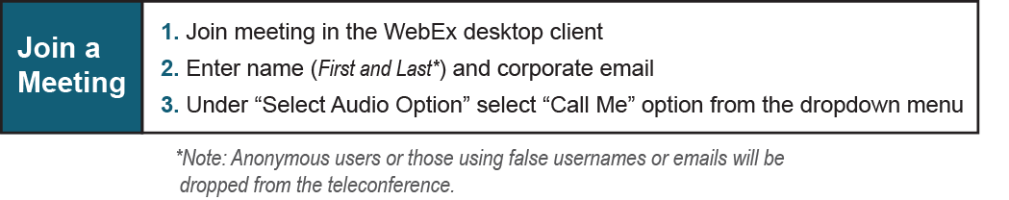

Provide feedback on the progress of this group: Facilitator Feedback Form
Visit learn.pjm.com, an easy-to-understand resource about the power industry and PJM’s role.

