August Planning Committee

**Teleconference / WebEx**

August 10, 2021

9:00 a.m. – 12:00 p.m. EPT

Administration (9:00 – 9:15)

1. Welcome, announcements and review of the Anti-trust, Code of Conduct, and Media Participation Guidelines.
2. Approve Planning Committee (PC) Agenda for this meeting.
3. Approve draft minutes from the July 13, 2021 PC meeting.

Endorsements (9:15 – 10:00)

1. Manual 20: Resource Adequacy Analysis  
   Patricio Rocha-Garrido, PJM, will review the cover to cover update for Manual 20. The committee will be asked to vote on the manual changes at today’s meeting.
2. Load Model Selection   
   Patricio Rocha-Garrido will review the results of the Load Model selection process for the 2021 Reserve Requirement Study. The committee will be requested to endorse this Load Model selection at today’s meeting.

First Reads (10:00 – 10:20)

1. Manual 14G: Generation Interconnection Requests Update  
   Theresa Esterly, PJM, will provide a first read for updates to Manual 14G regarding the Behind the Meter Generation (BTMG) business rules on status changes. The committee will be asked to vote on the manual changes at the August 31st meeting.

Informational Updates (10:20 – 12:00)

1. Winter/Light Load Generator Deliverability Update

Jonathan Kern, PJM, will provide an update on winter and light load generator deliverability analysis.

1. Capacity Interconnection Rights for ELCC Resoures Update

Brian Chmielewski, PJM, will provide an update on work being done during the PC special session on Capacity Interconnection Rights (CIR) for ELCC Resources.

Materials and upcoming meeting dates for special sessions can be found [here](https://www.pjm.com/committees-and-groups/committees/pc).

1. Interconnection Process Reform

Jack Thomas, PJM, will provide an update on the Interconnection Process Reform Task Force.

Materials and upcoming meeting dates for task force can be found [here](https://www.pjm.com/committees-and-groups/task-forces/iprtf).

1. Reliability Compliance Update  
   Becky Davis, PJM, will provide an update on the activities, issues and items of interest at NERC, SERC, and RF.
2. Request for Clarification  
   Mark Stanisz, PJM Legal, will provide an informational update regarding PJM’s intent to file a request for clarification in response to the Commission’s July 15, 2021 Order in *The Dayton Power and Light Company* (Docket No. ER20-1068-000).

Informational Posting

Model Build Activity Update

* 2021 series MMWG Powerflow
  + Powertech to post Trial 2 cases with data checks on August 6, 2021
  + Transmission Owners to provide updates to the Trial 2 cases on August 13, 2021
  + PJM to provide Trial 2 updates to PowerTech on August 20, 2021
* 2022 series RTEP Powerflow and Short Circuit
  + Draft schedule will be posted for Transmission Owner review in mid-August

PJM Manual 03 Attachment E Automatic Sectionalizing Schemes

* The PJM Manual 03 Attachment E Automatic Sectionalizing Schemes Pending Approval and Recent Changes document has been posted as an Informational Only item to the August Planning Committee meeting website.

|  |  |  |  |  |
| --- | --- | --- | --- | --- |
| **Future Meeting Dates and Materials** | | | **Materials Due  to Secretary** | **Materials Published** |
| Date | Time | Meeting (Location) |
| Tuesday, August 10, 2021 | 9:00 a.m. – 12:00 p.m. | Planning Committee (WebEx) | Thursday, July 29, 2021 | Tuesday, August 03, 2021 |
| Friday, August 13, 2021 | 1:00 p.m. – 4:00 p.m. | Special PC: CIR for ELCC Resources (WebEx) | Thursday, August 05, 2021 | Tuesday, August 10, 2021 |
| Monday, August 23, 2021 | 9:00 a.m. – 4:00 p.m. | Interconnection Process Reform Task Force (WebEx) | Friday, August 13, 2021 | Wednesday, August 18, 2021 |
| Tuesday, August 31, 2021 | 9:00 a.m. – 12:00 p.m. | Planning Committee (WebEx) | Thursday, August 19, 2021 | Tuesday, August 24, 2021 |
| Tuesday, September 21, 2021 | 9:00 a.m. – 12:00 p.m. | Special PC: CIR for ELCC Resources (WebEx) | Tuesday, September 14, 2021 | Friday, September 17, 2021 |
| Tuesday, October 5, 2021 | 9:00 a.m. – 12:00 p.m. | Planning Committee (WebEx) | Thursday, September 23, 2021 | Tuesday, September 28, 2021 |
| Tuesday, November 2, 2021 | 9:00 a.m. – 12:00 p.m. | Planning Committee (WebEx) | Thursday, October 21, 2021 | Tuesday, October 26, 2021 |
| Tuesday, November 30, 2021 | 9:00 a.m. – 12:00 p.m. | Planning Committee (WebEx) | Thursday, November 18, 2021 | Tuesday, November 23, 2021 |

Author: Molly Mooney

Antitrust:

You may not discuss any topics that violate, or that might appear to violate, the antitrust laws including but not limited to agreements between or among competitors regarding prices, bid and offer practices, availability of service, product design, terms of sale, division of markets, allocation of customers or any other activity that might unreasonably restrain competition. If any of these items are discussed the chair will re-direct the conversation. If the conversation still persists, parties will be asked to leave the meeting or the meeting will be adjourned.

Code of Conduct:

As a mandatory condition of attendance at today's meeting, attendees agree to adhere to the PJM Code of Conduct as detailed in PJM Manual M-34 section 4.5, including, but not limited to, participants' responsibilities and rules regarding the dissemination of meeting discussion and materials.

Public Meetings/Media Participation:

Unless otherwise noted, PJM stakeholder meetings are open to the public and to members of the media. Members of the media are asked to announce their attendance at all PJM stakeholder meetings at the beginning of the meeting or at the point they join a meeting already in progress. Members of the Media are reminded that speakers at PJM meetings cannot be quoted without explicit permission from the speaker. PJM Members are reminded that "detailed transcriptional meeting notes" and white board notes from "brainstorming sessions" shall not be disseminated. Stakeholders are also not allowed to create audio, video or online recordings of PJM meetings. PJM may create audio, video or online recordings of stakeholder meetings for internal and training purposes, and your participation at such meetings indicates your consent to the same.

Participant Identification in WebEx:

When logging into the WebEx desktop client, please enter your real first and last name as well as a valid email address. Be sure to select the “call me” option.

PJM support staff continuously monitors WebEx connections during stakeholder meetings. Anonymous users or those using false usernames or emails will be dropped from the teleconference.

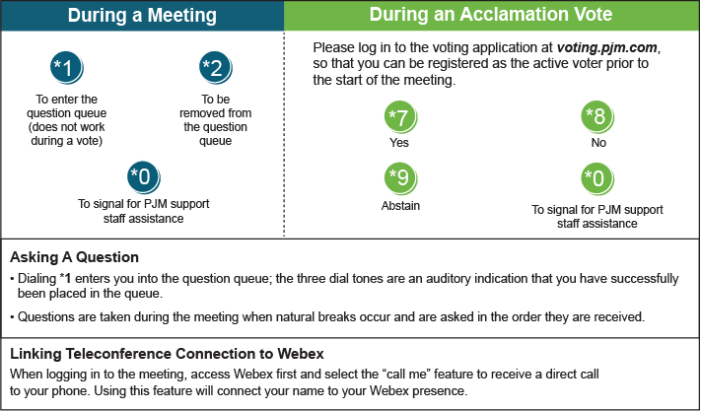

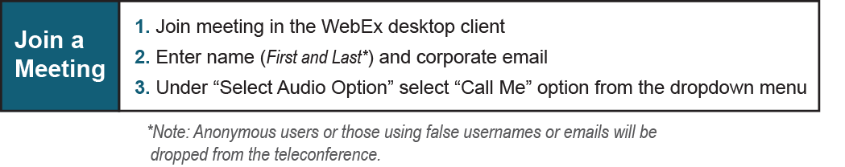

Provide feedback on the progress of this group: *Facilitator Feedback Form*   
Visit [*learn.pjm.com*](http://learn.pjm.com/), an easy-to-understand resource about the power industry and PJM’s role.