March Planning Committee

**Teleconference / WebEx**

March 8, 2022

9:00 a.m. – 12:00 p.m. EPT

Administration (9:00 – 9:15)

1. Welcome, announcements and review of the Anti-trust, Code of Conduct, and Media Participation Guidelines.
2. Approve Planning Committee (PC) Agenda for this meeting.
3. Approve draft minutes from the February 8, 2022 PC meeting.

Endorsements (9:15 – 9:45)

1. Deactivation Process Timing

Dave Egan, PJM, will provide a review of a proposed deactivation process timing update. The committee will be asked to approve the issue charge and endorse the proposed solution as part of the Quick Fix process outlined in Section 8.6.1 of Manual 34 at today’s meeting.

***Action Required:  Members are reminded to complete the necessary steps to update their browser prior to the meeting to avoid impact to Voting Application access.   Reference:*** [***Weak Encryption***](https://www.pjm.com/-/media/committees-groups/committees/pc/2022/20220208/20220208-item-04-pjm-retiring-use-of-weak-encryption-of-voting.ashxhttps:/www.pjm.com/-/media/committees-groups/committees/pc/2022/20220208/20220208-item-04-pjm-retiring-use-of-weak-encryption-of-voting.ashx)

First Reads (9:45 – 10:00)

1. Manual 14F: Competitive Planning Process Update

Joseph Hay, PJM, will provide a first read of Manual 14F regarding the biennial cover-to-cover review. The committee will be asked to vote on the manual changes at next month’s meeting.

1. Manual 21A: Determination of Accredited UCAP Using Effective Load Carrying Capability Analysis

Joshua Bruno, PJM, will provide a first read of Manual 21A revisions regarding an ELCC model run timing update and changes to reflect the continuation of the current method to provide unit specific backcasts only as requested. The committee will be asked to approve an Issue Charge and endorse the proposed Manual 21A revisions as part of the Quick Fix process outlined in Section 8.6.1 of Manual 34 at next month’s meeting.

Informational Updates (10:15 – 12:00)

1. Capacity Interconnection Rights for ELCC Resources Update

Brian Chmielewski, PJM, will provide an update from the work done during the PC special session on Capacity Interconnection Rights (CIR) for ELCC Resources.

[Issue Tracking: CIRs for ELCC Resources](https://www.pjm.com/committees-and-groups/issue-tracking/issue-tracking-details.aspx?Issue=83aadda8-b6c1-4630-9483-025b6b93fc28)

Materials for the special sessions can be found [here](https://www.pjm.com/committees-and-groups/committees/pc).

1. Generator Deliverability Timeline Update

Jonathan Kern, PJM, will provide a generator deliverability proposal development timeline update.

1. Interconnection Subcommittee Initiative

Jason Connell, PJM, will discuss forming an Interconnection subcommittee to continue the discussion of interconnection process improvements after the work of the IPRTF concludes.

1. Documenting the Appropriate UFLS Requirements Applicable to EKPC

Denise Foster Cronin, EKPC, will provide an informational review of an OC Problem Statement and Issue Charge to appropriately document the under frequency relay requirements applicable to EKPC.  The MRC and MC will ultimately be asked to endorse/approve the solution and corresponding OA revisions.

1. PJM Study - Illinois Clean Energy Jobs Act

Dave Egan, PJM, will review plans for a joint PJM/MISO Study on Illinois Clean Energy Jobs Act.

1. TTMS Charter Review

Gizella Mali, PJM, will review a draft version of the TTMS charter V2.

1. Reliability Compliance Update  
   Becky Davis, PJM, will provide an update on the activities, issues and items of interest at NERC, SERC, and RF.
2. DEA Order Update

Pauline Foley, PJM, will provide an update on the Commission’s February 8 Order rejecting PJM’s updated Compliance Filing (Dkt # ER13-198)

Informational Posting

Model Build Activity Update

* MMWG
  + Dynamics
    - PJM received Powertech’s data correction request for 20 seconds flat run on the MMWG 2021 series cases and is currently working on the request
* RTEP
  + Loadflow
    - The 2027 Light Load, Summer and Winter cases were delivered to PJM’s Transmission Planning Department for review
  + Short Circuit
    - The 2024 RTEP Trial 2 case was delivered to the Transmission Owners on February 25, 2022
* The upcoming Gen Model Window for MOD-032 data submittals for applicable Generator Owners will open on Sunday, May 1st, 2022 and end on Wednesday, June 15th, 2022

2021 RTEP Report Publication

[PJM’s 2021 RTEP Report](https://pjm.com/library/reports-notices/rtep-documents), documenting the studies and results required for reliability has been published to PJM.com. Contained within the ‘Reports and Notices’ section on PJM.com, this report includes key RTEP graphics and information.

|  |  |  |  |  |
| --- | --- | --- | --- | --- |
| **Future Meeting Dates and Materials** | | | **Materials Due  to Secretary** | **Materials Published** |
| Date | Time | Meeting (Location) |
| Tuesday, April 12, 2022 | 9:00 a.m. – 12:00 p.m. | Planning Committee (TBD) | Thursday, March 31, 2022 | Tuesday, April 5, 2022 |
| Tuesday, May 10, 2022 | 9:00 a.m. – 12:00 p.m. | Planning Committee (TBD) | Thursday, April 28, 2022 | Tuesday, May 3, 2022 |
| Tuesday, June 7, 2022 | 9:00 a.m. – 12:00 p.m. | Planning Committee (TBD) | Thursday, May 26, 2022 | Tuesday, May 31, 2022 |

Author: Marilyn Jayachandran

Antitrust:

You may not discuss any topics that violate, or that might appear to violate, the antitrust laws including but not limited to agreements between or among competitors regarding prices, bid and offer practices, availability of service, product design, terms of sale, division of markets, allocation of customers or any other activity that might unreasonably restrain competition. If any of these items are discussed the chair will re-direct the conversation. If the conversation still persists, parties will be asked to leave the meeting or the meeting will be adjourned.

Code of Conduct:

As a mandatory condition of attendance at today's meeting, attendees agree to adhere to the PJM Code of Conduct as detailed in PJM Manual M-34 section 4.5, including, but not limited to, participants' responsibilities and rules regarding the dissemination of meeting discussion and materials.

Public Meetings/Media Participation:

Unless otherwise noted, PJM stakeholder meetings are open to the public and to members of the media. Members of the media are asked to announce their attendance at all PJM stakeholder meetings at the beginning of the meeting or at the point they join a meeting already in progress. Members of the Media are reminded that speakers at PJM meetings cannot be quoted without explicit permission from the speaker. PJM Members are reminded that "detailed transcriptional meeting notes" and white board notes from "brainstorming sessions" shall not be disseminated. Stakeholders are also not allowed to create audio, video or online recordings of PJM meetings. PJM may create audio, video or online recordings of stakeholder meetings for internal and training purposes, and your participation at such meetings indicates your consent to the same.

Participant Identification in WebEx:

When logging into the WebEx desktop client, please enter your real first and last name as well as a valid email address. Be sure to select the “call me” option.

PJM support staff continuously monitors WebEx connections during stakeholder meetings. Anonymous users or those using false usernames or emails will be dropped from the teleconference.

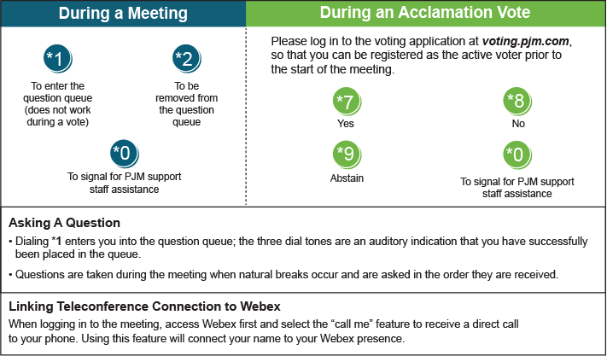

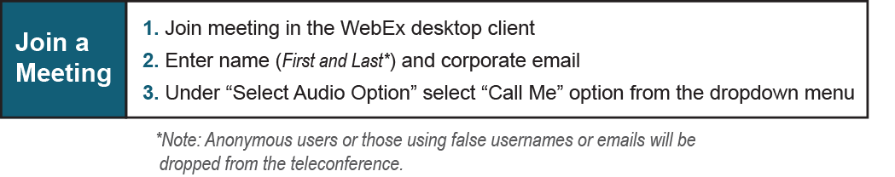

Provide feedback on the progress of this group: *Facilitator Feedback Form*   
Visit [*learn.pjm.com*](http://learn.pjm.com/), an easy-to-understand resource about the power industry and PJM’s role.