September Planning Committee

**Teleconference / WebEx**

September 6, 2022

9:00 a.m. – 10:30 a.m. EPT

*\*Operator assisted phone lines will be opened 30 minutes prior to the start of the meeting. Due to the high volume of remote participation, stakeholders are asked to connect early to allow additional time for operator queue processing.*

Administration (9:00 – 9:15)

1. Welcome, announcements and review of the Anti-trust, Code of Conduct, and Media Participation Guidelines.
2. Approve Planning Committee (PC) Agenda for this meeting.
3. Approve draft minutes from the August 9, 2022 PC meeting.

Michele Greening, PJM, will provide information and important dates for the upcoming October annual meeting. Reference slides are posted with meeting materials.

Endorsements

No endorsements in September.

First Reads (9:15 – 9:45)

1. 2022 Installed Reserve Margin Study Results Patricio Rocha Garrido, PJM, will review the 2022 Reserve Requirement Study results (IRM, FPR, WWRT). The Committee will be requested to endorse the study results at its next meeting.

Informational Updates (9:45 – 10:30)

1. Preliminary 2023 Capital Project Budget  
   James Snow, PJM, will review the Preliminary 2023 Capital Project Budget.
2. Capacity Interconnection Rights for ELCC Resources & Generator Deliverability Proposal Update

Brian Chmielewski, PJM, will provide an update from the work done in the PC special session on Capacity Interconnection Rights (CIR) for ELCC Resources and Generator Deliverability Proposal.

[Issue Tracking: CIRs for ELCC Resources](https://www.pjm.com/committees-and-groups/issue-tracking/issue-tracking-details.aspx?Issue=83aadda8-b6c1-4630-9483-025b6b93fc28)

Materials for the special sessions can be found [here](https://www.pjm.com/committees-and-groups/committees/pc).

1. Reliability Compliance Update  
   Becky Davis, PJM, will provide an update on the activities, issues and items of interest at NERC, SERC, and RF.
2. Generator Deactivation Analysis Timing – FERC Filing, ER 22-2342 Update  
   Dave Egan, PJM, will provide an update on PJM Section 205 filing to amend generator deactivation timing.
3. Pre-Qualification Application Update

Augustine Caven, PJM, will provide an update on a new pre-qualification application that is now available within PJM’s Competitive Planner tool, that may be used to submit new pre-qualification requests or updates during the ongoing September pre-qualification window.

Informational Posting

Model Build Activity Update

* + Dynamics
    - PJM is preparing updates for the 2023 MMWG series dynamic cases
  + Loadflow
    - PowerTech posted Trial 3 cases on August 26, 2022
    - Transmission Owners provided Trial 3 and Data Dictionary updates on September 2, 2022
    - PJM will submit Trial 3 updates to PowerTech by September 9, 2022
    - PJM will submit Data Dictionary updates to PowerTech by September 16, 2022
    - PowerTech will post pre-final cases by September 16, 2022
    - Data Coordinators vote to approve series by September 23, 2022
    - PowerTech will post the final cases by September 30, 2022
* RTEP
  + Dynamics
    - Final 2022 series RTEP dynamic cases have been sent to PJM’s Transmission Planning  and Interconnection Analysis department
  + Short Circuit
    - PJM is preparing for the 2023 series RTEP short circuit case build
    - A proposed draft schedule for the 2023 series short circuit model build has been shared with the Transmission Owners for review
    - PJM will send the Trial 0 case and files to the Transmission Owners in early September
  + Loadflow
    - PJM provided the Model on Demand seed case to the Transmission Owners for review
    - Transmission Owners to provide updates for the 2023 series RTEP case build in Model on Demand by September 23, 2022

Dynamic Line Ratings Task Force (DLRTF) Update

The first meeting of the DLRTF will be on September 30. The Task Force is assigned to the OC, but will also cover topics related to the PC and MIC. Information will be posted to the [DLRTF](https://pjm.com/committees-and-groups/task-forces/dlrtf) page.

Revised M3 Guidelines Posted

The Transmission Owners have posted revised M3 Guidelines to the Planning portion of the pjm.com website under the heading[Planning of Supplemental Projects](https://www.pjm.com/-/media/planning/rtep-dev/pjm-to-attachment-m3-process-guidelines.ashx). The Guidelines, which are subject to change by the TOs, provide general guidelines for the implementation of the M3 process.

|  |  |  |  |  |
| --- | --- | --- | --- | --- |
| **Future Meeting Dates and Materials** | | | **Materials Due  to Secretary** | **Materials Published** |
| Date | Time | Meeting (Location) |
| Tuesday,  October 4,2022 | 9:00 a.m. – 12:00 p.m. | Planning Committee (TBD) | Thursday,  September 22, 2022 | Tuesday,  September 27, 2022 |
| Tuesday,  November 1, 2022 | 9:00 a.m. – 12:00 p.m. | Planning Committee (TBD) | Thursday,  October 20, 2022 | Tuesday,  October 25, 2022 |
| Tuesday,  December 6,2022 | 9:00 a.m. – 12:00 p.m. | Planning Committee (TBD) | Wednesday  November 23, 2022 | Tuesday,  November 29, 2022 |

Author: Marilyn Jayachandran

Antitrust:

You may not discuss any topics that violate, or that might appear to violate, the antitrust laws including but not limited to agreements between or among competitors regarding prices, bid and offer practices, availability of service, product design, terms of sale, division of markets, allocation of customers or any other activity that might unreasonably restrain competition. If any of these items are discussed the chair will re-direct the conversation. If the conversation still persists, parties will be asked to leave the meeting or the meeting will be adjourned.

Code of Conduct:

As a mandatory condition of attendance at today's meeting, attendees agree to adhere to the PJM Code of Conduct as detailed in PJM Manual M-34 section 4.5, including, but not limited to, participants' responsibilities and rules regarding the dissemination of meeting discussion and materials.

Public Meetings/Media Participation:

Unless otherwise noted, PJM stakeholder meetings are open to the public and to members of the media. Members of the media are asked to announce their attendance at all PJM stakeholder meetings at the beginning of the meeting or at the point they join a meeting already in progress. Members of the Media are reminded that speakers at PJM meetings cannot be quoted without explicit permission from the speaker. PJM Members are reminded that "detailed transcriptional meeting notes" and white board notes from "brainstorming sessions" shall not be disseminated. Stakeholders are also not allowed to create audio, video or online recordings of PJM meetings. PJM may create audio, video or online recordings of stakeholder meetings for internal and training purposes, and your participation at such meetings indicates your consent to the same.

Participant Identification in WebEx:

When logging into the WebEx desktop client, please enter your real first and last name as well as a valid email address. Be sure to select the “call me” option.

PJM support staff continuously monitors WebEx connections during stakeholder meetings. Anonymous users or those using false usernames or emails will be dropped from the teleconference.

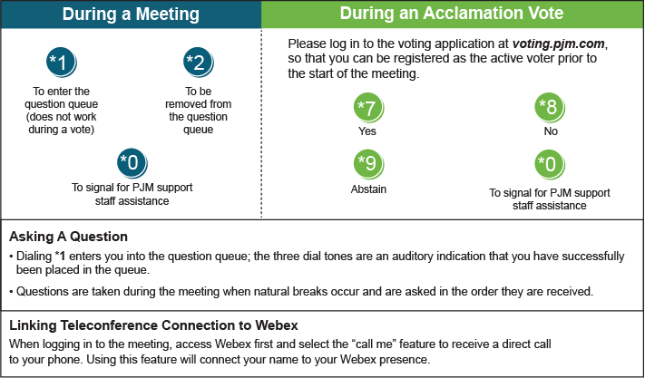

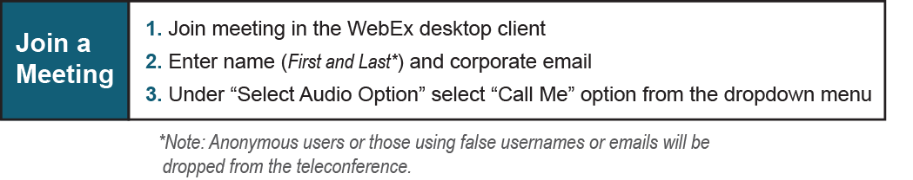

Provide feedback on the progress of this group: *Facilitator Feedback Form*   
Visit [*learn.pjm.com*](http://learn.pjm.com/), an easy-to-understand resource about the power industry and PJM’s role.