November Planning Committee

**Teleconference / WebEx**

November 1, 2022

9:00 a.m. – 12:00 p.m. EPT

*\*Operator assisted phone lines will be opened 30 minutes prior to the start of the meeting. Due to the high volume of remote participation, stakeholders are asked to connect early to allow additional time for operator queue processing.*

Administration (9:00 – 9:15)

1. Welcome, announcements and review of the Anti-trust, Code of Conduct, and Media Participation Guidelines.
2. Approve Planning Committee (PC) Agenda for this meeting.
3. Approve draft minutes from the October 4, 2022 PC meeting.
4. Review of PC Charter. The committee will be requested to endorse the Charter at next month’s meeting.

Endorsements

No endorsements in November.

First Reads

No first reads in November.

Informational Updates (9:15 – 9:30)

1. Reliability Compliance Update  
   Becky Davis, PJM, will provide an update on the activities, issues and items of interest at NERC, SERC, and RF.

CIR for ELCC Resources Special Session (9:30 – 12:00)

1. Capacity Interconnection Rights for ELCC Resources

Brian Chmielewski, PJM, will review the CIR for ELCC resources solution packages, investigate potential compromise packages to gain consensus and next steps.

Informational Posting

Model Build Activity Update

* MMWG
  + Dynamics
    - PJM has fixed the dynamic data issues identified by operation and planning dynamic data comparison process
    - PJM is collecting dynamic data updates for Transmission Owner dynamic devices
    - PJM is collecting dynamic load model data
  + Loadflow
    - PJM will provide updates to the 2023 summer study case to PowerTech by November 4, 2022
    - PowerTech will post the Trial 1 2023 summer study case by November 10, 2022
    - Transmission Owners will provide updates to PJM for the Trial 1 2023 summer study case by November 17, 2022
    - PJM will provide updates to PowerTech for the Trial 1 2023 summer study case by November 18, 2022
    - PowerTech will post the Trial 2 2023 summer study case by November 25, 2022
* RTEP
  + Short Circuit
    - PJM is building the Trial 1 two year case and will send it to the Transmission Owners for review in early January 2023
  + Loadflow
    - Transmission Owners to submit Trial 1 updates and LL Ratings via MOD along with updated Tie Line SharePoint data by November 18, 2022

Manual 03 Update

The PJM [Manual 03 Attachment E: Automatic Sectionalizing Schemes](https://www.pjm.com/markets-and-operations/etools/oasis/system-information.aspx) Pending Approval and Recent Changes document has been posted.

|  |  |  |  |  |
| --- | --- | --- | --- | --- |
| **Future Meeting Dates and Materials** | | | **Materials Due  to Secretary** | **Materials Published** |
| Date | Time | Meeting (Location) |
| Tuesday,  December 6,2022 | 9:00 a.m. – 12:00 p.m. | Planning Committee (TBD) | Wednesday  November 23, 2022 | Tuesday,  November 29, 2022 |

Author: Marilyn Jayachandran

Antitrust:

You may not discuss any topics that violate, or that might appear to violate, the antitrust laws including but not limited to agreements between or among competitors regarding prices, bid and offer practices, availability of service, product design, terms of sale, division of markets, allocation of customers or any other activity that might unreasonably restrain competition. If any of these items are discussed the chair will re-direct the conversation. If the conversation still persists, parties will be asked to leave the meeting or the meeting will be adjourned.

Code of Conduct:

As a mandatory condition of attendance at today's meeting, attendees agree to adhere to the PJM Code of Conduct as detailed in PJM Manual M-34 section 4.5, including, but not limited to, participants' responsibilities and rules regarding the dissemination of meeting discussion and materials.

Public Meetings/Media Participation:

Unless otherwise noted, PJM stakeholder meetings are open to the public and to members of the media. Members of the media are asked to announce their attendance at all PJM stakeholder meetings at the beginning of the meeting or at the point they join a meeting already in progress. Members of the Media are reminded that speakers at PJM meetings cannot be quoted without explicit permission from the speaker. PJM Members are reminded that "detailed transcriptional meeting notes" and white board notes from "brainstorming sessions" shall not be disseminated. Stakeholders are also not allowed to create audio, video or online recordings of PJM meetings. PJM may create audio, video or online recordings of stakeholder meetings for internal and training purposes, and your participation at such meetings indicates your consent to the same.

Participant Identification in WebEx:

When logging into the WebEx desktop client, please enter your real first and last name as well as a valid email address. Be sure to select the “call me” option.

PJM support staff continuously monitors WebEx connections during stakeholder meetings. Anonymous users or those using false usernames or emails will be dropped from the teleconference.

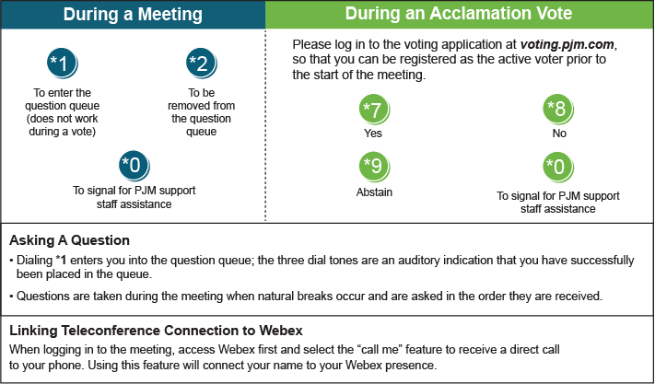

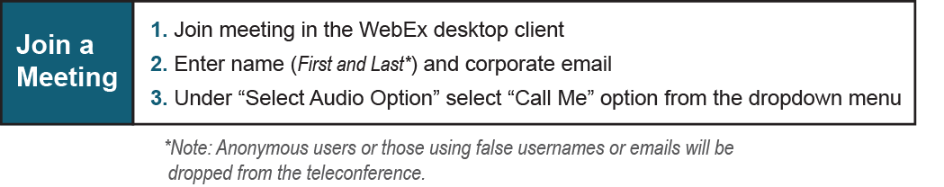

Provide feedback on the progress of this group: *Facilitator Feedback Form*   
Visit [*learn.pjm.com*](http://learn.pjm.com/), an easy-to-understand resource about the power industry and PJM’s role.