Transmission Expansion Advisory Committee
PJM Conference and Training Center
March 10, 2020
11:15 a.m. – 12:30 p.m. EPT
(Actual start time may vary dependent upon the completion of the Planning Committee meeting which immediately proceeds the TEAC meeting. Please subscribe to TEAC distribution list to receive TEAC notifications.)

Administration (11:15-11:20)
- Welcome, announcements and review of the Anti-trust, Code of Conduct, and Media Participation Guidelines. Review Transmission Expansion Advisory Committee Agenda for this meeting.

RTEP Updates (11:20-12:30)
- Interregional Planning Update
Mark Sims, PJM, will provide an update on Interregional Planning.
- Generation Deactivation Notification Update
Phil Yum, PJM, will provide an update on recent generation deactivation notifications.
- AEP Supplemental Projects
Bart Taberner, AEP, will present a need and solutions for supplemental projects in AEP.
- BGE Supplemental Projects
Eric Yeh, BGE, will present solutions for supplemental projects in BGE.
- ComEd Supplemental Projects
Paul Mills, ComEd, will present a need for a supplemental project in ComEd.
- Dominion Supplemental Projects
Kyle Hannah, Dominion, will present needs and solutions for supplemental projects in Dominion.
- PECO Supplemental Projects
John Sweriduk, PECO, will present needs for supplemental projects in PECO.
- PPL Supplemental Projects
Shadab Ali, PPL, will present a project scope change for a supplemental project in PPL.
- Reliability Analysis Update
Aaron Berner, PJM, will provide an update on the 2020 RTEP analysis.

Informational Posting
- Informational Only - M-3 Process Needs Status
This spreadsheet allows stakeholders to track process defined in Open Access Transmission Tariff,
Attachment M-3 and leading to the development of the supplemental projects.
- Informational Only – Aggregate Maps for Supplemental Projects
Aggregate geographic representation of supplemental projects not previously included in Local Plan.
- Informational Only – Planning Community Open Questions
Open questions regarding M-3 projects received through Planning Community.

- Informational Only – 2020 RTEP Machine List
List of machines modeled in 2020 Series RTEP cases.

Future Meeting Dates
Tuesday, April 14, 2020 | 1:00 p.m. – 3:00 p.m. Transmission Expansion Advisory Committee | PJM Conference & Training Center/ WebEx
Tuesday, May 12, 2020 | 1:00 p.m. – 3:00 p.m. Transmission Expansion Advisory Committee | PJM Conference & Training Center/ WebEx
Tuesday, June 02, 2020 | 1:00 p.m. – 3:00 p.m. Transmission Expansion Advisory Committee | PJM Conference & Training Center/ WebEx
Tuesday, July 07, 2020 | 1:00 p.m. – 3:00 p.m. Transmission Expansion Advisory Committee | PJM Conference & Training Center/ WebEx
Tuesday, August 04, 2020 | 1:00 p.m. – 3:00 p.m. Transmission Expansion Advisory Committee | PJM Conference & Training Center/ WebEx
Tuesday, September 01, 2020 | 1:00 p.m. – 3:00 p.m. Transmission Expansion Advisory Committee | PJM Conference & Training Center/ WebEx
Tuesday, October 06, 2020 | 1:00 p.m. – 3:00 p.m. Transmission Expansion Advisory Committee | PJM Conference & Training Center/ WebEx
Wednesday, November 04, 2020 | 1:00 p.m. – 3:00 p.m. Transmission Expansion Advisory Committee | PJM Conference & Training Center/ WebEx
Tuesday, December 01, 2020 | 1:00 p.m. – 3:00 p.m. Transmission Expansion Advisory Committee | PJM Conference & Training Center/ WebEx

Author: Ilyana Dropkin

Antitrust:
You may not discuss any topics that violate, or that might appear to violate, the antitrust laws including but not limited to agreements between or among competitors regarding prices, bid and offer practices, availability of service, product design, terms of sale, division of markets, allocation of customers or any other activity that might unreasonably restrain competition. If any of these items are discussed the chair will re-direct the conversation. If the conversation still persists, parties will be asked to leave the meeting or the meeting will be adjourned.

Code of Conduct:
As a mandatory condition of attendance at today's meeting, attendees agree to adhere to the PJM Code of Conduct as detailed in PJM Manual M-34 section 4.5, including, but not limited to, participants' responsibilities and rules regarding the dissemination of meeting discussion and materials.
Public Meetings/Media Participation:
Unless otherwise noted, PJM stakeholder meetings are open to the public and to members of the media. Members of the media are asked to announce their attendance at all PJM stakeholder meetings at the beginning of the meeting or at the point they join a meeting already in progress. Members of the Media are reminded that speakers at PJM meetings cannot be quoted without explicit permission from the speaker. PJM Members are reminded that "detailed transcriptional meeting notes" and white board notes from "brainstorming sessions" shall not be disseminated. Stakeholders are also not allowed to create audio, video or online recordings of PJM meetings. PJM may create audio, video or online recordings of stakeholder meetings for internal and training purposes, and your participation at such meetings indicates your consent to the same.
Participant Identification in WebEx:
When logging into the WebEx desktop client, please enter your real first and last name as well as a valid email address. Be sure to select the “call me” option.
PJM support staff continuously monitors WebEx connections during stakeholder meetings. Anonymous users or those using false usernames or emails will be dropped from the teleconference.


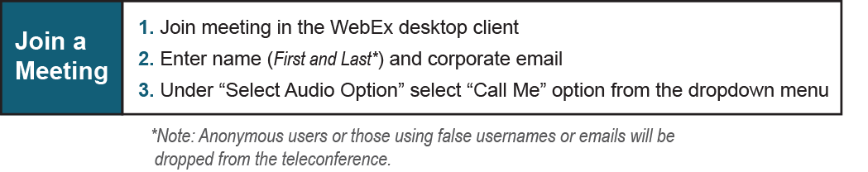

Provide feedback on the progress of this group: Facilitator Feedback Form
Visit learn.pjm.com, an easy-to-understand resource about the power industry and PJM’s role.

