Tech Change Forum
PJM Conference and Training Center
October 20, 2020
1:00 p.m. – 3:00 p.m. EPT

Administration (1:00-1:05)
Welcome & Ground Rules

Important Dates Review (1:05-1:10)
Important upcoming dates will be reviewed
- Foluso Afelumo, PJM, will highlight important upcoming 2020 Q3 and Q4 dates

Initiative Roadmap Updates
- Initiatives
A. Webex Meeting Controls

Product Roadmap Updates (1:10-2:20)
4. Roadmaps for individual products will be presented

- DR Hub, Power Meter, InSchedule, Billing Line Item Transfer, eSuite Home Page [Gerry McNamee]
- MSRS [Carla Thew]
- Account Manager, Bulletin Board, Data Viewer, eDataFeed, Messages, Resource Tracker, Tools Home and Voting Roadmaps [Bhavana Gagrani]
- Markets Gateway [Kim Warshel]
- Communities [Monica Burkett]
- PJM.com [Tawnya Luna]
- eDART [Vy Le]
- Data Miner [Swapna Kanury]

- Networks [Sandy Honore]
- Tools Security Update [Sunil Rachakonda]
- Planning Center: Gen Model, Queue Point and Competitive Planner [Ian Mundell]
- PJM Connect Upgrade Roadmap [Heather Bird]

- Monitoring Analytics MIRA Tool [Carl Smith]

- Emergency Procedures [Madeline Beach]

- No Planned Updates (this month) [Foluso Afelumo]

General Updates (2:20-2:33)
5. General updates will be presented
A. Elimination of Weak Encryption [Colin Brisson]
B. Posted Contingency File Update [Jack Thomas]
C. General Updates and Recent Production Issue Review [Foluso Afelumo]

Product Design Review & Feature Demonstrations (2:35-2:55)
6. Demonstrations
A. Membership Management Community - Market Participant Form [Monica Burkett]
B. MSRS User Interface (UI) Refresh Demonstration [Nick Disciullo]

General Feedback and Future Forum Topics (2:55)

Future Meeting Dates
November 17, 2020 | 1:00 p.m. - 3:00 p.m. | WebEx
December 15, 2020 | 1:00 p.m. - 3:00 p.m. | WebEx
Author: Risa Holland

Antitrust:
You may not discuss any topics that violate, or that might appear to violate, the antitrust laws including but not limited to agreements between or among competitors regarding prices, bid and offer practices, availability of service, product design, terms of sale, division of markets, allocation of customers or any other activity that might unreasonably restrain competition. If any of these items are discussed the chair will re-direct the conversation. If the conversation still persists, parties will be asked to leave the meeting or the meeting will be adjourned.

Code of Conduct:
As a mandatory condition of attendance at today's meeting, attendees agree to adhere to the PJM Code of Conduct as detailed in PJM Manual M-34 section 4.5, including, but not limited to, participants' responsibilities and rules regarding the dissemination of meeting discussion and materials.

Public Meetings/Media Participation:
Unless otherwise noted, PJM stakeholder meetings are open to the public and to members of the media. Members of the media are asked to announce their attendance at all PJM stakeholder meetings at the beginning of the meeting or at the point they join a meeting already in progress. Members of the Media are reminded that speakers at PJM meetings cannot be quoted without explicit permission from the speaker. PJM Members are reminded that "detailed transcriptional meeting notes" and white board notes from "brainstorming sessions" shall not be disseminated. Stakeholders are also not allowed to create audio, video or online recordings of PJM meetings. PJM may create audio, video or online recordings of stakeholder meetings for internal and training purposes, and your participation at such meetings indicates your consent to the same.
Participant Identification in WebEx:
When logging into the WebEx desktop client, please enter your real first and last name as well as a valid email address. Be sure to select the “call me” option.
PJM support staff continuously monitors WebEx connections during stakeholder meetings. Anonymous users or those using false usernames or emails will be dropped from the teleconference.



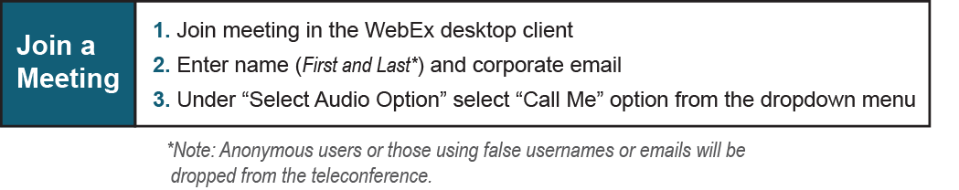

Provide feedback on the progress of this group: Facilitator Feedback Form
Visit learn.pjm.com, an easy-to-understand resource about the power industry and PJM’s role.

