Designated Entity Design Standards Task Force
PJM Conference and Training Center
March 22, 2016
8:00 a.m. – 4:00 p.m. EST (Issue Tracking)

Lines Subgroup Meeting (8:00 a.m. - 10:00 a.m.)
Administration (8:00 – 8:30)
Mr. Herman, PJM - Welcome, review of meeting guidelines and protocols (PJM Manual 34), agenda, and roll call
Mr. Herman will review the decision to proceed with subgroups for Transmission Lines, Substations and System Protection and Control Design/Coordination
Mr. Herman will introduce David Parish, AEP, and Rich Crouch, PSE&G, as the co-leads for the DEDSTF Lines Subgroup.
Mr. Crouch, will seek a subgroup volunteer to take meeting minutes including issue tracker
Develop scope of Lines Subgroup effort
(8:30 – 9:00) Mr. Parrish - Discussion regarding use of PJM TSS, MISO, SPP Technical Requirements – are there portions of these documents which we want to include in sub-group body of work?
(9:00 – 9:30) Mr. Crouch - Review of spreadsheet (provided by PSE&G); Discuss use of spreadsheet as a possible working document
(9:30 – 9:50) Mr. Parrish – Roundtable
(9:50 – 10:00) Mr. Parrish and Mr. Crouch – Action Items/Next Steps

Break (10:00 a.m. – 10:15 a.m.)

Protection Subgroup Meeting (10:15 a.m. - 12:15 p.m.)
. Administration (10:15 – 10:30)
Mr. Herman, PJM - Welcome, review of meeting guidelines and protocols (PJM Manual 34), agenda, and roll call
Mr. Herman will review the decision to proceed with subgroups for Transmission Lines, Substations and System Protection and Control Design/Coordination
Mr. Herman will introduce Dennis Field, ComEd, and James Hubertus, PSE&G, as the co-leads for the DEDSTF Protection Subgroup
Mr. Field and Mr. Hubertus will seek a subgroup volunteer to serve as secretary
Review/Discuss PJM Manual 7
Discussion of MISO and SPP Minimum Design Standard Documents
Discussion about desired approach to developing of PJM Minimum Design Standards
Determine action items for next meeting
Adjourn

Lunch (12:15 p.m. – 1:00 p.m.)

Substation Subgroup Meeting (1:00 p.m. - 3:00 p.m.)
Administration (1:00 – 1:15)
Mr. Herman, PJM - Welcome, review of meeting guidelines and protocols (PJM Manual 34), agenda, and roll call
Mr. Herman will review the decision to proceed with subgroups for Transmission Lines, Substations and System Protection and Control Design/Coordination
Mr. Herman will introduce Ronald Wellman, AEP, and Scott Herb, PPL, as the co-leads for the DEDSTF Substation Subgroup
Mr. Wellman and Mr. Herb will seek a subgroup volunteer to record meeting minutes
What does the end state look like
Overall document – what needs to be included/ excluded
Question to the group – Are the existing Transmission Owner Guidelines published on the PJM website adequate?
Plan/ path going forward

Future Agenda Items (3:00 p.m. - 4:00 p.m.)

Future Meeting Dates
April 14, 2016 | 8:00 a.m. – 4:00 p.m | PJM Conference & Training Center/ WebEx
May 16, 2016 | 8:00 a.m. – 4:00 p.m | PJM Conference & Training Center/ WebEx
June 15, 2016 | 8:00 a.m. – 4:00 p.m | PJM Conference & Training Center/ WebEx
July 19, 2016 | 8:00 a.m. – 4:00 p.m | PJM Conference & Training Center/ WebEx
August 17, 2016 | 8:00 a.m. – 4:00 p.m | PJM Conference & Training Center/ WebEx
September 12, 2016 | 8:00 a.m. – 4:00 p.m | PJM Conference & Training Center/ WebEx
October 25, 2016 | 8:00 a.m. – 4:00 p.m | PJM Conference & Training Center/ WebEx
November 15, 2016 | 8:00 a.m. – 4:00 p.m | PJM Conference & Training Center/ WebEx
December 12, 2016 | 8:00 a.m. – 4:00 p.m | PJM Conference & Training Center/ WebEx

Author: Anisha Fernandes

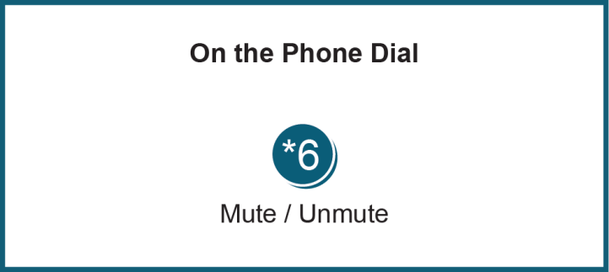

Anti-trust:
You may not discuss any topics that violate, or that might appear to violate, the antitrust laws including but not limited to agreements between or among competitors regarding prices, bid and offer practices, availability of service, product design, terms of sale, division of markets, allocation of customers or any other activity that might unreasonably restrain competition. If any of these items are discussed the chair will re-direct the conversation. If the conversation still persists, parties will be asked to leave the meeting or the meeting will be adjourned.

Code of Conduct:
As a mandatory condition of attendance at today's meeting, attendees agree to adhere to the PJM Code of Conduct as detailed in PJM Manual M-34 section 4.5, including, but not limited to, participants' responsibilities and rules regarding the dissemination of meeting discussion and materials.

Public Meetings/Media Participation:
Unless otherwise noted, PJM stakeholder meetings are open to the public and to members of the media. Members of the media are asked to announce their attendance at all PJM stakeholder meetings at the beginning of the meeting or at the point they join a meeting already in progress. Members of the Media are reminded that speakers at PJM meetings cannot be quoted without explicit permission from the speaker. PJM Members are reminded that "detailed transcriptional meeting notes" and white board notes from "brainstorming sessions" shall not be disseminated. Stakeholders are also not allowed to create audio, video or online recordings of PJM meetings.

