Carbon Pricing Senior Task Force (CPSTF)
PJM Conference and Training Center
October 24, 2019
9:00 a.m. – 3:15 p.m. EPT

Administration (9:00-9:05)
Ms. Jen Tribulski and Ms. Suzanne Coyne will provide welcome, announcements, and review of the Antitrust, Code of Conduct, and Public Meetings/Media Participation Guidelines Text. Stakeholders will be asked to approve the draft minutes from the August 26, 2019 meeting.

Work Plan (9:05-9:10)
- Ms. Suzanne Coyne will review the Carbon Pricing Senior Task Force stakeholder process Stage 1 work plan.

Education (9:10-3:00)
New England Stakeholder Process (IMAPP) (9:10–9:45)
Mr. Sebastian Lombardi, Day Pitney LLP/NEPOOL Counsel, will provide a summary of NEPOOL’s Integrating Markets and Public Policy (IMAPP) stakeholder process.
Cost-based Offers (9:45-10:15)
Ms. Melissa Pilong, PJM, will provide education on the Cost Development Guidelines for cost based offers with a focus on emission allowances.
Carbon Pricing Impacts on LMP (10:15-11:45)
Dr. Anthony Giacomoni, PJM, will provide education on the carbon component of LMP.
Carbon Pricing Modeling (1:00–2:30)
EDF and M.J. Bradley & Associates will provide information and results regarding EDF’s carbon pricing modeling efforts.
State RPS Fulfillment (2:30–3:00)
Mr. Skyler Marzewski, Mr. Devendra Canchi, and Mr. John Hyatt, Monitoring Analytics, will provide education on state RPS requirements and carbon adder impacts on LMP.

Action Items (3:00-3:15)
Ms. Jen Tribulski will discuss action items.

Future Meeting Dates
November 15, 2019 | 9:00 a.m. | PJM Conference & Training Center/ WebEx
December 20, 2019 | 9:00 a.m. | PJM Conference & Training Center/ WebEx
Author: Suzanne Coyne

Antitrust:
You may not discuss any topics that violate, or that might appear to violate, the antitrust laws including but not limited to agreements between or among competitors regarding prices, bid and offer practices, availability of service, product design, terms of sale, division of markets, allocation of customers or any other activity that might unreasonably restrain competition. If any of these items are discussed the chair will re-direct the conversation. If the conversation still persists, parties will be asked to leave the meeting or the meeting will be adjourned.

Code of Conduct:
As a mandatory condition of attendance at today's meeting, attendees agree to adhere to the PJM Code of Conduct as detailed in PJM Manual M-34 section 4.5, including, but not limited to, participants' responsibilities and rules regarding the dissemination of meeting discussion and materials.

Public Meetings/Media Participation:
Unless otherwise noted, PJM stakeholder meetings are open to the public and to members of the media. Members of the media are asked to announce their attendance at all PJM stakeholder meetings at the beginning of the meeting or at the point they join a meeting already in progress. Members of the Media are reminded that speakers at PJM meetings cannot be quoted without explicit permission from the speaker. PJM Members are reminded that "detailed transcriptional meeting notes" and white board notes from "brainstorming sessions" shall not be disseminated. Stakeholders are also not allowed to create audio, video or online recordings of PJM meetings. PJM may create audio, video or online recordings of stakeholder meetings for internal and training purposes, and your participation at such meetings indicates your consent to the same.
Participant Identification in WebEx:
When logging into the WebEx desktop client, please enter your real first and last name as well as a valid email address. Be sure to select the “call me” option.
PJM support staff continuously monitors WebEx connections during stakeholder meetings. Anonymous users or those using false usernames or emails will be dropped from the teleconference.



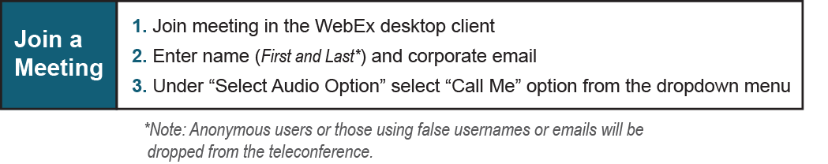
Provide feedback on the progress of this group: Facilitator Feedback Form
Visit learn.pjm.com, an easy-to-understand resource about the power industry and PJM’s role.

