Financial Risk Mitigation Senior Task Force (FRMSTF)
PJM Conference and Training Center
July 17, 2019
9:00 a.m. – 4:20 p.m. EPT

Administration (9:00-9:05)
- Ms. Michele Greening will provide welcome, announcements and review of the Antitrust, Code of Conduct, and Public Meetings/Media Participation Guidelines. Stakeholders will be asked to approve draft minutes from the June 25, 2019 meeting.

Work Plan (9:05-9:15)
- Ms. Anita Patel will review the Financial Risk Mitigation Senior Task Force stakeholder process work plan and dashboard webpage.

Stakeholder Education (9:15-11:15)
- Mr. Demetri Karousos, Nodal Exchange, will present stakeholder education on the topic of external clearing house

PJM Reports (11:15-12:15)
- PJM Report on the Desktop Review of the Methodologies for Initial Margin Calculation (11:15-11:45)
Mr. Alex Eydeland will review a report on the methodologies for initial margin calculation.
- PJM Report on Position/Concentration Limit Options (11:45-12:15)
Mr. Todd Bessemer will review a discussion paper on position and concentration limit options.
Lunch 12:15-1:00

Discussion Papers and Initial Proposals (1:00- 4:20)
- Variation Margining and Post-Auction Settlement (1:00-1:30)
Mr. Todd Bessemer will provide an overview of the discussion paper addressing variation margining and post-auction settlement.
- PJM Proposal for Enduring Governance of PJM’s Financial Markets (1:30-1:50)
Mr. Dave Anders will provide an initial proposal regarding Enduring Governance. Stakeholders are encouraged to provide alternate proposals at the next FRMSTF meeting.
- Recommended Changes to FTR Product Range and Auction Process (1:50-4:20)
- Mr. Brian Chmielewski will provide an overview of the initial proposal addressing PJM’s recommended changes to the FTR product range and auction process. (1:50-2:20)
- Noha Sidhom, The Energy Trade Institute, will provide a presentation discussing the FTR market rules and an alternative proposal. (2:20-3:05)
- Mark Price, DC Energy, will provide a presentation discussing CAISO: A Case Study. (3:05-3:35)
- Joe Bowring, Monitoring Analytics, will provide a presentation discussing the IMM’s alternative proposal on the ARR/FTR Market Design. (3:35-4:20)

Future Agenda Items (4:20)
PJM Discussion Paper on Credit Events and Discretionary Authority
PJM Position Paper on Due Diligence Criteria and Assessment Process
PJM Position Paper on Financial Criteria for Participation and Financial Surveillance Process
PJM Position Paper on Authorities and Discretion to Deny or Revoke Trading Rights

Future Meeting Dates
August 5, 2019 | 9:00 a.m. | PJM Conference & Training Center/ WebEx
September 5, 2019 | 9:00 a.m. | PJM Conference & Training Center/ WebEx
September 25, 2019 | 9:00 a.m. | PJM Conference & Training Center/ WebEx
October 18, 2019 | 9:00 a.m. | PJM Conference & Training Center/ WebEx
November 7, 2019 | 9:00 a.m. | PJM Conference & Training Center/ WebEx
Author: M. Greening

Antitrust:
You may not discuss any topics that violate, or that might appear to violate, the antitrust laws including but not limited to agreements between or among competitors regarding prices, bid and offer practices, availability of service, product design, terms of sale, division of markets, allocation of customers or any other activity that might unreasonably restrain competition. If any of these items are discussed the chair will re-direct the conversation. If the conversation still persists, parties will be asked to leave the meeting or the meeting will be adjourned.

Code of Conduct:
As a mandatory condition of attendance at today's meeting, attendees agree to adhere to the PJM Code of Conduct as detailed in PJM Manual M-34 section 4.5, including, but not limited to, participants' responsibilities and rules regarding the dissemination of meeting discussion and materials.

Public Meetings/Media Participation:
Unless otherwise noted, PJM stakeholder meetings are open to the public and to members of the media. Members of the media are asked to announce their attendance at all PJM stakeholder meetings at the beginning of the meeting or at the point they join a meeting already in progress. Members of the Media are reminded that speakers at PJM meetings cannot be quoted without explicit permission from the speaker. PJM Members are reminded that "detailed transcriptional meeting notes" and white board notes from "brainstorming sessions" shall not be disseminated. Stakeholders are also not allowed to create audio, video or online recordings of PJM meetings. PJM may create audio, video or online recordings of stakeholder meetings for internal and training purposes, and your participation at such meetings indicates your consent to the same.
Participant Identification in WebEx:
When logging into the WebEx desktop client, please enter your real first and last name as well as a valid email address. Be sure to select the “call me” option.
PJM support staff continuously monitors WebEx connections during stakeholder meetings. Anonymous users or those using false usernames or emails will be dropped from the teleconference.



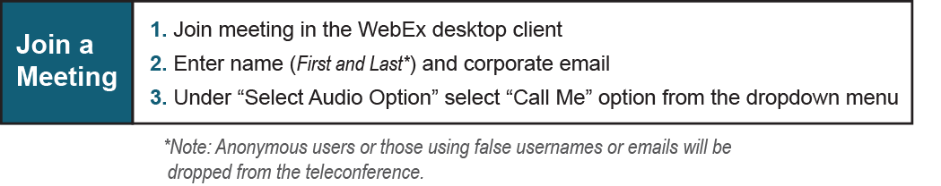
Provide feedback on the progress of this group: Facilitator Feedback Form
Visit learn.pjm.com, an easy-to-understand resource about the power industry and PJM’s role.

