Transmission Replacement Processes Senior Task Force (TRPSTF)
WebEx/Teleconference
February 1, 2018
9:30 a.m. – 3:00 p.m. EPT

Administration
Call to order, roll call, review of meeting minutes, review of the Anti-trust, Code of Conduct, and Media Participation Guidelines and request for additional agenda items.

Design Components Solution Matrix Discussion
- Discussion of open items between AMP and the TOs.
- PJM staff to present draft proposal to the design components solution matrix.
- Review design component matrix.

Future Meeting Dates
February 23, 2018 | 9:30 a.m. – 3:00 p.m. | PJM CTC & WebEx/Teleconference
March 28, 2018 | 9:30 a.m. – 3:00 p.m. | PJM CTC & WebEx/Teleconference
April 30, 2018 | 9:30 a.m. – 3:00 p.m. | PJM CTC & WebEx/Teleconference
Author: Jason Quevada

Antitrust:
You may not discuss any topics that violate, or that might appear to violate, the antitrust laws including but not limited to agreements between or among competitors regarding prices, bid and offer practices, availability of service, product design, terms of sale, division of markets, allocation of customers or any other activity that might unreasonably restrain competition. If any of these items are discussed the chair will re-direct the conversation. If the conversation still persists, parties will be asked to leave the meeting or the meeting will be adjourned.

Code of Conduct:
As a mandatory condition of attendance at today's meeting, attendees agree to adhere to the PJM Code of Conduct as detailed in PJM Manual M-34 section 4.5, including, but not limited to, participants' responsibilities and rules regarding the dissemination of meeting discussion and materials.

Public Meetings/Media Participation:
Unless otherwise noted, PJM stakeholder meetings are open to the public and to members of the media. Members of the media are asked to announce their attendance at all PJM stakeholder meetings at the beginning of the meeting or at the point they join a meeting already in progress. Members of the Media are reminded that speakers at PJM meetings cannot be quoted without explicit permission from the speaker. PJM Members are reminded that "detailed transcriptional meeting notes" and white board notes from "brainstorming sessions" shall not be disseminated. Stakeholders are also not allowed to create audio, video or online recordings of PJM meetings. PJM may create audio, video or online recordings of stakeholder meetings for internal and training purposes, and your participation at such meetings indicates your consent to the same.
Participant Identification in WebEx:
When logging into the WebEx desktop client, please enter your real first and last name as well as a valid email address. Be sure to select the “call me” option.
PJM support staff continuously monitors WebEx connections during stakeholder meetings. Anonymous users or those using false usernames or emails will be dropped from the teleconference.



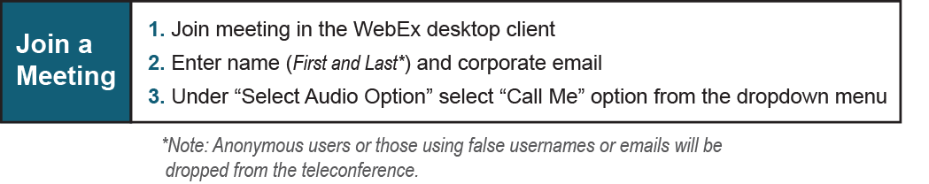

Provide feedback on the progress of this group: Facilitator Feedback Form
Visit learn.pjm.com, an easy-to-understand resource about the power industry and PJM’s role.

Statement of the PJM Transmission Owners upon Resumption of Meetings
Of the Transmission Replacement Processes Senior Task Force
7/18/2017
The MRC voted to suspend meetings of the Transmission Replacement Processes Senior Task Force to give the Federal Energy Regulatory Commission the opportunity to act on the responses to the Order to Show Cause issued in Docket No. EL16-71 and the PJM TOs’ proposal to add Section M-3 to the PJM Tariff pending in Docket No. ER17-179. That suspension was initiated because of the substantial overlap between the issues raised in the FERC proceedings and the subject matter being addressed by the Task Force. The suspension recognized that until FERC rules on those issues, it will be very difficult, if not impossible, to make significant progress on them in the Task Force. The potential for progress is also impeded because discussions of the TRPSTF are not subject to FERC’s rules regarding the confidentiality and use of settlement discussions, which makes the TOs legitimately concerned that statements made or positions taken during Task Force discussions could undermine their arguments in the FERC proceedings. The MRC vote not to continue the suspension of the Task Force has not removed these barriers to progress or resolved the TOs’ legitimate concerns regarding the confidentiality and use of discussions occurring during Task Force meetings. While the PJM Transmission Owners will participate in upcoming meetings of the Task Force and are willing to engage in constructive discussion of matters outside of the subject matter of the FERC proceedings, we do not believe that meaningful discussion or progress is possible where the subject matter overlaps the issues currently pending before the FERC and will not compromise our litigation position in task force discussions.

