Members Committee Webinar
PJM Conference and Training Center
May 26, 2020
1:00 p.m. – 3:30 p.m. EPT

Administration (1:00-1:05)
Welcome, announcements and Anti-trust and Code of Conduct announcement – Janell Fabiano

Informational Updates (1:05-1:25)
- Interregional Coordination (1:05 – 1:15)
Joseph Ciabattoni will provide an update on interregional coordination activities

2. Dispatch Interactive Map Application (DIMA) (1:15-1:25)
Ed Kovler will preview the Quick Fix Problem Statement and Issue Charge PJM is bringing to the
Operating Committee.

Upcoming Stakeholder Process Items (1:25 – 1:35)
3. Stakeholder Process Forum (1:25 – 1:30)
Michele Greening will preview the agenda for today’s Stakeholder Process Forum
4. Stakeholder Process Training (1:30-1:35)
Janell Fabiano will announce the upcoming Stakeholder Process Training scheduled for June 11, 2020

Reports (1:35-3:35)
5. State Activities (1:35-1:40)
Receive report on recent activities of the Organization of PJM States, Inc. – Gregory Carmean
- Market Monitoring Report (1:40-1:50)
Receive report of the Independent Market Monitor – Joe Bowring

- PJM Updates (1:50-2:15)
- Receive report on market operations – Jennifer Freeman
- Receive report on system operations – Hong Chen
- Receive report on recent regulatory activities – Jeanine Watson
D. Receive Q1 2020 financial review– Megan Heater
- Standing Committee Reports (2:15-2:35)
A. Markets and Reliability Committee (MRC) – Dave Anders
- Market Implementation Committee (MIC) – Bhavana Keshavamurthy
- Operating Committee (OC) – Danielle Croop
- Planning Committee (PC) – Molly Mooney

- Open Issue Reports (2:35 – 3:25)
A. ARR/FTR Market Review (AFMTF) – Dave Anders/ Emmy Messina
B. Effective Load Carrying Capability for Limited Duration Resources and Intermittent Resources
(CCSTF) – Melissa Pilong/ Jacklyn Lukach
C. Transparency and End of Life Planning (MRC) – Jeff McLaughlin

- Open Issue Reports – Informational
Item | Issue | Committee | Contact
A. | Five Minute Dispatch and Pricing | MIC | Susan Kenney/ Alex Scheirer
B. | Real Time Market Values | MIC | Laura Walter/ Kevin Hatch
C. | Stability Limits in Markets and Operations | MIC | Bhavana Keshavamurthy
D. | Fuel Cost Policy | MIC | Bhavana Keshavamurthy/ Diane Antonelli
E. | Critical Infrastructure Stakeholder Oversight | PC | Christina Stotesbury/ Joe Hay
F. | Carbon Pricing | CPSTF | Suzanne Coyne
G. | Surety Bonds | CS | Kathleen McElwaine
H. | Distributed Energy Resources in PJM Markets | DERS | Scott Baker/ Andrew Gledhill
I. | Financial Risk Mitigation | FRMSTF | Anita Patel/ Michele Greening
J. | RTEP Market Efficiency Analysis | MEPETF | Jack Thomas
K. | Modeling Generation in Markets Gateway | MGSTF | Glen Boyle/ Lauren Strella Wahba
L. | Load Reconciliation Process | MSS | Ray Fernandes/ Nick Disciullo

Future Agenda Items (3:25 – 3:30)

Future Meeting Dates
June 15, 2020  July 20, 2020  September 14, 2020  October 26, 2020  November 16, 2020/  December 14, 2020 | 1:00 p.m.  1:00 p.m.  1:00 p.m.  1:00 p.m.  1:00 p.m.  1:00 p.m. | WebEx/ Teleconference  WebEx/ Teleconference  WebEx/ Teleconference  WebEx/ Teleconference  WebEx/ Teleconference  WebEx/ Teleconference
Author: Janell L Fabiano

Antitrust:
You may not discuss any topics that violate, or that might appear to violate, the antitrust laws including but not limited to agreements between or among competitors regarding prices, bid and offer practices, availability of service, product design, terms of sale, division of markets, allocation of customers or any other activity that might unreasonably restrain competition. If any of these items are discussed the chair will re-direct the conversation. If the conversation still persists, parties will be asked to leave the meeting or the meeting will be adjourned.

Code of Conduct:
As a mandatory condition of attendance at today's meeting, attendees agree to adhere to the PJM Code of Conduct as detailed in PJM Manual M-34 section 4.5, including, but not limited to, participants' responsibilities and rules regarding the dissemination of meeting discussion and materials.
Public Meetings/Media Participation:
Unless otherwise noted, PJM stakeholder meetings are open to the public and to members of the media. Members of the media are asked to announce their attendance at all PJM stakeholder meetings at the beginning of the meeting or at the point they join a meeting already in progress. Members of the Media are reminded that speakers at PJM meetings cannot be quoted without explicit permission from the speaker. PJM Members are reminded that "detailed transcriptional meeting notes" and white board notes from "brainstorming sessions" shall not be disseminated. Stakeholders are also not allowed to create audio, video or online recordings of PJM meetings. PJM may create audio, video or online recordings of stakeholder meetings for internal and training purposes, and your participation at such meetings indicates your consent to the same.
Participant Identification in WebEx:
When logging into the WebEx desktop client, please enter your real first and last name as well as a valid email address. Be sure to select the “call me” option.
PJM support staff continuously monitors WebEx connections during stakeholder meetings. Anonymous users or those using false usernames or emails will be dropped from the teleconference.



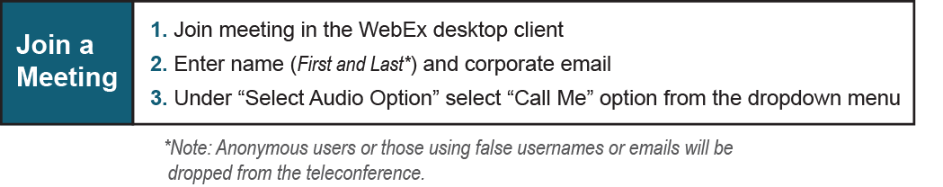
Provide feedback on the progress of this group: Facilitator Feedback Form
Visit learn.pjm.com, an easy-to-understand resource about the power industry and PJM’s role.

