Members Committee
One Hundred Ninety-Ninth Meeting
Webex Only
May 28, 2020
1:15 p.m. – 5:00 p.m. EPT
*Operator assisted phone lines will be opened 30 minutes prior to the start of the meeting. Due to the high volume of remote participation, stakeholders are asked to connect early to allow additional time for operator queue processing.

Administration (1:15-1:20)
- Announce sector selections of new members since the last meeting – David Anders
- Confirm the presence of a quorum of representatives or designated alternates for this meeting – David Anders
- Anti-trust, Code of Conduct, Meeting Participation, and Safety announcements – David Anders

Consent Agenda (1:20-1:25)
- Approve draft minutes of the May 4, 2020 meeting.

Endorsements/Approvals (1:25-2:10)
- Transparency and End Of Life Planning (1:25-2:10)
Jim Gluck will review the work completed at the MRC Special Sessions for Transparency and End of Life Planning including proposed solutions. The committee will be asked to endorse/approve a proposed solution and associated governing document revisions as appropriate. MRC endorsement/approval will be sought on the same day.
Issue Tracking: Transparency and End of Life Planning
- Mark Ringhausen, Old Dominion Electric Cooperative, will speak to the joint stakeholder solution proposal and draft OA revisions posted.
- Dave Souder will speak to PJM’s solution proposal.

Reports (2:10-2:25)
- MC Vice Chair Report (2:10-2:20)
- Provide an update on the Members Committee Annual Plan – Katie Guerry
- Provide a report on plans for the July 27, 2020 Liaison Committee meeting with the PJM Board of Managers – Katie Guerry

- Webinar Feedback (2:20-2:25)
Stakeholders may raise any items identified for further discussion from the May 26, 2020 Members Committee Webinar.

Informational Only
Proposed Amendments to Attachment M-3 of the PJM Tariff
On May 7, 2020, the Transmission Owners initiated and issued to stakeholders through PJM their Notice of Transmission Owners Consultation with the Members Committee Regarding Proposed Amendments to Attachment M-3 of the PJM Tariff, and that notice has been made is available on behalf of the PJM Transmission Owners and has been posted with today’s meeting materials. The PJM Transmission Owners plan to hold a webinar on June 1, 2020, from 2:00 PM to 4:00 PM (Eastern) to provide an opportunity for stakeholders to ask questions and comments on the proposed Amendments to Attachment M-3. Please note that in addition to the webinar, written comments on the Attachment M-3 Amendments may be submitted for consideration by email to: Comments_for_Transmission_Owners@pjm.com on or before June 8, 2020.

Future Agenda Items (2:25)

Future Meeting Dates
June 18, 2020 | 1:15 p.m. | PJM Conference & Training Center/ WebEx
July 23, 2020 | 1:15 p.m. | PJM Conference & Training Center/ WebEx
September 17, 2020 | 1:15 p.m. | PJM Conference & Training Center/ WebEx
October 29, 2020 | 1:15 p.m. | PJM Conference & Training Center/ WebEx
November 19, 2020 | 1:15 p.m. | PJM Conference & Training Center/ WebEx
December 17, 2020 | 1:15 p.m. | PJM Conference & Training Center/ WebEx
Author: M. Greening

Antitrust:
You may not discuss any topics that violate, or that might appear to violate, the antitrust laws including but not limited to agreements between or among competitors regarding prices, bid and offer practices, availability of service, product design, terms of sale, division of markets, allocation of customers or any other activity that might unreasonably restrain competition. If any of these items are discussed the chair will re-direct the conversation. If the conversation still persists, parties will be asked to leave the meeting or the meeting will be adjourned.

Code of Conduct:
As a mandatory condition of attendance at today's meeting, attendees agree to adhere to the PJM Code of Conduct as detailed in PJM Manual M-34 section 4.5, including, but not limited to, participants' responsibilities and rules regarding the dissemination of meeting discussion and materials.

Public Meetings/Media Participation:
Unless otherwise noted, PJM stakeholder meetings are open to the public and to members of the media. Members of the media are asked to announce their attendance at all PJM stakeholder meetings at the beginning of the meeting or at the point they join a meeting already in progress. Members of the Media are reminded that speakers at PJM meetings cannot be quoted without explicit permission from the speaker. PJM Members are reminded that "detailed transcriptional meeting notes" and white board notes from "brainstorming sessions" shall not be disseminated. Stakeholders are also not allowed to create audio, video or online recordings of PJM meetings. PJM may create audio, video or online recordings of stakeholder meetings for internal and training purposes, and your participation at such meetings indicates your consent to the same.
Participant Identification in WebEx:
When logging into the WebEx desktop client, please enter your real first and last name as well as a valid email address. Be sure to select the “call me” option.
PJM support staff continuously monitors WebEx connections during stakeholder meetings. Anonymous users or those using false usernames or emails will be dropped from the teleconference.

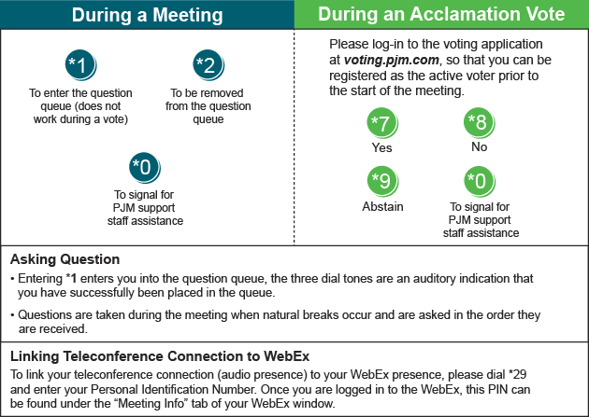

Provide feedback on the progress of this group: Facilitator Feedback Form
Visit learn.pjm.com, an easy-to-understand resource about the power industry and PJM’s role.

