Members Committee

Two Hundred Twenty-second Meeting

Webex Only

February 24, 2022

11:15 a.m. – 1:15 p.m. EPT

***\*Operator assisted phone lines will be opened 30 minutes prior to the start of the meeting. Due to the high volume of remote participation, stakeholders are asked to connect early to allow additional time for operator queue processing.***

Administration (11:15-11:25)

1. Announce sector selections of new members since the last meeting. – Dave Anders
2. Confirm the presence of a quorum of representatives or designated alternates for this meeting – Dave Anders
3. Anti-trust, Code of Conduct, Meeting Participation, and Safety announcements – Dave Anders

Consent Agenda (11:25-11:30)

1. **Approve** draft minutes of the January 26, 2022 Members Committee meeting.
2. **Approve** draft minutes of the February 2, 2022 Special Members Committee meeting.
3. **Approve/Endorse** proposed revisions to the Operating Agreement (OA) and Manual 15: Cost Development Guidelines addressing clarifications to Fuel Cost Policy standards and Schedule 2 Penalty revisions.

Reports (11:30-12:15)

1. Hill Energy Resource & Services Default Resolution (11:30-12:00)

PJM will present its plan for resolution of the defaulted portfolio.

1. MC Vice Chair Report (12:00-12:10)
2. Provide an update on the Members Committee Annual Plan – Becky Robinson
3. Provide a report on the February 14, 2022 Liaison Committee meeting with the PJM Board of Managers – Becky Robinson
4. Webinar Feedback (12:10-12:15)

Stakeholders may raise any items identified for further discussion from the February 22, 2022 Members Committee Webinar.

|  |
| --- |
| Future Agenda Items (12:15) |
|  |

|  |  |  |  |  |  |  |
| --- | --- | --- | --- | --- | --- | --- |
| **Future Meeting Dates and Materials** | | | | **Materials Due  to Secretary** | | **Materials Published** |
| Date | Time | Location |  | |  | |
| March 23, 2022 | 1:15 p.m. | WebEx | March 11, 2022 | | March 16, 2022 | |
| April 27, 2022 | 1:15 p.m. | TBD | April 15, 2022 | | April 20, 2022 | |
| May 17, 2022 | 10:00 a.m. | PJM Conference & Training Center and WebEx | May 5, 2022 | | May 10, 2022 | |
| June 29, 2022 | 1:15 p.m. | PJM Conference & Training Center and WebEx | June 17, 2022 | | June 22, 2022 | |

Author: M. Greening

Antitrust:

You may not discuss any topics that violate, or that might appear to violate, the antitrust laws including but not limited to agreements between or among competitors regarding prices, bid and offer practices, availability of service, product design, terms of sale, division of markets, allocation of customers or any other activity that might unreasonably restrain competition. If any of these items are discussed the chair will re-direct the conversation. If the conversation still persists, parties will be asked to leave the meeting or the meeting will be adjourned.

Code of Conduct:

As a mandatory condition of attendance at today's meeting, attendees agree to adhere to the PJM Code of Conduct as detailed in PJM Manual M-34 section 4.5, including, but not limited to, participants' responsibilities and rules regarding the dissemination of meeting discussion and materials.

Public Meetings/Media Participation:

Unless otherwise noted, PJM stakeholder meetings are open to the public and to members of the media. Members of the media are asked to announce their attendance at all PJM stakeholder meetings at the beginning of the meeting or at the point they join a meeting already in progress. Members of the Media are reminded that speakers at PJM meetings cannot be quoted without explicit permission from the speaker. PJM Members are reminded that "detailed transcriptional meeting notes" and white board notes from "brainstorming sessions" shall not be disseminated. Stakeholders are also not allowed to create audio, video or online recordings of PJM meetings. PJM may create audio, video or online recordings of stakeholder meetings for internal and training purposes, and your participation at such meetings indicates your consent to the same.

Participant Identification in Webex:

When logging into the Webex desktop client, please enter your real first and last name as well as a valid email address. Be sure to select the “call me” option.

PJM support staff continuously monitors Webex connections during stakeholder meetings. Anonymous users or those using false usernames or emails will be dropped from the teleconference.

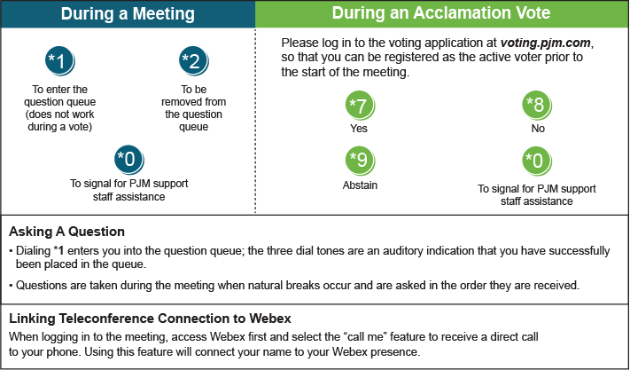

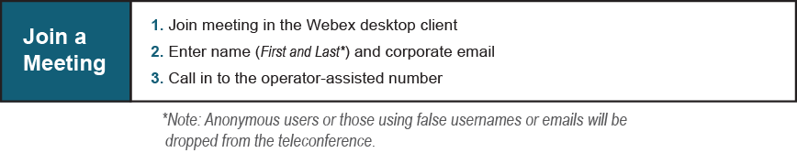

Provide feedback on the progress of this group: [*Facilitator Feedback Form*](https://www.pjm.com/committees-and-groups/committees/form-facilitator-feedback.aspx)   
Visit [*learn.pjm.com*](https://learn.pjm.com/), an easy-to-understand resource about the power industry and PJM’s role.