Market Implementation Committee
PJM Conference & Training Center, Audubon, PA
November 8, 2017
9:00 a.m. – 4:00 p.m. EPT

Administration (9:00-9:10)
Welcome, announcements and review of the Antitrust, Code of Conduct, and Public Meetings/Media Participation Guidelines – Ms. Christina Stotesbury and Ms. Chantal Hendrzak

The committee will be asked to approve draft minutes from the October 11, 2017 Market Implementation Committee meeting.

Ms. Christina Stotesbury, PJM, and Ms. Chantal Hendrzak, will review the active MIC issues on Issue Tracking and discuss potential paths and timelines for resolution.

Mr. Foluso Afelumo, PJM, will provide a brief update on security changes to the Account Manager tool.

Endorsements/Approvals (9:10-10:20)
- Proposed FTR Credit Requirements for Transmission Upgrades (9:10-9:20)
Mr. Hal Loomis, PJM, will review a proposed change in FTR credit requirements to reduce exposure posed by congestion reductions resulting from major transmission upgrades. The committee will be asked to endorse the proposal.

- Proposed changes to Price Responsive Demand for Capacity Performance requirements (9:20-10:00)
Mr. Pete Langbein, PJM, will review the proposals that came from the Demand Response Subcommittee to update Price Responsive Demand for Capacity Performance requirements. The committee will be asked to endorse a proposal.

- Manual 11, 18, 27, 28, and 29 Revisions for 5-minute Settlements (10:00-10:10)
Mr. Ray Fernandez, PJM, will present revisions to Manuals 11, 18, 27, 28, and 29 associated with the implementation of 5-Minute Settlements. The committee will be asked to endorse the manual revisions.

- Distributed Energy Resources (DER) Charter (10:10-10:20)
Mr. Scott Baker, PJM, will provide an update on the Distributed Energy Resource issue that has been worked at Special Sessions of the MIC, and present two charters to convert the effort to a subcommittee. The committee will be asked to endorse a charter.

Break (10:20-10:30)

First Readings (10:30-11:15)
- FTR Modeling, Performance & Surplus (10:30-11:00)
Mr. Brian Chmielewski, PJM, will present a first read of proposals that have been worked in the FTRMPS Special Sessions of the MIC.
- Long Term FTR Modeling Enhancements for Future Transmission Expansions
- FTR Auction Case Performance
- FTR Surplus
The committee will be asked to endorse a proposal for each issue at the December meeting.

- Seasonal DR Aggregation Registration Rules – Problem Statement and Issue Charge (11:00-11:15)
Ms. Katie Guerry, EnerNOC, will present a first read of a problem statement and issue charge to address the aggregation of summer and winter Demand Response MWs for the Capacity Performance Annual Requirement. The committee will be asked to endorse the problem statement and issue charge at the December meeting

Working Issues (11:15-12:15)
- Market Path/Interface Pricing Point Alignment (11:15-11:45)
Mr. John Dadourian, Monitoring Analytics, and Mr. Tim Horger, PJM, will review the Market Path/Interface Pricing Point Alignment issue and present a proposed solution. Stakeholders will be given an opportunity to offer interests, design components and solution options.

- Transmission Penalty Factors (11:45-12:15)
Mr. Devendra Canchi, Monitoring Analytics, will review the Transmission Penalty Factors issue and matrix. Stakeholders will be given an opportunity to offer interests and design components.

Lunch (12:15-1:00)

Additional Updates (1:00-2:00)
- Interregional Coordination Activity (1:00-1:15)
Mr. Phil D’Antonio, PJM, will provide an update on Interregional Coordination efforts.

- Operationalizing Gas Pipeline Contingencies (1:15-1:30)
Mr. Brian Fitzpatrick, PJM, will provide an update on continuing efforts to operationalize gas pipeline contingencies.

- Market Operations Price Transparency Issue (1:30-1:45)
Mr. Rami Dirani, PJM, will provide an update on the Market Operations Price Transparency issue worked in Special Sessions of the MIC.

- Net Energy Injections – Quarterly Report (1:45-2:00)
Ms. Jennifer Warner-Freeman, PJM, will review the 3rd Quarter Net Energy Injections report.

Informational Section
Credit Subcommittee (CS)
Meeting materials will be posted to the CS website.

Demand Response Subcommittee (DRS)
Meeting materials will be posted to the DRS web site.

Intermittent Resources Subcommittee (IRS)
Meeting materials will be posted to the IRS web site.

Market Settlements Subcommittee (MSS)
Meeting materials are posted to the MSS web site.

Report on Market Operations
The Report on Market Operations will be reviewed during the MC Webinar.

Future Meeting Dates
December 13, 2017 | 9:00 a.m. | PJM Interconnection – Conference & Training Center
January 10, 2018 | 9:00 a.m. | PJM Interconnection – Conference & Training Center
February 7, 2018 | 9:00 a.m. | PJM Interconnection – Conference & Training Center
March 7, 2018 | 9:00 a.m. | PJM Interconnection – Conference & Training Center
April 4, 2018 | 9:00 a.m. | PJM Interconnection – Conference & Training Center
May 2, 2018 | 9:00 a.m. | PJM Interconnection – Conference & Training Center
June 6, 2018 | 9:00 a.m. | PJM Interconnection – Conference & Training Center

Author: Christina Stotesbury

Antitrust:
You may not discuss any topics that violate, or that might appear to violate, the antitrust laws including but not limited to agreements between or among competitors regarding prices, bid and offer practices, availability of service, product design, terms of sale, division of markets, allocation of customers or any other activity that might unreasonably restrain competition. If any of these items are discussed the chair will re-direct the conversation. If the conversation still persists, parties will be asked to leave the meeting or the meeting will be adjourned.

Code of Conduct:
As a mandatory condition of attendance at today's meeting, attendees agree to adhere to the PJM Code of Conduct as detailed in PJM Manual 34 Section 4.5, including, but not limited to, participants' responsibilities and rules regarding the dissemination of meeting discussion and materials.

Public Meetings/Media Participation:
Unless otherwise noted, PJM stakeholder meetings are open to the public and to members of the media. Members of the media are asked to announce their attendance at all PJM stakeholder meetings at the beginning of the meeting or at the point they join a meeting already in progress. Members of the Media are reminded that speakers at PJM meetings cannot be quoted without explicit permission from the speaker. PJM Members are reminded that "detailed transcriptional meeting notes" and white board notes from "brainstorming sessions" shall not be disseminated. Stakeholders are also not allowed to create audio, video or online recordings of PJM meetings. PJM may create audio, video or online recordings of stakeholder meetings for internal and training purposes, and your participation at such meeting indicates your consent to the same.

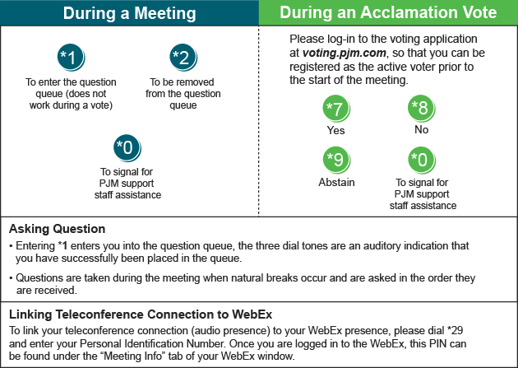

Provide feedback on the progress of this group: Facilitator Feedback Form
Visit learn.pjm.com, an easy-to-understand resource about the power industry and PJM’s role.

