Market Implementation Committee

WebEx Only

September 9, 2021

9:00 a.m. – 3:00 p.m. EPT

Administration (9:00 – 9:05)

Nicholas DiSciullo will review the Antitrust, Code of Conduct, Public Meetings/Media Participation and the WebEx Participant Identification Requirements.

The Committee will be asked to approve the draft minutes from the August 11, 2021 Market Implementation Committee meeting.

Reactive Power Compensation Plan Update

Endorsements/Approvals (9:05 – 10:25)

1. Manual 15 Revisions - Incremental & No Load Energy Offer (9:05 – 9:20)

Tom Hauske will provide an overview of the Manual 15: Cost Development Guidelines revisions that were developed in the CDS.

The committee will be asked to endorse the Manual 15 revisions at this meeting.

1. Regional Transmission and Energy Scheduling Practices Revisions (9:20 – 9:30)

Chris Pacella will provide an overview of revisions to the Regional Transmission and Energy Scheduling Practices document.

The committee will be asked to endorse the revisions at this meeting.

1. RPM Capacity Transfer Rights (9:30 – 9:55)

Kevin Zemanek, Buckeye Power, will review the Buckeye proposal.

The committee will be asked to endorse the proposal at this meeting.

[Issue Tracking: Capacity Transfer Rights in RPM](https://www.pjm.com/committees-and-groups/issue-tracking/issue-tracking-details.aspx?Issue=%7b459A68BA-82B9-4199-8CCF-950FA0C74DDF%7d)

1. Undefined Regulation Mileage Ratio Calculation (9:55 – 10:25)
2. Michael Olaleye will review the PJM proposal.
3. Joe Bowring, IMM, will review the IMM proposal.

The committee will be asked to endorse the PJM and IMM proposals at this meeting.

[Issue Tracking: Undefined Regulation Mileage Ratio Calculation](https://www.pjm.com/committees-and-groups/issue-tracking/issue-tracking-details.aspx?Issue=8f567a45-cd61-4d1c-97dd-cc2d3bd772ee)

First Readings (10:25 – 12:50)

1. Peak Shaving Plan: Performance Rating (10:25 – 10:45)

Ed Rich will provide a first read of the Problem Statement and Issue Charge and solution addressing the Peak Shaving Adjustment shortfall calculation.

The committee will be asked to approve the issue charge and endorse the solution as part of the Quick Fix process outlined in Section 8.6.1 of Manual 34 at its next meeting.

1. Energy Efficiency (EE) Addback (10:45 – 11:20)
2. Jeff Bastian will provide a first read of the IMM/PJM proposal addressing the calculation of the EE Addback.
3. Lisa Morelli will facilitate a discussion on the CBIR matrix. While the PJM/IMM package is being presented as a first read in support of the expedited treatment of this issue charge, additional solution options and proposals may still be provided prior to and during the meeting.

[Issue Tracking: Energy Efficiency Addback](https://www.pjm.com/committees-and-groups/issue-tracking/issue-tracking-details.aspx?Issue=38674ff9-a78e-4b7d-b8ab-96d05bd7ef21)

1. ARR/FTR Market Task Force Update (11:20 – 12:50)
2. Dave Anders and Brian Chmielewski will provide an overview of the activities of the task force and proposals developed through the ARR/FTR Market Task Force. Brian will provide additional detail on the PJM/Joint Stakeholder proposal.
3. Joe Bowring, IMM, will provide additional detail on the IMM proposal.
4. Additional stakeholder proposals will be presented.

Lunch (12:50 – 1:20)

Working Items (1:20 – 1:50)

1. Regulation for Virtual Combined Cycles (1:20 – 1:50)

Lisa Morelli will facilitate a discussion to identify solution options for the Regulation for Virtual Combined Cycles issue charge as part of the Consensus Based Issue Resolution process. Additional interests and design components can be provided in advance of the meeting.

[Issue Tracking: Regulation for Virtual Combined Cycles](https://www.pjm.com/committees-and-groups/issue-tracking/issue-tracking-details.aspx?Issue=4156560d-cfb4-45e6-aacd-33ec5c9447ed)

Additional Items (1:50 – 3:00)

1. Parameter Limited Schedules / Real-Time Values (1:50 – 2:05)

Keyur Patel and Lauren Strella Wahba will provide an update on PJM’s approach for a response to FERC on Parameter Limited Schedules and Real Time Values. Stakeholders are invited to provide feedback on the draft Tariff redlines related to submission of real time values that PJM intends to propose as part of its Answer to the Show Cause Order.

1. 2022 PJM Project Budget (2:05 – 2:20)

Jim Snow will provide an update on the preliminary 2022 project budget.

1. nGEM Project Update (2:20 – 2:35)

Ray Fernandez will provide an update on the Next Generation Energy Market (nGEM) Software replacement project.

1. Capacity Market Seller Offer Cap Order and Revised Auction Timelines (2:35 – 3:00)

Chen Lu will provide an overview of the Capacity Market Seller Offer Cap order FERC recently issued in Docket Nos. EL-19-47, EL19-63 and ER21-2444. Pete Langbein will present and solicit feedback on draft timelines for the pre-auction activities for the upcoming December Base Residual Auction which are impacted by this order and the timing of the auction itself.

Informational Section

**ARR FTR Market Task Force (AFMTF)**   
Meeting materials are posted to the [AFMTF website](https://www.pjm.com/committees-and-groups/task-forces/afmtf).

**Cost Development Subcommittee (CDS)**   
Meeting materials are posted to the [CDS website](https://www.pjm.com/committees-and-groups/subcommittees/cds).

**Demand Response Subcommittee (DRS)**   
Meeting materials are posted to the [DRS website](http://www.pjm.com/committees-and-groups/subcommittees/drs.aspx).

**DER & Inverter-based Resources Subcommittee (DIRS)**

Meeting materials are posted to the [DIRS website.](https://www.pjm.com/committees-and-groups/subcommittees/dirs.aspx)

**Market Settlements Subcommittee (MSS)**

Meeting materials are posted to the [MSS website](http://www.pjm.com/committees-and-groups/subcommittees/mss.aspx).

Report on Market Operations

The Report on Market Operations will be reviewed during the [MC Webinar](http://www.pjm.com/committees-and-groups/committees/mc.aspx).

|  |  |  |  |  |
| --- | --- | --- | --- | --- |
| **Future Meeting Dates and Materials** | | | **Materials Due  to Secretary** | **Materials Published** |
| Date | Time | Location | 5 p.m. | 4 p.m. |
| October 6 | 9 a.m. | WebEx | September 24 | September 29 |
| November 3 | 9 a.m. | WebEx | October 22 | October 27 |
| December 1 | 9 a.m. | WebEx | November 19 | November 24 |

Author: Nicholas DiSciullo

Antitrust:

You may not discuss any topics that violate, or that might appear to violate, the antitrust laws including but not limited to agreements between or among competitors regarding prices, bid and offer practices, availability of service, product design, terms of sale, division of markets, allocation of customers or any other activity that might unreasonably restrain competition. If any of these items are discussed the chair will re-direct the conversation. If the conversation still persists, parties will be asked to leave the meeting or the meeting will be adjourned.

Code of Conduct:

As a mandatory condition of attendance at today's meeting, attendees agree to adhere to the PJM Code of Conduct as detailed in PJM Manual M-34 section 4.5, including, but not limited to, participants' responsibilities and rules regarding the dissemination of meeting discussion and materials.

Public Meetings/Media Participation:

Unless otherwise noted, PJM stakeholder meetings are open to the public and to members of the media. Members of the media are asked to announce their attendance at all PJM stakeholder meetings at the beginning of the meeting or at the point they join a meeting already in progress. Members of the Media are reminded that speakers at PJM meetings cannot be quoted without explicit permission from the speaker. PJM Members are reminded that "detailed transcriptional meeting notes" and white board notes from "brainstorming sessions" shall not be disseminated. Stakeholders are also not allowed to create audio, video or online recordings of PJM meetings. PJM may create audio, video or online recordings of stakeholder meetings for internal and training purposes, and your participation at such meetings indicates your consent to the same.

Participant Identification in WebEx:

When logging into the WebEx desktop client, please enter your real first and last name as well as a valid email address. Be sure to select the “call me” option.

PJM support staff continuously monitors WebEx connections during stakeholder meetings. Anonymous users or those using false usernames or emails will be dropped from the teleconference.

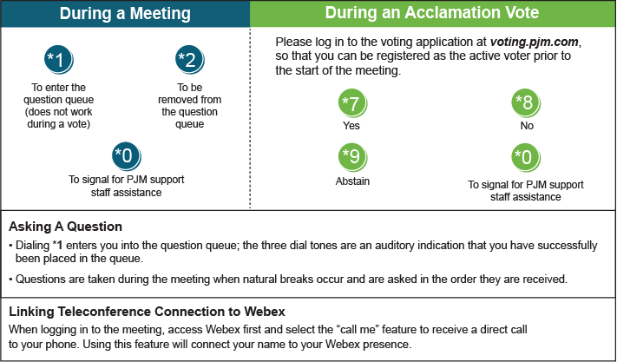

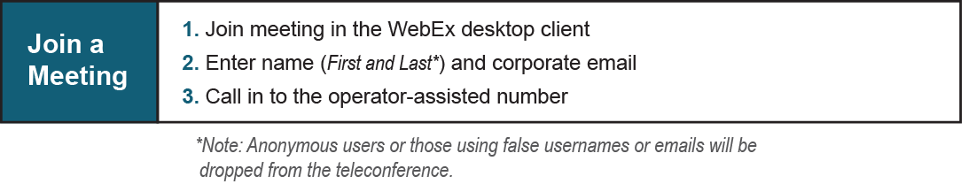

Provide feedback on the progress of this group: [*Facilitator Feedback Form*](https://www.pjm.com/committees-and-groups/committees/form-facilitator-feedback.aspx)   
Visit [*learn.pjm.com*](https://learn.pjm.com/), an easy-to-understand resource about the power industry and PJM’s role.