Market Implementation Committee

WebEx / Conference & Training Center

October 6, 2022

9:00 a.m. – 4:00 p.m. EPT

Administration (9:00 – 9:10)

Amanda Martin will review the Antitrust, Code of Conduct, Public Meetings/Media Participation and the WebEx Participant Identification Requirements.

The Committee will be asked to approve the draft minutes from the September 7, 2022 Market Implementation Committee.

1. Amanda Martin will review the MIC Work Plan and MIC Charter. Stakeholders will have the opportunity to offer feedback or revisions on the Work Plan and Charter.

Endorsements/Approvals (9:10 – 9:40)

1. Operating Reserve Clarification for Resources Operating as Requested by PJM (9:10 – 9:25)

Lisa Morelli will review a proposal to proceed with removal of the CT Rule in Manual 28: Operating Agreement Accounting.

The committee will be asked to endorse the proposal at this meeting.

[Issue Tracking: Operating Reserve Clarification for Resources Operating as Requested by PJM](https://www.pjm.com/committees-and-groups/issue-tracking/issue-tracking-details.aspx?Issue=6897c7e7-d8b7-438e-9e3f-b6099f9dd7ec)

1. Critical Natural Gas Infrastructure – Demand Response Participation (9:25 – 9:40)

Jack O’Neill will review manual revisions addressing prohibition of Critical Natural Gas Infrastructure load as a demand response resource.  This proposal was developed at the Demand Response Subcommittee pursuant to recommendations included in the FERC/NERC report on the severe cold weather event in Texas and South Central US in February 2021.

**The committee will be asked to endorse the proposal at this meeting**.

[Issue Tracking: Critical Gas Infrastructure – Demand Response Participation](https://pjm.com/committees-and-groups/issue-tracking/issue-tracking-details.aspx?Issue=826f9f52-5517-48ab-a3e1-546616fc767d)

First Readings (9:40 – 11:25)

1. Manual 27 Periodic Review (9:40 – 9:55)

Rebecca Stadelmeyer will review revisions to Manual 27: Open Access Transmission Tariff Accounting as part of the periodic review. The committee will be asked to endorse the revisions at its next meeting.

1. Local Considerations in Net Cost of New Entry (CONE) (9:55 – 10:25)

Gary Helm will provide a first read of a Problem Statement and Issue Charge addressing how local considerations may affect the development of Net CONE. The committee will be asked to approve the issue charge at its next meeting.

1. Demand Response Subcommittee (DRS) and DER & Inverter-based Resources Subcommittee (DIRS) Consolidation (10:25 – 10:55)

Scott Baker and Pete Langbein will review a request to sunset the DIRS and DRS and consolidate the work of the two groups under a new MIC subcommittee. A first read of the new subcommittee draft charter will be provided. The committee will be asked to approve the new charter and approve the sunset of the DIRS and DRS at its next meeting.

1. Hybrid Resources Phase II (10:55 – 11:25)

Andrew Levitt will provide a first read of the package detailing the Hybrid Resources Phase II solutions. The committee will be asked to endorse the package at its next meeting.

[Issue Tracking: Solar-Battery Hybrid Resources](https://www.pjm.com/committees-and-groups/issue-tracking/issue-tracking-details.aspx?Issue=3423b18c-59c2-49dd-84c5-af42b1ba0256)

Working Items (11:25 – 12:40)

1. Operating Reserve Clarification for Resources Operating as Requested by PJM (11:25 – 12:10)

Joel Luna, IMM, will provide education surrounding the impact of negative day-ahead and real-time LMPs in the calculation of the balancing operating reserve credits.

[Issue Tracking: Operating Reserve Clarification for Resources Operating as Requested by PJM](https://www.pjm.com/committees-and-groups/issue-tracking/issue-tracking-details.aspx?Issue=f9b3dbf5-4149-4ea6-9ad3-0c452ff9f386)

1. Day-ahead Zonal Load Bus Distribution Factors (12:10 – 12:40)

Lisa Morelli will facilitate a discussion to solicit design components, design component options and packages addressing Day-ahead Zonal Load Bus Distribution Factors.

[Issue Tracking: Day-ahead Zonal Load Bus Distribution Factors](https://pjm.com/committees-and-groups/issue-tracking/issue-tracking-details.aspx?Issue=6657e9e9-4bca-41d3-b5a1-9468b7964475)

Lunch (12:40 – 1: 40)

Additional Items (1:40 – 4:00)

1. Variable Operating & Maintenance Cost Development (1:40 – 1:55)

Roger Cao will review conforming revisions to Manual 15: Cost Development Guidelines and the Operating Agreement. The revisions reflect the PJM proposal on variable operating and maintenance costs that was developed through the Cost Development Subcommittee and endorsed at the August MIC.

[Issue Tracking: Variable Operating and Maintenance Cost](https://www.pjm.com/committees-and-groups/issue-tracking/issue-tracking-details.aspx?Issue=d756f89d-17d7-4559-b1fe-b59e81049da2)

1. Cost Development Subcommittee Update (1:55 – 2:00)

Nicole Scott will provide an informational update on the work to be performed at the Cost Development Subcommittee.

1. Default Cost of New Entry (CONE) and default Avoidable Cost Rate (ACR) Values Periodic Review (2:00 – 3:30)
   1. Skyler Marzewski will present an overview of the default CONE and default ACR values, the proposed approach for conducting the required periodic review of default CONE and default ACR values, and solicit input on the approach.
   2. Sam Newell, Brattle, will provide a review of the default Avoidable Cost Rates (ACRs) and their approach to calculate the default ACRs.
2. Fuel Requirements for Black Start Resources (3:30 – 4:00)

Tom Hauske and Dave Kimmel will review revisions to Manual 27: Open Access Transmission Tariff Accounting, Manual 12: Balancing Operations, and Schedule 6A of the OATT for the Fuel Requirements for Black Start Resources. These revisions conform with the PJM/Brookfield/DCOPC proposal, which was endorsed with 76% support in the offline MIC/OC vote.  The proposal and these revisions are scheduled for a vote at the October 24 MRC meeting. [Issue Tracking: Fuel Requirements for Black Start Resources](https://pjm.com/committees-and-groups/issue-tracking/issue-tracking-details.aspx?Issue=b7f726e1-9f06-414e-8516-4d69b5050af4)

Informational Section

Manual 3 Updates

Periodic review updates to Manual 3: Transmission Operations are posted as informational only with meeting materials

Fast Start Pricing Monthly Metrics Update

~~Materials are posted as informational only.~~

Fast Start Pricing Metrics will no longer be provided with MIC materials since it has been one year since implementation. Metrics can be found in the IMM Report on the [MC Webinar](https://pjm.com/committees-and-groups/committees/mc) page.

Interregional Coordination Update

Materials are posted as informational only.

Stability Limits in Markets and Operations

Materials are posted as informational only.

ARR FTR Market Task Force (AFMTF)   
Meeting materials are posted to the [AFMTF website](https://www.pjm.com/committees-and-groups/task-forces/afmtf).

Regulation Market Design Senior Task Force (RMDSTF)

Meeting materials are posted to the [RMDSTF website](https://www.pjm.com/committees-and-groups/task-forces/rmdstf).

Reactive Power Compensation Task Force (RPCTF)   
Meeting materials are posted to the [RPCTF website.](https://www.pjm.com/committees-and-groups/task-forces/rpctf)

Cost Development Subcommittee (CDS)   
Meeting materials are posted to the [CDS website](https://www.pjm.com/committees-and-groups/subcommittees/cds).

Demand Response Subcommittee (DRS)   
Meeting materials are posted to the [DRS website](http://www.pjm.com/committees-and-groups/subcommittees/drs.aspx).

DER & Inverter-based Resources Subcommittee (DIRS)

Meeting materials are posted to the [DIRS website.](https://www.pjm.com/committees-and-groups/subcommittees/dirs.aspx)

Market Settlements Subcommittee (MSS)

Meeting materials are posted to the [MSS website](http://www.pjm.com/committees-and-groups/subcommittees/mss.aspx).

OC/MIC Fuel Requirements for Black Start Resources

Meeting materials are posted to the [Operating Committee website](https://www.pjm.com/committees-and-groups/committees/oc).

Report on Market Operations

The Report on Market Operations will be reviewed during the [MC Webinar](http://www.pjm.com/committees-and-groups/committees/mc.aspx).

|  |  |  |  |  |
| --- | --- | --- | --- | --- |
| **Future Meeting Dates and Materials** | | | **Materials Due  to Secretary** | **Materials Published** |
| Date | Time | Location | 5 p.m. | 4 p.m. |
| November 2 | 9 a.m. | WebEx / Conference & Training Center | October 21 | October 26 |
| December 7 | 9 a.m. | WebEx / Conference & Training Center | November 23 | November 30 |

Author: Amanda Martin

Antitrust:

You may not discuss any topics that violate, or that might appear to violate, the antitrust laws including but not limited to agreements between or among competitors regarding prices, bid and offer practices, availability of service, product design, terms of sale, division of markets, allocation of customers or any other activity that might unreasonably restrain competition. If any of these items are discussed the chair will re-direct the conversation. If the conversation still persists, parties will be asked to leave the meeting or the meeting will be adjourned.

Code of Conduct:

As a mandatory condition of attendance at today's meeting, attendees agree to adhere to the PJM Code of Conduct as detailed in PJM Manual M-34 section 4.5, including, but not limited to, participants' responsibilities and rules regarding the dissemination of meeting discussion and materials.

Public Meetings/Media Participation:

Unless otherwise noted, PJM stakeholder meetings are open to the public and to members of the media. Members of the media are asked to announce their attendance at all PJM stakeholder meetings at the beginning of the meeting or at the point they join a meeting already in progress. Members of the Media are reminded that speakers at PJM meetings cannot be quoted without explicit permission from the speaker. PJM Members are reminded that "detailed transcriptional meeting notes" and white board notes from "brainstorming sessions" shall not be disseminated. Stakeholders are also not allowed to create audio, video or online recordings of PJM meetings. PJM may create audio, video or online recordings of stakeholder meetings for internal and training purposes, and your participation at such meetings indicates your consent to the same.

Participant Identification in WebEx:

When logging into the WebEx desktop client, please enter your real first and last name as well as a valid email address. Be sure to select the “call me” option.

PJM support staff continuously monitors WebEx connections during stakeholder meetings. Anonymous users or those using false usernames or emails will be dropped from the teleconference.

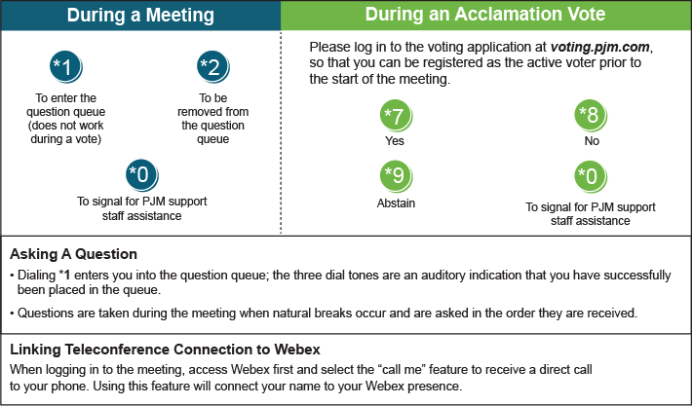

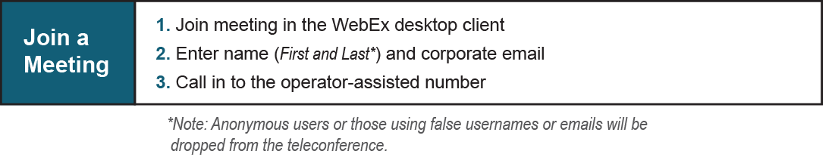

Provide feedback on the progress of this group: [*Facilitator Feedback Form*](https://www.pjm.com/committees-and-groups/committees/form-facilitator-feedback.aspx)   
Visit [*learn.pjm.com*](https://learn.pjm.com/), an easy-to-understand resource about the power industry and PJM’s role.