Markets and Reliability Committee
Webex Only
September 17, 2020
9:00 a.m. – 11:50 a.m.
*Operator assisted phone lines will be opened 30 minutes prior to the start of the meeting. Due to the high volume of remote participation, stakeholders are asked to connect early to allow additional time for operator queue processing.

Administration (9:00-9:05)
Welcome, announcements and Anti-trust, Code of Conduct, and Public Meetings/Media Participation – Stu Bresler and Dave Anders

Consent Agenda (9:05-9:10)
- Approve minutes of the August 20, 2020 meeting of the Markets and Reliability Committee (MRC).

Endorsements/Approvals (9:10-10:40)
- Cost Development Subcommittee (9:10-9:20)
Glen Boyle will review proposed revisions to the Cost Development Subcommittee charter. The committee will be asked to endorse the revised charter.

- Critical Infrastructure Stakeholder Oversight Senior Task Force (9:20-9:40)
This item has been removed.
- PMU Placement in RTEP Planning Process (9:20-9:50)
Shaun Murphy will review proposed revisions to Manual 01: Control Center and Data Exchange Requirements and Manual 14B: PJM Region Transmission Planning Process addressing PMU Placement in RTEP Planning Process. Friendly amendments have been posted and will be reviewed. The committee will be asked to endorse the Manual revisions.
Issue Tracking: RTEP Phasor Measurement Unit (PMU) Placement

- Capacity Capability Senior Task Force Proposed Solutions (9:50-10:40)
Melissa Pilong will provide an update of the work completed at the Capacity Capability Senior Task Force (CCSTF).
Issue Tracking: Effective Load Carrying Capability for Limited Duration Resources and Intermittent Resources
- Andrew Levitt will review the main motion endorsed by the CCSTF, Package A.
- Betty Watson, Modern Energy, will review the alternative solution endorsed by the CCSTF, Package D.
The committee will be asked to endorse a proposed solution and corresponding Reliability Assurance Agreement (RAA) revisions. Members Committee endorsement will be sought on the same day.

First Readings (10:40-11:40)
- 2020 Installed Reserve Margin Study Results (10:40-10:55)
Tom Falin will review the 2020 Reserve Requirement Study results (IRM, FPR). The committee will be asked to endorse the study results at its next meeting.
- Liquidation Process (10:55-11:20)
Nigeria Bloczynski will review proposed revisions addressing a path forward for PJM’s default management process. The committee will be asked to approve/endorse the proposed revisions at its next meeting.
Issue Tracking: Financial Risk Mitigation
- PJM Manuals (11:20-11:40)
  - Gabrielle Genuario and Roger Cao will review proposed revisions to Manual 15 as part of the Biennial Review. The committee will be asked to endorse the proposed revisions at its next meeting.

Informational Reports (11:40-11:50)
- Remedial Action Scheme Retirement (11:40-11:50)
Chris Szmodis, PPL, will review the retirement of the Susquehanna Catty Corner Remedial Action Scheme (RAS).

Informational Posting Only
- PJM Manual 03: Transmission Operations, Attachment E: Automatic Sectionalizing Schemes
Automatic Sectionalizing Schemes Pending Approval and Recent Changes have been posted with today’s meeting materials.

Future Agenda Items (11:50)

Future Meeting Dates
October 29, 2020 | 9:00 a.m. | PJM Conference & Training Center/ WebEx
November 19, 2020 | 9:00 a.m. | PJM Conference & Training Center/ WebEx
December 17, 2020 | 9:00 a.m. | PJM Conference & Training Center/ WebEx

Author: M. Greening

Antitrust:
You may not discuss any topics that violate, or that might appear to violate, the antitrust laws including but not limited to agreements between or among competitors regarding prices, bid and offer practices, availability of service, product design, terms of sale, division of markets, allocation of customers or any other activity that might unreasonably restrain competition. If any of these items are discussed the chair will re-direct the conversation. If the conversation still persists, parties will be asked to leave the meeting or the meeting will be adjourned.

Code of Conduct:
As a mandatory condition of attendance at today's meeting, attendees agree to adhere to the PJM Code of Conduct as detailed in PJM Manual M-34 section 4.5, including, but not limited to, participants' responsibilities and rules regarding the dissemination of meeting discussion and materials.

Public Meetings/Media Participation:
Unless otherwise noted, PJM stakeholder meetings are open to the public and to members of the media. Members of the media are asked to announce their attendance at all PJM stakeholder meetings at the beginning of the meeting or at the point they join a meeting already in progress. Members of the Media are reminded that speakers at PJM meetings cannot be quoted without explicit permission from the speaker. PJM Members are reminded that "detailed transcriptional meeting notes" and white board notes from "brainstorming sessions" shall not be disseminated. Stakeholders are also not allowed to create audio, video or online recordings of PJM meetings. PJM may create audio, video or online recordings of stakeholder meetings for internal and training purposes, and your participation at such meetings indicates your consent to the same.
Participant Identification in WebEx:
When logging into the WebEx desktop client, please enter your real first and last name as well as a valid email address. Be sure to select the “call me” option.
PJM support staff continuously monitors WebEx connections during stakeholder meetings. Anonymous users or those using false usernames or emails will be dropped from the teleconference.

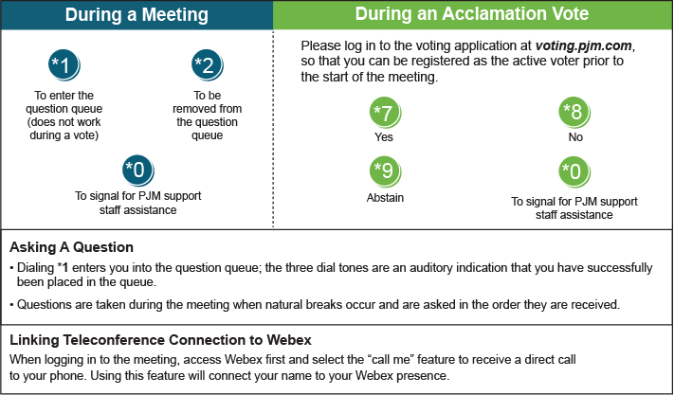

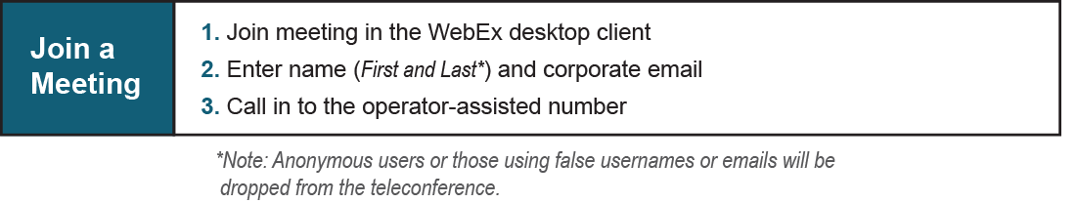
Provide feedback on the progress of this group: Facilitator Feedback Form
Visit learn.pjm.com, an easy-to-understand resource about the power industry and PJM’s role.

