Markets and Reliability Committee
Webex Only
March 29, 2021
9:00 a.m. – 11:15 a.m.
*Operator assisted phone lines will be opened 30 minutes prior to the start of the meeting. Due to the high volume of remote participation, stakeholders are asked to connect early to allow additional time for operator queue processing.

Administration (9:00-9:05)
Welcome, announcements and Anti-trust, Code of Conduct, and Public Meetings/Media Participation – Stu Bresler and Dave Anders

Consent Agenda (9:05-9:10)
- Approve minutes of the February 24, 2021 meeting of the Markets and Reliability Committee (MRC).
- Endorse proposed revisions to Manual 02: Transmission Service Request resulting from its periodic cover-to-cover review.
- Endorse proposed revisions to Manual 11: Energy & Ancillary Service Market Operations resulting from its periodic cover-to-cover review.
- Endorse proposed revisions to Manual 37: Reliability Coordination resulting from its periodic cover-to-cover review.
- Approve proposed revisions to remove the TLR buy-through congestion process from Schedule 1, Section 1.10.6A of the Operating Agreement.
Issue Tracking: Transmission Loading Relief (TLF) Buy-Through

Endorsements/ Approvals
None

First Readings (9:10-11:20)
- Long-Term 5-Minute Dispatch & Pricing (9:10-9:30)
Aaron Baizman will review the proposed solution and associated Tariff revisions addressing the Long-Term Five Minute Dispatch & Pricing changes. The committee will be asked to endorse the proposed solutions at its next meeting. Members Committee endorsement will be sought on the same day.
Issue Tracking: Five Minute Dispatch and Pricing

- Capital Recovery Factor for Avoidable Project Investment Cost Determinations (9:30-9:50)
Jeff Bastian will review the proposed solution and associated Tariff revisions addressing the Capital Recovery Factor for Avoidable Project Investment Cost Determinations. The committee will be asked to approve the proposed solution at its next meeting. Members Committee endorsement will be sought on the same day.
Issue Tracking: Capital Recover Factor (CRF) for Avoidable Project Investment Cost Determinations (APIR)
- Critical Infrastructure Stakeholder Oversight (CISO) (9:50-10:30)
  - Christina Stotesbury will provide an overview of the CISO work activities and timeline.
  - Mike Herman will review the proposed solutions to address the Mitigation and Avoidance of future CIP-014 facilities.
  - Pauline Foley will review Operating Agreement revisions supporting the solutions.
The committee will be asked to endorse the proposed Mitigation solution and the proposed Avoidance solution at its next meeting.
Issue Tracking: Critical Infrastructure Stakeholder Oversight
- Interconnection Construction Service Agreement Superseding Language and Automatic Termination Provision (10:30-10:50)
Mark Sims will review a proposed solution and associated Tariff revisions addressing concerns associated with the pro forma Interconnection Construction Service Agreement’s (a) lack of superseding language and (b) current automatic termination provision. The committee will be asked to endorse the proposed solution at its next meeting.
- PJM Manuals (10:50-11:00)
- Chris Franks will review proposed revisions to Manual 14D: Generator Operational Requirements, Section 5.3.7 regarding the Resource Tracker Ownership Confirmation Requirement. The committee will be asked to endorse the proposed solution at its next meeting.
Issue Tracking: Resource Tracker Ownership Confirmation Requirement

Informational Reports (11:00-11:15)
- High Voltage Direct Current Senior Task Force (HVDCSTF) Update (11:00-11:15)
Lisa Krizenoskas will provide an update regarding the status of the HVDCSTF.
Issue Tracking: Integration of HVDC Converter as a New Type of Capacity Resource

Future Agenda Items (11:15)

Future Meeting Dates
April 21, 2021 | 9:00 a.m. | WebEx
May 26, 2021 | 9:00 a.m. | WebEx
June 23, 2021 | 9:00 a.m. | WebEx
July 28, 2021 | 9:00 a.m. | TBD
August 25, 2021 | 9:00 a.m. | TBD
September 29, 2021 | 9:00 a.m. | TBD
October 20, 2021 | 9:00 a.m. | TBD
November 17, 2021 | 9:00 a.m. | TBD
December 15, 2021 | 9:00 a.m. | TBD

Author: M. Greening

Antitrust:
You may not discuss any topics that violate, or that might appear to violate, the antitrust laws including but not limited to agreements between or among competitors regarding prices, bid and offer practices, availability of service, product design, terms of sale, division of markets, allocation of customers or any other activity that might unreasonably restrain competition. If any of these items are discussed the chair will re-direct the conversation. If the conversation still persists, parties will be asked to leave the meeting or the meeting will be adjourned.

Code of Conduct:
As a mandatory condition of attendance at today's meeting, attendees agree to adhere to the PJM Code of Conduct as detailed in PJM Manual M-34 section 4.5, including, but not limited to, participants' responsibilities and rules regarding the dissemination of meeting discussion and materials.

Public Meetings/Media Participation:
Unless otherwise noted, PJM stakeholder meetings are open to the public and to members of the media. Members of the media are asked to announce their attendance at all PJM stakeholder meetings at the beginning of the meeting or at the point they join a meeting already in progress. Members of the Media are reminded that speakers at PJM meetings cannot be quoted without explicit permission from the speaker. PJM Members are reminded that "detailed transcriptional meeting notes" and white board notes from "brainstorming sessions" shall not be disseminated. Stakeholders are also not allowed to create audio, video or online recordings of PJM meetings. PJM may create audio, video or online recordings of stakeholder meetings for internal and training purposes, and your participation at such meetings indicates your consent to the same.
Participant Identification in Webex:
When logging into the Webex desktop client, please enter your real first and last name as well as a valid email address. Be sure to select the “call me” option.
PJM support staff continuously monitors Webex connections during stakeholder meetings. Anonymous users or those using false usernames or emails will be dropped from the teleconference.

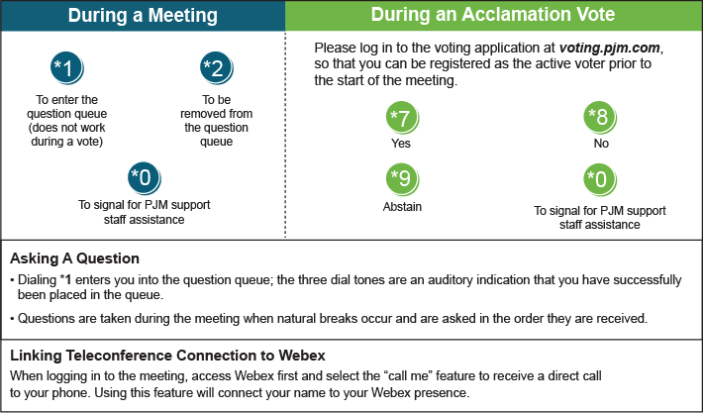

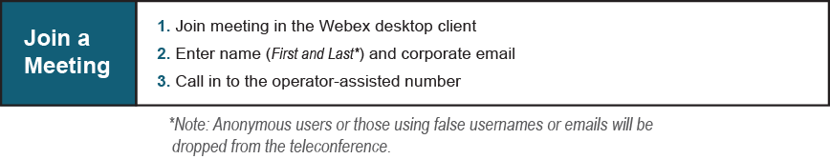
Provide feedback on the progress of this group: Facilitator Feedback Form
Visit learn.pjm.com, an easy-to-understand resource about the power industry and PJM’s role.

