OC Special Session – Dynamic Line Ratings
WebEx Only
March 30, 2021
1:00 p.m. – 5:00 p.m. EPT

Administration (1:00-1:15)
Alexandra Scheirer, secretary, will welcome participants, make announcements, and review the Antitrust, Code of Conduct, and Public Meetings/Media Participation Guidelines.
Janell Fabiano, facilitator, and Eric Hsia, PJM, will make opening remarks.

Education (1:15-4:10)
Dynamic Line Ratings Overview
Shaun Murphy, PJM, will provide an overview of the dynamic line ratings technology and the history of dynamic line ratings in PJM.
EMS and eDART Functionality Education
Dave Hislop, PJM, and Ryan Nice, PJM, will provide education the current and planned functionality in EMS and eDART to accommodate dynamic line ratings.
Operations Contingency and Outage Impacts Education
Dave Hislop, PJM, will provide education on the impacts of dynamic line ratings on operations contingency and outages.
Transmission Planning Impacts Education
Julia Spatafore, PJM, will provide education on the impacts of dynamic line ratings on transmission planning
Modeling Dynamic Line Ratings in Markets Education
Tim Horger, PJM, will provide education on modeling hourly dynamic line ratings in the Real-Time, Day-Ahead and FTR markets.
Modeling Dynamic Line Ratings Markets Efficiency Planning Process Education
Nick Dumitriu, PJM, will provide education on modeling hourly dynamic line ratings in the Market Efficiency planning process.
Dynamic Line Ratings NOPR Update
Jim Burlew, PJM, will provide an update on PJM’s comments on the FERC NOPR concerning dynamic line ratings.
Dynamic Line Ratings Education
Joe Bowring, IMM, will provide education on Dynamic Line Ratings.
Installation Considerations Education
Bill Skumanich, RTR Energy Solutions, and Joey Alexander, Ampacimon, will provide education on dynamic line ratings installation considerations.

Next Steps (4:10-4:20)
Darlene Phillips, OC Chair, will discuss issue timelines and next steps.
Author: Alexandra Scheirer

Antitrust:
You may not discuss any topics that violate, or that might appear to violate, the antitrust laws including but not limited to agreements between or among competitors regarding prices, bid and offer practices, availability of service, product design, terms of sale, division of markets, allocation of customers or any other activity that might unreasonably restrain competition. If any of these items are discussed the chair will re-direct the conversation. If the conversation still persists, parties will be asked to leave the meeting or the meeting will be adjourned.

Code of Conduct:
As a mandatory condition of attendance at today's meeting, attendees agree to adhere to the PJM Code of Conduct as detailed in PJM Manual M-34 section 4.5, including, but not limited to, participants' responsibilities and rules regarding the dissemination of meeting discussion and materials.
Public Meetings/Media Participation:
Unless otherwise noted, PJM stakeholder meetings are open to the public and to members of the media. Members of the media are asked to announce their attendance at all PJM stakeholder meetings at the beginning of the meeting or at the point they join a meeting already in progress. Members of the Media are reminded that speakers at PJM meetings cannot be quoted without explicit permission from the speaker. PJM Members are reminded that "detailed transcriptional meeting notes" and white board notes from "brainstorming sessions" shall not be disseminated. Stakeholders are also not allowed to create audio, video or online recordings of PJM meetings. PJM may create audio, video or online recordings of stakeholder meetings for internal and training purposes, and your participation at such meetings indicates your consent to the same.
Participant Identification in Webex:
When logging into the Webex desktop client, please enter your real first and last name as well as a valid email address. Be sure to select the “call me” option.
PJM support staff continuously monitors Webex connections during stakeholder meetings. Anonymous users or those using false usernames or emails will be dropped from the teleconference.



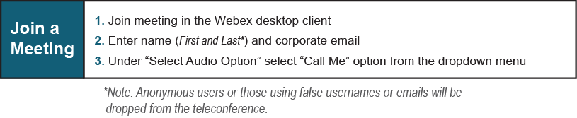
Provide feedback on the progress of this group: Facilitator Feedback Form
Visit learn.pjm.com, an easy-to-understand resource about the power industry and PJM’s role.

