September Planning Committee
Teleconference / WebEx
September 1, 2020
9:00 a.m. – 12:00 p.m. EPT

Administration (9:00 – 9:15)
- Welcome, announcements and review of the Anti-trust, Code of Conduct, and Media Participation Guidelines.
- Approve Planning Committee (PC) Agenda for this meeting
- Approve draft minutes from the August 4th, 2020 PC meeting

Endorsements ( )

First Reads (9:15 – 10:15)
- 2020 Installed Reserve Margin Study Results
Patricio Rocha Garrido, PJM, will review the 2020 Reserve Requirement Study results (IRM, FPR). The Committee will be requested to endorse the study results at its next meeting.

- Critical Infrastructure Stakeholder Update
Christina Stotesbury, PJM, will provide an update on CISO activies. Package sponsors will present a first read of their proposals to address both the Mitigation and Avoidance of future CIP-014 facilities.
Issue Tracking: Critical Infrastructure Stakeholder Oversight

Informational Updates (10:15 – 12:00)
- Remedial Action Scheme Retirement
Chris Szmodis, PPL, will review the retirement of the Susquehanna Catty Corner RAS.
- Preliminary 2021 Project Budget
Jim Snow, PJM, will review the Preliminary 2021 Project Budget.
- PJM 3-Party Service Agreement Update
Alejandro Bautista, PJM, will provide and update on streamlining PJM 3-party service agreement appendix 1 definitions.
- State Agreement Approach
Mark Sims, PJM, will continue the informational discussions on the PJM State Agreement Approach.
- Recent Load Impacts
Andrew Gledhill, PJM, will present the estimated Covid-19 impacts on recent loads.
- Reliability Compliance Update
Mark Kuras, PJM, will provide an update on the activities, issues and items of interest at NERC, SERC, and RF.
- FERC Update – Compliance Filing in Docket No. ER19-1958-000
PJM Legal will discuss its compliance filing due on September 18, 2020.
- Post-MRC Discussion Regarding PMUs
Mark Stanisz and Jim Burlew, PJM, will address certain legal issues regarding phasor measurement units (PMUs) that arose at the August 20 MRC meeting.
- Geomagnetic Disturbance Update
Stan Sliwa, PJM, will provide an update on efforts being made to PJM Planning processes in light of NERC Reliability Standard TPL-007-4: Transmission System Planned Performance for Geomagnetic Disturbance Events.
- Storage As Transmission Asset Update
Michele Greening, PJM will discuss work being done at the most recent Storage As Transmission Asset Special Planning Committee sessions.
Issue Tracking: Storage As a Transmssion Asset
- Capacity Capability Senior Task Force Update
Andrew Levitt, PJM, will provide an overview on the Effective Load Carrying Capability (ELCC) data submission requirements and applicable deadlines by delivery year for intermittent and limited duration resources.

Informational Posting
Model Build Activity Update
2020 Series MMWG
- Powerflow – Powertech will provide Trial 3 cases to PJM by Friday August 28, 2020; Transmission Owners to submit Trial 3 updates and Data Dictionary to PJM by Friday September 11, 2020; PJM submit Trial 3 updates and Data Dictionary to Powertech by Friday September 18, 2020
- Dynamics – Transmission Owners to submit dynamic device and load models to PJM by Friday September 25,2020

2021 Series RTEP
- Powerflow – Transmission Owners to submit Trial 0 seedcase updates via Model on Demand by Friday September 25, 2020
- Short Circuit –PJM will send the Trial 0 case to the Transmission Owners by Friday September 4, 2020; Transmission Owners to submit updates by Friday October 2, 2020

Future Meeting Dates
Tuesday, September 22, 2020 | 9:00 a.m. – 12:00 p.m. | Special PC: Critical Infrastructure | WebEx
Tuesday, September 22, 2020 | 1:00 p.m. – 3:00 p.m. | Special PC: Post ISA Education Session | WebEx
Friday, September 25, 2020 | 9:00 a.m. – 12:00 p.m. | Special PC: Storage As a Transmission Asset | WebEx
Tuesday, October 06, 2020 | 9:00 a.m. – 12:00 p.m. | Planning Committee | WebEx
Thursday, October 22, 2020 | 1:00 p.m. – 4:00 p.m. | Special PC: Storage As a Transmission Asset | WebEx
Wednesday, November 04, 2020 | 9:00 a.m. – 12:00 p.m. | Planning Committee | WebEx
Tuesday, December 01, 2020 | 9:00 a.m. – 12:00 p.m. | Planning Committee | WebEx
Author: Molly Mooney

Antitrust:
You may not discuss any topics that violate, or that might appear to violate, the antitrust laws including but not limited to agreements between or among competitors regarding prices, bid and offer practices, availability of service, product design, terms of sale, division of markets, allocation of customers or any other activity that might unreasonably restrain competition. If any of these items are discussed the chair will re-direct the conversation. If the conversation still persists, parties will be asked to leave the meeting or the meeting will be adjourned.

Code of Conduct:
As a mandatory condition of attendance at today's meeting, attendees agree to adhere to the PJM Code of Conduct as detailed in PJM Manual M-34 section 4.5, including, but not limited to, participants' responsibilities and rules regarding the dissemination of meeting discussion and materials.

Public Meetings/Media Participation:
Unless otherwise noted, PJM stakeholder meetings are open to the public and to members of the media. Members of the media are asked to announce their attendance at all PJM stakeholder meetings at the beginning of the meeting or at the point they join a meeting already in progress. Members of the Media are reminded that speakers at PJM meetings cannot be quoted without explicit permission from the speaker. PJM Members are reminded that "detailed transcriptional meeting notes" and white board notes from "brainstorming sessions" shall not be disseminated. Stakeholders are also not allowed to create audio, video or online recordings of PJM meetings. PJM may create audio, video or online recordings of stakeholder meetings for internal and training purposes, and your participation at such meetings indicates your consent to the same.
Participant Identification in WebEx:
When logging into the WebEx desktop client, please enter your real first and last name as well as a valid email address. Be sure to select the “call me” option.
PJM support staff continuously monitors WebEx connections during stakeholder meetings. Anonymous users or those using false usernames or emails will be dropped from the teleconference.

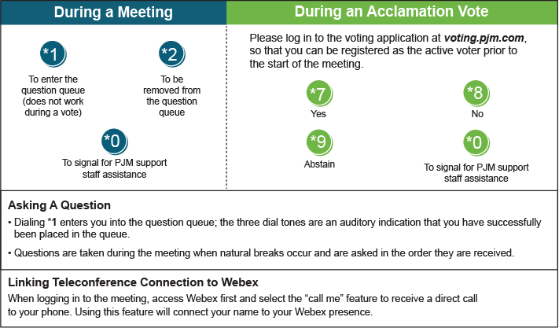

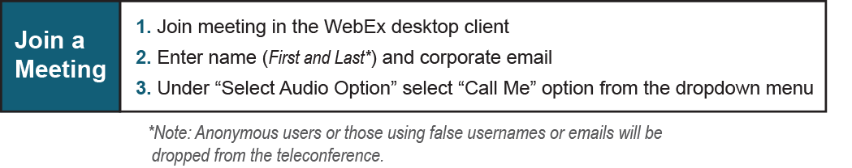

Provide feedback on the progress of this group: Facilitator Feedback Form
Visit learn.pjm.com, an easy-to-understand resource about the power industry and PJM’s role.

