Risk Management Committee

Webex

July 26, 2022

1:00 p.m. – 4:00 p.m. EPT

Administration (1:00-1:10)

Jim Gluck and Emmy Messina will provide a welcome, announcements, and review the Antitrust, Code of Conduct, Public Meetings/Media Participation, and the Webex Participant Identification Requirements.

The Committee will be asked to approve the draft minutes from the June 28, 2022 Risk Management Committee meeting.

1. Emmy Messina will review the Risk Management Committee work plan.

Endorsements (1:10-1:45)

1. Peak Market Activity Credit Requirement (1:10-1:20)

Lisa Drauschak, PJM, will review a Problem Statement and Issue Charge regarding opportunities to address concerns regarding the Peak Market Activity credit requirement. **The committee will be asked to approve the issue charge.**

FTR Residual Credit Risk (1:20-1:30)

Lisa Drauschak, PJM, will review a Problem Statement and Issue Charge regarding opportunities to address residual credit risk in the PJM FTR market. **The committee will be asked to approve the issue charge.**

1. Bankruptcy Protections (1:30-1:45)

Colleen Hicks, PJM, will review a solution package addressing bankruptcy protections. The committee will be asked to endorse this solution package.

[Issue Tracking: Bankruptcy Protections](https://pjm.com/committees-and-groups/issue-tracking/issue-tracking-details.aspx?Issue=686f7356-146b-4fa8-8417-7ba0f8e9ba7c)

Working Items (1:45-3:30)

1. Peak Market Activity Credit Requirement – Education (1:45-2:15)

Gwen Kelly and Jesse Diaz, PJM, will provide education supporting the Peak Market Activity Credit Requirement Issue Charge contingent on the issue charge being endorsed at today’s meeting.

FTR Residual Credit Risk – Education (2:15-2:45)

Mike Wynder and Kathy McElwaine, PJM, will provide education supporting the FTR Residual Credit Risk Issue Charge contingent on the issue charge being endorsed at today’s meeting.

FTR Bilateral Review and Reporting Requirements Matrix (2:45-3:15)

Jim Gluck, PJM, will facilitate a continued discussion on design components, solution options, and solution packages. All participants are encouraged to provide their input.

[Issue Tracking: FTR Bilateral Review and Reporting Requirements](https://pjm.com/committees-and-groups/issue-tracking/issue-tracking-details.aspx?Issue=b2c1be66-9571-4332-b5b0-7984d40d67a0)

Market Participant Default Flexibility (3:15-3:30)

Jim Gluck, PJM, will facilitate a continued discussion on solution options and solution packages. All participants are encouraged to provide their input.

[Issue Tracking: Market Participant Default Flexibility](https://pjm.com/committees-and-groups/issue-tracking/issue-tracking-details.aspx?Issue=bd8348bc-f0e2-4c19-8db9-0156f62c6846)

Additional Items (3:30-3:55)

1. FTR Credit Requirement Implementation (3:30-3:40)

PJM will provide an update on next steps regarding implementation of the revised FTR Credit Requirement filing currently pending FERC action.

1. Key Risk Metrics (3:40-3:55)

Gwen Kelly, PJM, will review key risk metrics for the committee’s consideration and feedback.

Informational Section

Energy Price Formation Senior Task Force (EPFSTF)

Meeting materials and upcoming meeting dates are available on the [EPFSTF website](https://pjm.com/committees-and-groups/task-forces/epfstf). Discussions involving risk may occur at the EPFSTF.

Outage Coordination Issue Charge at the Operating Committee (OC)

Meeting materials and upcoming meeting dates are available on the [OC website](https://www.pjm.com/committees-and-groups/committees/oc).

|  |
| --- |
| **Future Topics** |
|  |

|  |  |  |  |  |  |
| --- | --- | --- | --- | --- | --- |
| **Future Meeting Dates and Materials** | | | | **Materials Due  to Secretary** | **Materials Published** |
| Date | Time | Location |  | |  |
| August 23, 2022 | 1:00 p.m. | PJM Conference & Training Center/Webex | August 11, 2022 | | August 16, 2022 |
| September 20, 2022 | 1:00 p.m. | PJM Conference & Training Center/Webex | September 8, 2022 | | September 13, 2022 |
| October 19, 2022 | 1:00 p.m. | PJM Conference & Training Center/Webex | October 7, 2022 | | October 12, 2022 |
| November 15, 2022 | 1:00 p.m. | PJM Conference & Training Center/Webex | November 3, 2022 | | November 8, 2022 |
| December 20, 2022 | 1:00 p.m. | PJM Conference & Training Center/Webex | December 8, 2022 | | December 13, 2022 |

Author: Emmy Messina

Antitrust:

You may not discuss any topics that violate, or that might appear to violate, the antitrust laws including but not limited to agreements between or among competitors regarding prices, bid and offer practices, availability of service, product design, terms of sale, division of markets, allocation of customers or any other activity that might unreasonably restrain competition. If any of these items are discussed the chair will re-direct the conversation. If the conversation still persists, parties will be asked to leave the meeting or the meeting will be adjourned.

Code of Conduct:

As a mandatory condition of attendance at today's meeting, attendees agree to adhere to the PJM Code of Conduct as detailed in PJM Manual M-34 section 4.5, including, but not limited to, participants' responsibilities and rules regarding the dissemination of meeting discussion and materials.

Public Meetings/Media Participation:

Unless otherwise noted, PJM stakeholder meetings are open to the public and to members of the media. Members of the media are asked to announce their attendance at all PJM stakeholder meetings at the beginning of the meeting or at the point they join a meeting already in progress. Members of the Media are reminded that speakers at PJM meetings cannot be quoted without explicit permission from the speaker. PJM Members are reminded that "detailed transcriptional meeting notes" and white board notes from "brainstorming sessions" shall not be disseminated. Stakeholders are also not allowed to create audio, video or online recordings of PJM meetings. PJM may create audio, video or online recordings of stakeholder meetings for internal and training purposes, and your participation at such meetings indicates your consent to the same.

Participant Identification in Webex:

When logging into the Webex desktop client, please enter your real first and last name as well as a valid email address. Be sure to select the “call me” option.

PJM support staff continuously monitors Webex connections during stakeholder meetings. Anonymous users or those using false usernames or emails will be dropped from the teleconference.

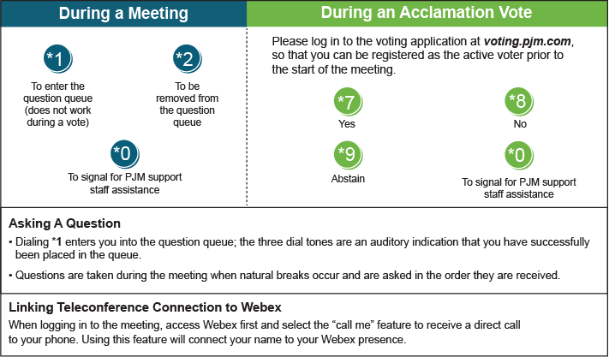

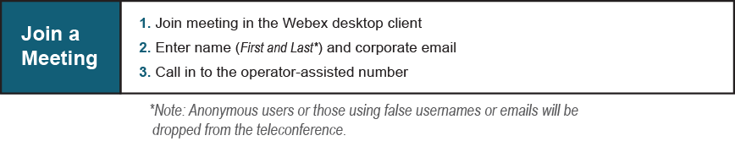

Provide feedback on the progress of this group: [*Facilitator Feedback Form*](https://www.pjm.com/committees-and-groups/committees/form-facilitator-feedback.aspx)   
Visit [*learn.pjm.com*](https://learn.pjm.com/), an easy-to-understand resource about the power industry and PJM’s role.