Demand Response Subcommittee
PJM Conference and Training Center
February 27, 2019
9:00 a.m. – 12:00 p.m. EPT

(9:00 - 9:15) Administration
- Welcome, Announcements and Anti-trust and Code of Conduct announcement
- Roll call: in-person only
- Review prior minutes – 1/30/2019 meeting
- Request for any additional agenda items
- Brief update/discussion of DR related activity in other stakeholder groups – MIC, OC, PC, or other

(9:15 – 9:30) Review of Economic DR activity during late January, early February cold snap.
- Jim McAnany will review estimated Economic DR activity from January 30th through February 1rst. PJM will post estimated and actual Economic DR activity during high load days on pjm.com on the Demand Response webpage under the Hot & Cold Day Reports section.

(9:30 – 10:30) Load Management Testing requirements
- Jack O’Neill will review the work plan and start the education process for the Load Management Testing requirements problem statement which is up for endorsement at the next MIC meeting. If time permits, stakeholder may be requested to identify their interests regarding this issue.

(10:30 – 10:45) Review Load Management performance report
- Masha Nyemko will review the recently posted Load management performance report. This report is published by PJM twice a year and summarizes Load Management resource performance during events and tests. Load Management performance reports are located on the Demand Response webpage under the Load Management Performance reports section.

(10:45 – 11:00) Break

(11:00 – 11:30) Review updated DR rules for On-Site Generators (DER) that reduce load
- Pete Langbein will continue discussion with updated examples and FAQs based on feedback on this agenda item at January DRS meeting. The rules were recently updated through the DERS to clarify DR participation when the location went through the interconnection process for expected injections to the distribution and/or transmission system. PJM also published additional detail regarding Economic DR energy settlement eligibility for locations that use On-site generation for their own purpose but would also like to participate in Economic DR for an incremental amount of generation.

(11:30 – 11:45) Review 2018 Distributed Energy Resources (DER) that Participate in PJM Markets as Demand Response report
- Masha Nyemko will review the updated report that focuses on DER/On-Site Generators that participate as DR and highlight any significant difference from the 2017 report. The report is located on pjm.com on the Demand Response webpage under the Other Reports section.

(11:45 – 12:00) DR Hub release update
- Glenn Long will provide an update on the upcoming DR Hub release which includes additional information on the new test/re-test web service structure. Please ask your technical team to join for this agenda item if there are questions on the upcoming changes.

Future Agenda Items
Participants will have the opportunity to request the addition of any new item(s) to the agenda of a future meeting.

Future Meeting Dates
Wednesday | 2/27/2019 | 9:00 am – 12:00 pm | PJM Conference & Training Center/ Webex
Thursday | 3/28/2019 | 9:00 am – 4:00 pm | PJM Conference & Training Center/ Webex
Wednesday | 4/24/2019 | 9:00 am – 4:00 pm | PJM Conference & Training Center/ Webex
Tuesday | 5/28/2019 | 9:00 am – 4:00 pm | PJM Conference & Training Center/ Webex
Wednesday | 6/19/2019 | 9:00 am – 4:00 pm | PJM Conference & Training Center/ Webex
Tuesday | 7/23/2019 | 9:00 am – 4:00 pm | PJM Conference & Training Center/ Webex
Tuesday | 8/13/2019 | 9:00 am – 4:00 pm | PJM Conference & Training Center/ Webex
Thursday | 9/5/2019 | 9:00 am – 4:00 pm | PJM Conference & Training Center/ Webex
Wednesday | 10/2/2019 | 9:00 am – 4:00 pm | PJM Conference & Training Center/ Webex
Wednesday | 11/6/2019 | 9:00 am – 4:00 pm | PJM Conference & Training Center/ Webex
Monday | 12/9/2019 | 9:00 am – 4:00 pm | PJM Conference & Training Center/ Webex

Author: Jack Thomas

Antitrust:
You may not discuss any topics that violate, or that might appear to violate, the antitrust laws including but not limited to agreements between or among competitors regarding prices, bid and offer practices, availability of service, product design, terms of sale, division of markets, allocation of customers or any other activity that might unreasonably restrain competition. If any of these items are discussed the chair will re-direct the conversation. If the conversation still persists, parties will be asked to leave the meeting or the meeting will be adjourned.

Code of Conduct:
As a mandatory condition of attendance at today's meeting, attendees agree to adhere to the PJM Code of Conduct as detailed in PJM Manual M-34 section 4.5, including, but not limited to, participants' responsibilities and rules regarding the dissemination of meeting discussion and materials.

Public Meetings/Media Participation:
Unless otherwise noted, PJM stakeholder meetings are open to the public and to members of the media. Members of the media are asked to announce their attendance at all PJM stakeholder meetings at the beginning of the meeting or at the point they join a meeting already in progress. Members of the Media are reminded that speakers at PJM meetings cannot be quoted without explicit permission from the speaker. PJM Members are reminded that "detailed transcriptional meeting notes" and white board notes from "brainstorming sessions" shall not be disseminated. Stakeholders are also not allowed to create audio, video or online recordings of PJM meetings.

Participant Identification in WebEx:
When logging into the WebEx desktop client, please enter your real first and last name as well as a valid email address. Be sure to select the “call me” option.
PJM support staff continuously monitors WebEx connections during stakeholder meetings. Anonymous users or those using false usernames or emails will be dropped from the teleconference.



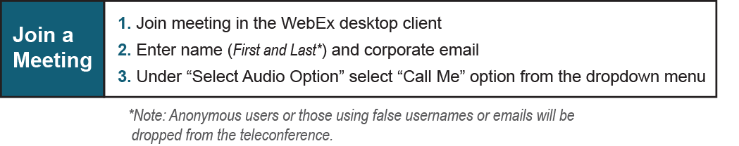

Provide feedback on the progress of this group: Facilitator Feedback Form
Visit learn.pjm.com an easy-to-understand resource about the power industry and PJM’s role.

