Demand Response Subcommittee
PJM Conference and Training Center
April 24, 2019
9:00 a.m. – 12:00 p.m. EPT

(9:00 - 9:15) Administration
- Welcome, Announcements and Anti-trust and Code of Conduct announcement
- Roll call: in-person only
- Review prior minutes – 3/28/2019 meeting
- Request for any additional agenda items
- Brief update/discussion of DR related activity in other stakeholder groups – MIC, OC, PC, or other
- The Economic DR On-Site Generator presentation was reposted to the Training Material webpage based on prior DRS suggestions.

(9:15 – 9:30) DR Training Survey reminder
- Andrea Yeaton will provide a quick summary of DR Training survey. PJM has requested stakeholder input on DR training to guide future enhancements.

(9:30 – 10:50) Load Management Test requirements
- Jack O’Neill will discuss a PJM proposed solution for the Test requirements. Stakeholders will discuss pros and cons of this proposal and suggest other proposals, as appropriate. The focus will be on solution components and how they meet identified interests.

(10:50 – 11:00) BREAK

(11:00 – 11:20) Economic DR regulation certification process changes
- Jim McAnany will discuss Economic DR regulation certification changes based on recent experience and questions from CSPs. PJM is in the process of updating training material to clarify this process.

(11:20 – 11:40) DR Hub Test event notification through webservices
- Glenn Long will review the DR Hub Test event notification and CSP acknowledgement process. This was discussed at the DRS in 2018 and implemented in DR Hub at the end of 2018. PJM has received some questions from CSP and would like to provide a brief reminder on how this works.

(11:40 – 11:50) DR Hub release scheduled for 4/30/19
- Andrea Yeaton will review the DR Hub changes scheduled for the 4/30/19 DR Hub release. The changes were adopted through the DERS stakeholder process and targeted at DER/BtMG used for DR activity.

Future Agenda Items
Participants will have the opportunity to request the addition of any new item(s) to the agenda of a future meeting.

Future Meeting Dates
Wednesday | 4/24/2019 | 9:00 am – 12:00 pm | PJM Conference & Training Center/ Webex
Tuesday | 5/28/2019 | 9:00 am – 4:00 pm | PJM Conference & Training Center/ Webex
Wednesday | 6/19/2019 | 9:00 am – 4:00 pm | PJM Conference & Training Center/ Webex
Tuesday | 7/23/2019 | 9:00 am – 4:00 pm | PJM Conference & Training Center/ Webex
Tuesday | 8/13/2019 | 9:00 am – 4:00 pm | PJM Conference & Training Center/ Webex
Thursday | 9/5/2019 | 9:00 am – 4:00 pm | PJM Conference & Training Center/ Webex
Wednesday | 10/2/2019 | 9:00 am – 4:00 pm | PJM Conference & Training Center/ Webex
Wednesday | 11/6/2019 | 9:00 am – 4:00 pm | PJM Conference & Training Center/ Webex
Monday | 12/9/2019 | 9:00 am – 4:00 pm | PJM Conference & Training Center/ Webex

Author: Jack Thomas

Antitrust:
You may not discuss any topics that violate, or that might appear to violate, the antitrust laws including but not limited to agreements between or among competitors regarding prices, bid and offer practices, availability of service, product design, terms of sale, division of markets, allocation of customers or any other activity that might unreasonably restrain competition. If any of these items are discussed the chair will re-direct the conversation. If the conversation still persists, parties will be asked to leave the meeting or the meeting will be adjourned.

Code of Conduct:
As a mandatory condition of attendance at today's meeting, attendees agree to adhere to the PJM Code of Conduct as detailed in PJM Manual M-34 section 4.5, including, but not limited to, participants' responsibilities and rules regarding the dissemination of meeting discussion and materials.

Public Meetings/Media Participation:
Unless otherwise noted, PJM stakeholder meetings are open to the public and to members of the media. Members of the media are asked to announce their attendance at all PJM stakeholder meetings at the beginning of the meeting or at the point they join a meeting already in progress. Members of the Media are reminded that speakers at PJM meetings cannot be quoted without explicit permission from the speaker. PJM Members are reminded that "detailed transcriptional meeting notes" and white board notes from "brainstorming sessions" shall not be disseminated. Stakeholders are also not allowed to create audio, video or online recordings of PJM meetings.

Participant Identification in WebEx:
When logging into the WebEx desktop client, please enter your real first and last name as well as a valid email address. Be sure to select the “call me” option.
PJM support staff continuously monitors WebEx connections during stakeholder meetings. Anonymous users or those using false usernames or emails will be dropped from the teleconference.



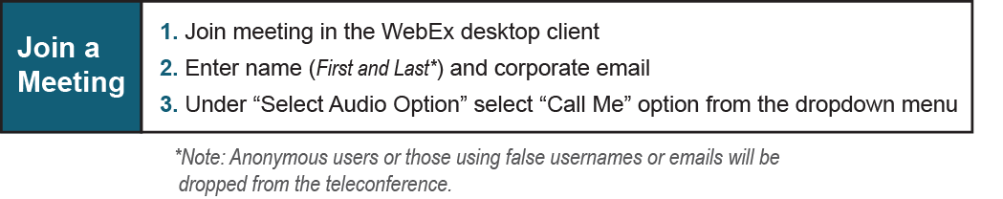

Provide feedback on the progress of this group: Facilitator Feedback Form
Visit learn.pjm.com an easy-to-understand resource about the power industry and PJM’s role.

