Financial Risk Mitigation Senior Task Force (FRMSTF)
Webex
April 23, 2020
9:00 a.m. – 12:00 p.m. EPT

Administration (9:00-9:05)
- Ms. Michele Greening will provide welcome, announcements and review of the Antitrust, Code of Conduct, and Public Meetings/Media Participation Guidelines. Stakeholders will be asked to approve draft minutes from the March 30, 2020 meeting.

Work Plan (9:05-9:15)
- Ms. Anita Patel will review the Financial Risk Mitigation Senior Task Force stakeholder process work plan and will provide a review of the open report recommendations on the dashboard with the work being completed in this phase of the FRMSTF.

Education (9:15-10:15)
Liquidation Process (9:15-10:15)
- Mr. Donald House, ERCOT, will provide education pertaining to ERCOT’s CRR (FTR) liquidation process. (9:15-9:45)
- Mr. Asanga Perera will provide education pertaining to PJM’s FTR default cost allocation process. (9:45-10:15)

Informational Discussions (10:15-12:00)
- Liquidation Process (10:15-10:30)
Mr. Asanga Perera will lead a discussion on PJM’s initial thoughts on objectives and design components.
Break 10:30-10:40
- FTR Credit Requirement Enhancements (10:40-12:00)
Ms. Bridgid Cummings will continue the discussion regarding the identification of FTR credit requirement components and additional considerations of a holistic FTR Credit Requirement calculation.

Future Agenda Items (12:00)
Continued discussion and development of Matrix Design Components
Initial discussion of Solution Options within the Matrix Design Components

Future Meeting Dates
May 11, 2020 |  | 9:00 a.m. | PJM Conference & Training Center/ WebEx
June 24, 2020 | 9:00 a.m. |  | PJM Conference & Training Center/ WebEx
July 21, 2020 | 9:00 a.m. |  | PJM Conference & Training Center/ WebEx
August 26, 2020 | 9:00 a.m. |  | PJM Conference & Training Center/ WebEx
September 29, 2020 | 9:00 a.m. |  | PJM Conference & Training Center/ WebEx
Author: M. Greening

Antitrust:
You may not discuss any topics that violate, or that might appear to violate, the antitrust laws including but not limited to agreements between or among competitors regarding prices, bid and offer practices, availability of service, product design, terms of sale, division of markets, allocation of customers or any other activity that might unreasonably restrain competition. If any of these items are discussed the chair will re-direct the conversation. If the conversation still persists, parties will be asked to leave the meeting or the meeting will be adjourned.

Code of Conduct:
As a mandatory condition of attendance at today's meeting, attendees agree to adhere to the PJM Code of Conduct as detailed in PJM Manual M-34 section 4.5, including, but not limited to, participants' responsibilities and rules regarding the dissemination of meeting discussion and materials.

Public Meetings/Media Participation:
Unless otherwise noted, PJM stakeholder meetings are open to the public and to members of the media. Members of the media are asked to announce their attendance at all PJM stakeholder meetings at the beginning of the meeting or at the point they join a meeting already in progress. Members of the Media are reminded that speakers at PJM meetings cannot be quoted without explicit permission from the speaker. PJM Members are reminded that "detailed transcriptional meeting notes" and white board notes from "brainstorming sessions" shall not be disseminated. Stakeholders are also not allowed to create audio, video or online recordings of PJM meetings. PJM may create audio, video or online recordings of stakeholder meetings for internal and training purposes, and your participation at such meetings indicates your consent to the same.
Participant Identification in WebEx:
When logging into the WebEx desktop client, please enter your real first and last name as well as a valid email address. Be sure to select the “call me” option.
PJM support staff continuously monitors WebEx connections during stakeholder meetings. Anonymous users or those using false usernames or emails will be dropped from the teleconference.



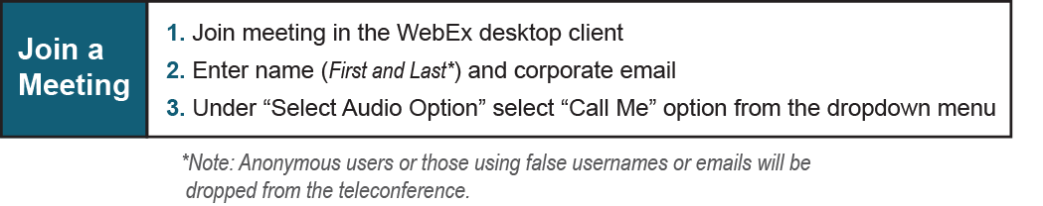
Provide feedback on the progress of this group: Facilitator Feedback Form
Visit learn.pjm.com, an easy-to-understand resource about the power industry and PJM’s role.

