Financial Risk Mitigation Senior Task Force (FRMSTF)
Webex
September 29, 2020
9:00 a.m. – 12:15 p.m. EPT

Administration (9:00-9:05)
- Michele Greening will provide a welcome, announcements and review of the Antitrust, Code of Conduct, and Public Meetings/Media Participation Guidelines. Stakeholders will be asked to approve draft minutes from the August 26, 2020 meeting.

Work Plan (9:05-9:15)
- Ms. Anita Patel will review the Financial Risk Mitigation Senior Task Force stakeholder process work plan.

Informational Updates (9:15-10:50)
- External Clearing Timeline (9:15-9:20)
Megan Heater will provide an update regarding the process to evaluate the third party clearing proposal.
- Initial Margining and FTR Credit Requirements (9:20-10:05)
Alex Eydeland and Bridgid Cummings will provide an update regarding Initial Margining and FTR Credit Requirements.
- Minimum Capitalization (10:05-10:15)
Daniel Sarti will provide an update regarding Minimum Capitalization requirements.

Discussion (10:15-12:15)
- Liquidation Process (10:15-12:15)
- Nigeria Bloczynski will present proposed revisions to PJM’s default management process. (10:15-11:00)

- Howards Haas, Monitoring Analytics will provide a response to the PJM proposal.

- Howard Haas, Monitoring Analytics, will provide a presentation on a default/liquidation proposal. (11:00-11:30)

- Dave Hicks, Perast Capital Management, will provide a presentation on a liquidation proposal. (11:30-12:00)

- PJM will close the meeting with next steps and review voting logistics. (12:00-12:15)
The task force will be asked to endorse a proposed solution in a vote following the September 29 FRMSTF meeting.

Future Agenda Items (12:15)
External Clearing Timeline
Continued Minimum Capitalization Requirements Discussion

Future Meeting Dates
October 19, 2020 | 9:00 a.m. | PJM Conference & Training Center/ Webex
November 9, 2020 | 9:00 a.m. | PJM Conference & Training Center/ Webex

Author: M. Greening

Antitrust:
You may not discuss any topics that violate, or that might appear to violate, the antitrust laws including but not limited to agreements between or among competitors regarding prices, bid and offer practices, availability of service, product design, terms of sale, division of markets, allocation of customers or any other activity that might unreasonably restrain competition. If any of these items are discussed the chair will re-direct the convcaersation. If the conversation still persists, parties will be asked to leave the meeting or the meeting will be adjourned.

Code of Conduct:
As a mandatory condition of attendance at today's meeting, attendees agree to adhere to the PJM Code of Conduct as detailed in PJM Manual M-34 section 4.5, including, but not limited to, participants' responsibilities and rules regarding the dissemination of meeting discussion and materials.

Public Meetings/Media Participation:
Unless otherwise noted, PJM stakeholder meetings are open to the public and to members of the media. Members of the media are asked to announce their attendance at all PJM stakeholder meetings at the beginning of the meeting or at the point they join a meeting already in progress. Members of the Media are reminded that speakers at PJM meetings cannot be quoted without explicit permission from the speaker. PJM Members are reminded that "detailed transcriptional meeting notes" and white board notes from "brainstorming sessions" shall not be disseminated. Stakeholders are also not allowed to create audio, video or online recordings of PJM meetings. PJM may create audio, video or online recordings of stakeholder meetings for internal and training purposes, and your participation at such meetings indicates your consent to the same.
Participant Identification in WebEx:
When logging into the WebEx desktop client, please enter your real first and last name as well as a valid email address. Be sure to select the “call me” option.
PJM support staff continuously monitors WebEx connections during stakeholder meetings. Anonymous users or those using false usernames or emails will be dropped from the teleconference.



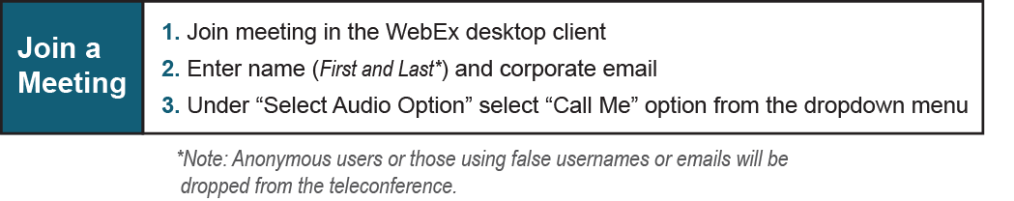
Provide feedback on the progress of this group: Facilitator Feedback Form
Visit learn.pjm.com, an easy-to-understand resource about the power industry and PJM’s role.

