Market Efficiency Process Enhancement Task Force (MEPETF)
PJM Conference and Training Center
July 30, 2019
1:00 p.m. – 4:00 p.m. EPT

Administration (1:00 - 1:10)
- Welcome, review agenda, PJM meeting guidelines, roll call and Anti-trust and Code of Conduct announcements, and approve the draft meeting minutes from the July 1, 2019 MEPETF meeting – Mr. Fran Barrett and Mr. Jack Thomas.

(1:10 – 1:40) Benefit-to-Cost Calculation for Market Efficiency Projects (MEP)
- Mr. Brian Chmielewski (PJM) will provide background on the benefits-to-cost calculation and introduce potential concepts and changes that may be required.

(1:40 – 2:50) Basic Congestion Concepts and Benefits Calculations for MEP
- Mr. Howard Haas (IMM) will provide information around basic congestion concepts and the calculation of project benefits.

(2:50 – 3:30) Impact of Including Negative Benefits in the Benefits Calculation
- Mr. Nick Dumitriu (PJM) will provide some information on why negative benefits were removed from the benefit-to-cost calculation and provide example of how including negative benefits will affect the calculation.

(3:30 – 4:00) Polling Questions for Potential Intraregional TMEP Process
- Mr. Barrett and Mr. Thomas will facilitate the process to help create poll questions centered on creating a new intraregional Targeted Market Efficiency Project process.

Future Agenda Items
Participants will have the opportunity to request the addition of any new item(s) to the agenda of a future meeting.

Future Meeting Dates
August 26, 2019 | 9:00 a.m. – 12:00 p.m. | PJM Interconnection - Conference and Training Center
September 27, 2019 | 9:00 a.m. – 12:00 p.m. | PJM Interconnection - Conference and Training Center
October 10, 2019 | 9:00 a.m. – 12:00 p.m. | PJM Interconnection - Conference and Training Center
December 3, 2019 | 9:00 a.m. – 12:00 p.m. | PJM Interconnection - Conference and Training Center

Author: J. Thomas

Antitrust:
You may not discuss any topics that violate, or that might appear to violate, the antitrust laws including but not limited to agreements between or among competitors regarding prices, bid and offer practices, availability of service, product design, terms of sale, division of markets, allocation of customers or any other activity that might unreasonably restrain competition. If any of these items are discussed the chair will re-direct the conversation. If the conversation still persists, parties will be asked to leave the meeting or the meeting will be adjourned.

Code of Conduct:
As a mandatory condition of attendance at today's meeting, attendees agree to adhere to the PJM Code of Conduct as detailed in PJM Manual M-34 section 4.5, including, but not limited to, participants' responsibilities and rules regarding the dissemination of meeting discussion and materials.

Public Meetings/Media Participation:
Unless otherwise noted, PJM stakeholder meetings are open to the public and to members of the media. Members of the media are asked to announce their attendance at all PJM stakeholder meetings at the beginning of the meeting or at the point they join a meeting already in progress. Members of the Media are reminded that speakers at PJM meetings cannot be quoted without explicit permission from the speaker. PJM Members are reminded that "detailed transcriptional meeting notes" and white board notes from "brainstorming sessions" shall not be disseminated. Stakeholders are also not allowed to create audio, video or online recordings of PJM meetings. PJM may create audio, video or online recordings of stakeholder meetings for internal and training purposes, and your participation at such meetings indicates your consent to the same.
Participant Identification in WebEx:
When logging into the WebEx desktop client, please enter your real first and last name as well as a valid email address. Be sure to select the “call me” option.
PJM support staff continuously monitors WebEx connections during stakeholder meetings. Anonymous users or those using false usernames or emails will be dropped from the teleconference.



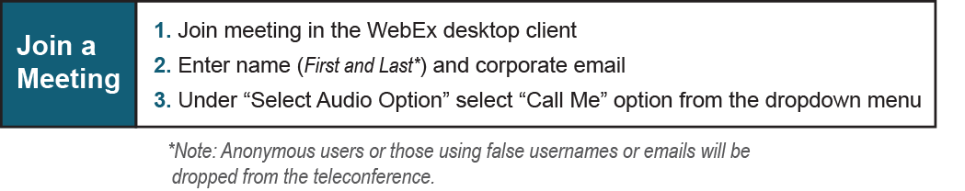

Provide feedback on the progress of this group: Facilitator Feedback Form
Visit learn.pjm.com, an easy-to-understand resource about the power industry and PJM’s role.

