DRAFT AGENDA
PJM Interconnection
Net Energy Metering Senior Task Force (NEMSTF) - Meeting #9
Tech Center, Visitor Center
2600 Monroe Boulevard, Valley Forge Corporate Center
Norristown, PA
04.16.2012
9:30am – 3:30pm

- Administration (20 min)
Participant introductions, reminder of meeting & Anti-trust guidelines, roll call, review minutes and status of action items from prior meeting.
- OPSI – 2012 – 5 Resolution regarding pjm’s involvement in net energy metering (15 MIN)
Mr. Barrett will inform the stakeholders of a recent OPSI resolution – See attached exhibit
- Review of consolidated interests priority polling results (25 min)
The stakeholders will review and discuss the results of the priority polling. Upon completion of the discussion, the interests will be set aside to enable brainstorming on potential design components.
- Design components brainstorming (4 HR)
  - Reminder: Mr. Barrett has solicited design components from the stakeholders in advance of the meeting.
  - Brainstorm potential NEM design components. Discuss and look for opportunities to refine, group, or consolidate. Consider any new design ideas or sub components.
  - Populate the Matrix with design components, document status quo
  - Conduct webex poll – rank the relative priority of identified design components (h, m, l)
  - Stretch Goal: begin to develop independent options.
    - Reminder: Independent options will be considered for linkages and assembly into comprehensive packages at a future meeting.

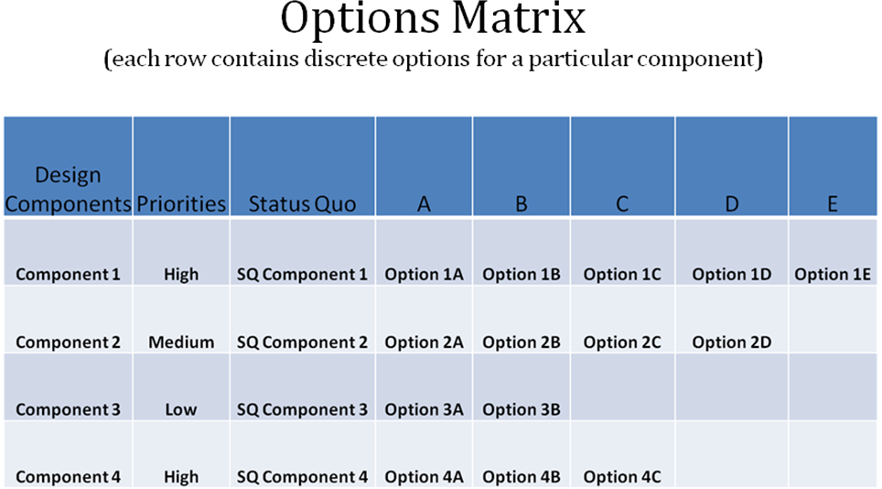
- Meeting summary AND CALL FOR Future Agenda Items (5 Min)
Participants will have the opportunity to request the addition of any new item(s) to the agenda of a future meeting.
- Future meeting dates AND MEETING VENUES
2012
April 30 | 9:30 – 3:30pm | PJM Interconnection, Business Center
May 11 | 9:30 – 3:30pm | PJM Interconnection, Conference and Training Center, Tesla
May 18 | 9:30 – 3:30pm | PJM Interconnection, Conference and Training Center, Tesla
May 24 | 9:30 – 3:30pm | PJM Interconnection, Conference and Training Center, Tesla
May 25 | 9:30 – 3:30pm | PJM Interconnection, Conference and Training Center, Tesla
May 30 | 9:30 – 3:30pm | PJM Interconnection, Conference and Training Center, Tesla
Anti-trust:
You may not discuss any topics that violate, or that might appear to violate, the antitrust laws including but not limited to agreements between or among competitors regarding prices, bid and offer practices, availability of service, product design, terms of sale, division of markets, allocation of customers or any other activity that might unreasonably restrain competition. If any of these items are discussed the chair will re-direct the conversation. If the conversation still persists, parties will be asked to leave the meeting or the meeting will be adjourned.

Code of Conduct:
As a mandatory condition of attendance at today's meeting, attendees agree to adhere to the PJM Code of Conduct as detailed in PJM Manual M-34 section 4.5, including, but not limited to, participants' responsibilities and rules regarding the dissemination of meeting discussion and materials.

Public Meetings/Media Participation:
Unless otherwise noted, PJM stakeholder meetings are open to the public and to members of the media. Members of the media are asked to announce their attendance at all PJM stakeholder meetings at the beginning of the meeting or at the point they join a meeting already in progress. Members of the Media are reminded that speakers at PJM meetings cannot be quoted without explicit permission from the speaker. PJM Members are reminded that "detailed transcriptional meeting notes" and white board notes from "brainstorming sessions" shall not be disseminated. PJM Members are also not allowed to create audio, video or online recordings of PJM meetings.

